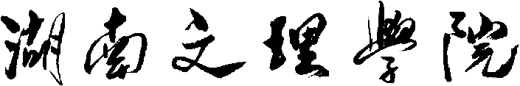

目 录

目录

目 录 2

摘 要 3

Abstract 4

引 言 5

第一章 绪 论 6

1.1 研究背景以及发展现状 6

1.2研究目的和意义 6

第二章 开发工具介绍 7

2.1 Unity3d游戏引擎介绍 7

2.2 C#脚本语言介绍 7

第三章 游戏设计 8

3.1 游戏界面功能设计 8

3.1.1 加载界面功能设计 8

3.1.2 选择职业功能界面设计 8

3.1.3 主界面功能设计 9

3.1.4 签到界面功能设计 10

3.1.5 角色界面功能设计 10

3.1.6 任务界面功能设计 11

3.1.7 技能界面功能设计 11

3.1.8 夺宝界面功能设计 12

3.1.9 装备界面功能设计 12

3.1.10 背包界面功能设计 13

3.1.11 商店界面功能设计 13

3.1.12 设置界面功能设计 14

3.1.13 游戏界面功能设计 15

3.2 地图设计 15

3.2.1 地图1-炼狱十字 16

3.2.2 地图2-云顶天宫 16

3.2.2 环境光设计 17

3.3 战斗系统设计 18

3.3.1 动画控制器 18

3.3.2 动画状态机 19

3.7 主角设计 21

3.8 怪物设计 22

第四章 游戏相关技术 23

4.1 导航网格寻路 23

4.1.1 寻路网格的烘培 23

4.1.2 网格寻路原理 24

4.1.3 寻路系统的优化处理 25

4.2 场景的烘培 26

4.2.1 Unity的灯光模式 26

4.2.2 光照贴图 27

4.2.3 生成光照贴图 27

4.3 数据持久化技术 30

第五章 游戏测试 32

测试环境 32

5.1 Unity环境测试 32

5.2 移动端发布测试 34

5.2.1 安卓平台发布 34

5.2.2 安卓屏幕自适应测试 35

5.2.3 游戏运行测试 35

总结 37

参考文献 39

致 谢 40

附录（部分代码） 41

（1）场景异步加载代码 41

（2）选择职业界面管理脚本 42

（3）大厅界面管理脚本 45

（4）装备界面管理脚本 50

（5）背包界面管理脚本 59

（6）角色界面管理脚本 70

（7）设置界面管理脚本 80

（8）商店界面管理脚本 84

（9）签到界面管理脚本 90

（10）技能界面管理脚本 94

（11）任务界面管理脚本 102

（12）抽奖界面管理脚本 103

（13）玩家代码（基类） 109

（14）玩家技能代码 121

（15）怪物代码（基类） 123

（16）游戏设置 128

（17）游戏管理脚本 133

（18）游戏服务器脚本 134

摘 要

随着计算机技术的发展，游戏行业得到了飞速的发展，一款好的游戏作品可以让人放松心情，给人带来好的游戏体验。如今市面上存在有很多优秀的游戏作品，它们深受人们的喜爱，而它们都是用的游戏引擎进行开发，在游戏引擎的世界里，Unity3d游戏引擎深受人们的喜爱，它可以用来制作2D小游戏，也可以用来开发大型的3D游戏，强大的引擎系统可以实现真实世界的事物，因此Unity3d在游戏开发领取有着不可估量的作用，而去研究它是如何开发一款不错的游戏也有着重大的意义。

本次课题是做一个角色扮演类的3D手机游戏，去研究开发过程中所使用到的3D技术，其中，游戏主角和怪物需要实现一系列的动画去展现给玩家，所使用的动画系统是Unity3d自带的Animator，通过与场景中事物的交互，达到趣味化的效果，同时也将会通过设计去实现相应的特效和音频等美术资源，配合UI界面把美好的游戏元素呈现给玩家，最终开发出一款不错的游戏作品。

**关键词**：Unity3d游戏引擎；角色扮演类的3D手机游戏；3D技术

Abstract

With the development of computer technology, the game industry has been rapid development, a good game works can let people relax, give people a good game experience. Today there are a lot of excellent game works on the market, they are loved by people, and they are developed with the game engine, in the game engine world, Unity3d game engine is very popular, it can be used to make 2D games, can also be used to develop large-scale 3D games, powerful engine system can achieve real-world things, so Unity3d in game development has an immeasurable role, And it makes a lot of sense to study how it develops a good game. This topic is to do a role-playing class of 3D mobile phone games, to study the development process used in 3D technology, in which, the game protagonists and monsters need to achieve a series of animation to show to the player, the animation system used is Unity3d comes with Animator, through interaction with things in the scene, to achieve interesting effects, but also through the design to achieve the corresponding effects and audio and other art resources, with the UI interface to present the beautiful elements of the game to the player, Finally developed a good game.

**Keywords:** Unity3d game engine; role-playing 3D mobile games; 3D technology

引 言

本课题通过使用Unity3d游戏引擎和C#脚本语言去开发一款3D角色扮演类的手机游戏，主角可以通过消灭地图BOSS最终完成胜利，被怪物击败则判定为失败，主角可通过释放技能来快速击败怪物，不同的职业有不同的特点，玩家需要了解不同职业的优缺点，有策略地通关相应的地图，还可以前往商店购买相关的装备增强角色，不同的装备有不同的属性，玩家合理地搭配装备可以有效解决相关职业的缺点。游戏中的怪物可以智能地追击玩家，并通过动画的形式进行交互，怪物BOSS还会拥有强力的技能，需要玩家灵活地去躲避。

第一章 绪 论

1.1 研究背景以及发展现状

游戏产业作为一个新兴产业，从初期形成到现如今的快速发展并迅速走向成熟时期，游戏行业已经成为文化娱乐产业、网络经济的重要组成部分，成为所有行业中发展前景可观的朝阳产业。目前国内的游戏研发人才缺口巨大，移动端人才需求非常迫切。随着网络快速发展和不断成熟，我国游戏产业呈现快速稳定发展的良好趋势，拥有庞大的群众基础，与此同时，亦需要一大批游戏研发人员，助力游戏产业开发。

Unity3d是目前火爆的专业游戏引擎，Unity3d引擎占据全功能游戏引擎市场45%的份额，居全球首位。全世界有6亿的玩家在玩使用Unity引擎制作的游戏。Unity 3D开发人员占有比例为47%，Unity3d全球用户已经超过330万人，中国区的开发者数量已成为全球第一。同时，Unity3d不仅仅适用于游戏领域，其在汽车、运输与制造、电影与动画、建筑等方面也同样适用，因此，Unity3d是一个很全面的游戏引擎，其深受开发者的喜爱。

1.2研究目的和意义

通过使用Unity3d游戏引擎，独立完成一款可运行的游戏成品，游戏使用多种电脑技术，使其能够达到趣味化、情景化、真实化，把现实生活中难以呈现的美在游戏中表现出来，让有趣的事物呈现在人们眼前，使玩家得到更好的游戏体验。

通过使用Unity3d游戏引擎来开发一款游戏，可以学到游戏开发中所使用的技术和游戏开发基本流程，了解C#编程语言的特点和如何与Unity3d进行交互，还可以了解到Unity3d游戏引擎的强大之处，使玩家在游戏的过程中体验到三维游戏的独特魅力。

第二章 开发工具介绍

2.1 Unity3d游戏引擎介绍

所谓的游戏引擎，就是一种“软件框架”，专门为游戏开发而设计的软件框架，提供游戏开发所需要的基础。利用游戏引擎去开发游戏，可以省去很多计算机底层的重复操作，可以极大地提高开发效率。而Unity3d游戏引擎，它可以用来开发2D和3D游戏，附带有各种强大的内置系统，例如物理系统，可以高度还原真实世界中发生的物理现象，又如动画系统，可以让一个人物表现出逼真的行为效果。Unity3d除了能做游戏之外，还在美术、建筑、汽车设计、影视领域有着重要的作用，例如看房子，你可以利用Unity3d去开发一款VR看房子的软件，可以让购买者身临其境地查看房子的布局，又如教学领域中，你可以开发一款3维教学软件，可以让学生更好地理解三维物体的结构。在这里我们可以看出Unity提供了一整套完善的软件解决方案，可用于创作、运营和变现任何实时互动的2D和3D内容。同时它还支持平台包括手机、平板电脑、PC、游戏主机、增强现实和虚拟现实设备，可以实现跨平台发布产品。

据百度百科数据记载，基于Unity开发的游戏和体验月均下载量高达30亿次，并且其在2019年的安装量已超过370亿次，全平台（包括PC/主机/移动设备）所有游戏中有超过一半都是使用Unity创作的，在Apple应用商店和Google Play上排名最靠前的1000款游戏中，53%都是用Unity创作的。目前很火的游戏《王者荣耀》就是使用Unity引擎进行开发。从这些数据可以看出，Unity游戏引擎深受人们的喜爱。而本次课题我将使用Unity3d去开发一款游戏，去发掘Unity3d游戏引擎的独特之处。

2.2 C#脚本语言介绍

Unity使用的脚本语言是C#，C#是微软公司在2000年6月发布的一种新的编程语言，主要由安德斯·海尔斯伯格（Anders Hejlsberg）主持开发。C#有着简洁的语法，，它继承了C和C++的优点，而又在C和C++的基础上进行了简化，这让你可以迅速成为一名熟练的开发人员，从这一点上，C#语言就受到广泛的好评。C#是一种面向对象的脚本语言，在C#的类型系统中，每种类型都可以看作一个对象，可以有效地构建管理框架。

第三章 游戏设计

3.1 游戏界面功能设计

一款好的游戏应该具有舒适的图形用户界面和美观的场景，因此UI和场景元素的设计就显得非常的重要。本款游戏的UI主要使用Unity3d自带的UGUI功能搭建界面，游戏界面的设计不应该只注重图片，还可以适当地添加特效和动画，让界面更加美观和生动，以达到丰富游戏元素的目的。

3.1.1 加载界面功能设计

在加载界面，为了给玩家一个好的游戏印象，我没有使用僵硬的图片去布局，而是添加了很多的特效等动态元素，例如雾效、风车的转动动画，这些再加上阴暗的天空，让人好奇这种游戏的风格是怎么样的，可以起到吸引人眼球的效果。同时我仅仅使用了简单的文本Text和滑动条Slider来显示进度，当滑动条到达最右边，也就意味着加载完毕，将出现开始游戏按钮，玩家可通过点击开始游戏按钮就能进入下一个场景，如图3.1.1所示。

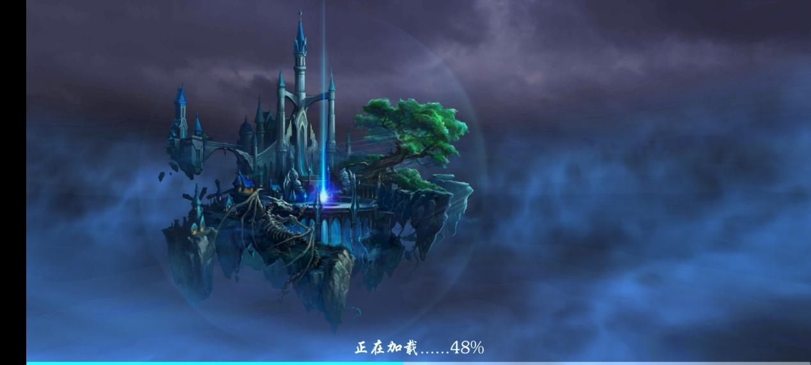

图 3.1.1

3.1.2 选择职业功能界面设计

为了风格的一致性，选择职业的场景也将是偏暗的，但我打了很多灯光，让某些区域可以变得光亮和更加具有特色，在这个场景里，角色背后的建筑就是灯光照明的效果，而旁边的一些区域则显得比较昏暗，同时在UI上，我采用的是四角分布的布局，尽可能让中间空旷，左下方和右下方分别为两个按钮Button，左上方为职业角色的介绍，又上方可以通过两个开关控件（Toggle）进行职业的切换，最终可以点击开始游戏按钮进入下一个场景，也可点击退出游戏关闭应用，如图3.1.2所示。

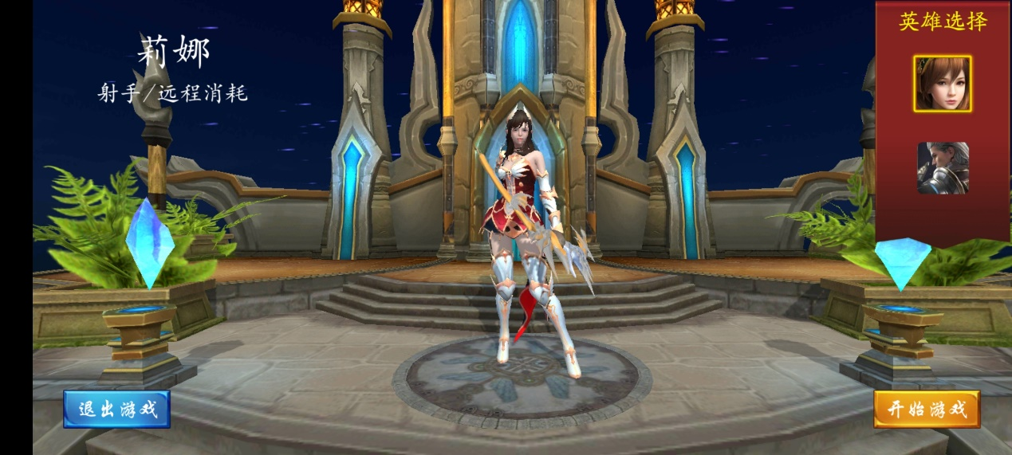

图 3.1.2

3.1.3 主界面功能设计

主界面的UI设计与背景融为一体，为浅蓝色，甚至是灯光和特效也都为同一种颜色，界面布局为上下布局，下方布置了7个功能按钮，通过文本的形式告知玩家每个按钮的具体功能，左下方布置了一个文本用于显示时间，右下方布置了一个地图管理的窗口，玩家可通过左右箭头图标更换地图，点击开始游戏按钮即可进入游戏，左上方为角色信息的显示，可实时告知玩家角色的属性信息，其中包括血量、经验值和等级；中上位置则为金币和钻石的显示信息，都是Text文本，右上方则布置了为商店和设置两个按钮功能，如图3.1.3所示。

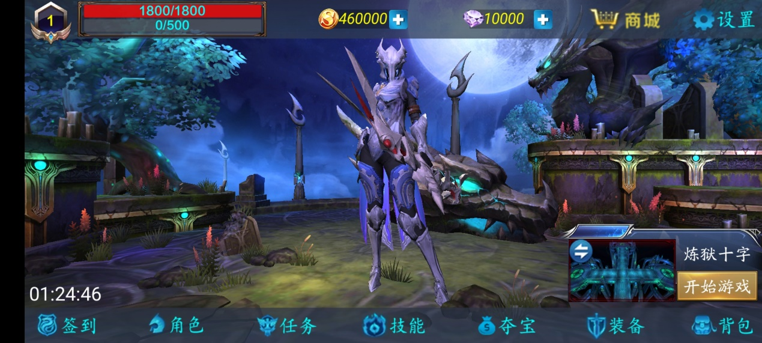

图 3.1.3

3.1.4 签到界面功能设计

签到界面一共有14个按钮（Button），当可以签到时，点击对应的按钮即可领取对应的奖励并完成签到，当不符合签到条件时，按钮将不可点击且置为灰色，如图3.1.4所示。

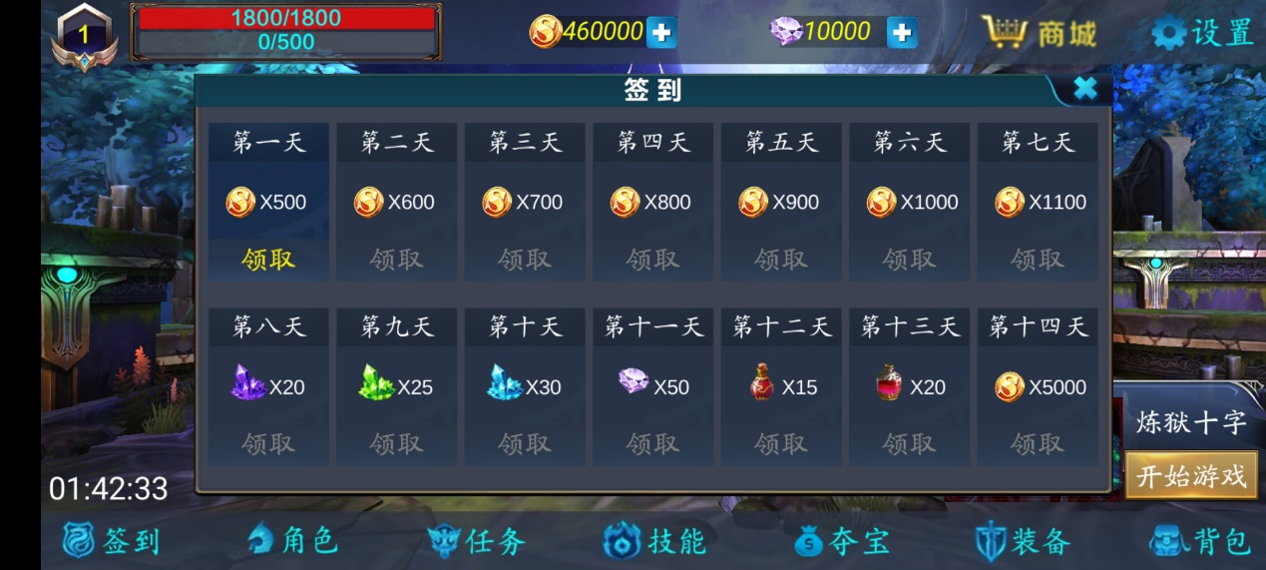

图 3.1.4

3.1.5 角色界面功能设计

角色界面左侧显示角色信息，右侧显示角色皮肤信息，下方为皮肤价格信息，玩家可通过右下角的滚动视图进行皮肤切换，从而购买或装备相应的皮肤，如图3.1.5所示。

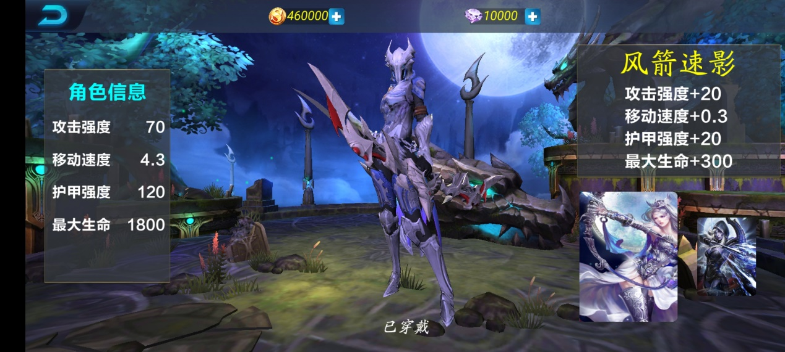

图 3.1.5

3.1.6 任务界面功能设计

任务界面分为每日任务和成就任务，每日任务为一个列表，完成任务右侧的领取按钮将会激活，未完成则处于不可点击的状态，如图3.1.6所示。

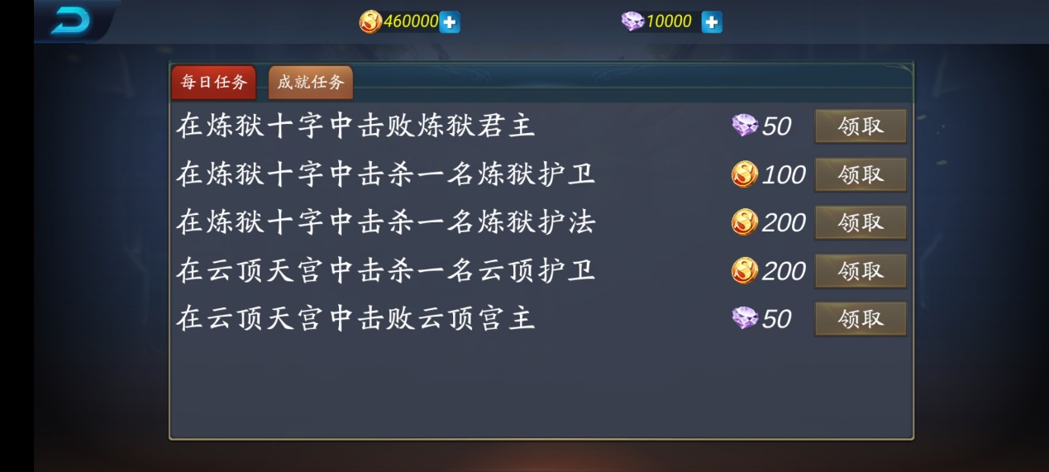

图 3.1.6

3.1.7 技能界面功能设计

技能界面上边显示拥有的升级材料数量，中间显示角色的技能信息，玩家可通过点击右侧的升级按钮，如果符合条件即可升级技能成功，如图3.1.7所示。

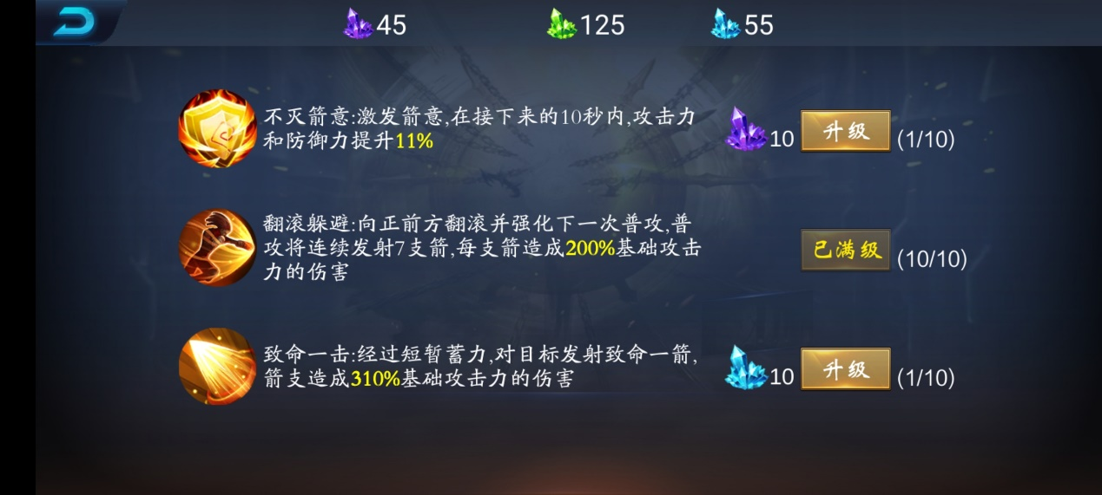

图 3.1.7

3.1.8 夺宝界面功能设计

夺宝界面主要进行的是抽奖，界面摆放有22个道具，除了贵重物件之外，其余道具的获得概率是相等的，当幸运值达到一百，也就是星星被点亮时，进行抽奖则必定获得稀有物品，这是一种随机数算法，概率与幸运值系数绑定，玩家可点击界面种的按钮抽五次或抽一次进行抽奖，如图3.1.8所示。

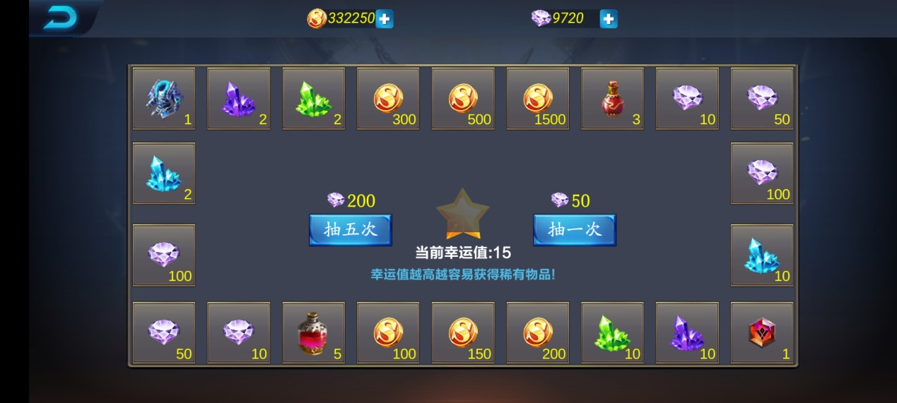

图 3.1.8

3.1.9 装备界面功能设计

装备界面用于装备的管理，界面有7个装备格子，每个装备格子对应角色身上的某一个肢体部位，点击装备格子可以弹出对话框，选择是否卸下装备，又侧有8个文本组件（Text）用于显示每件装备的属性信息，如图3.1.9所示。

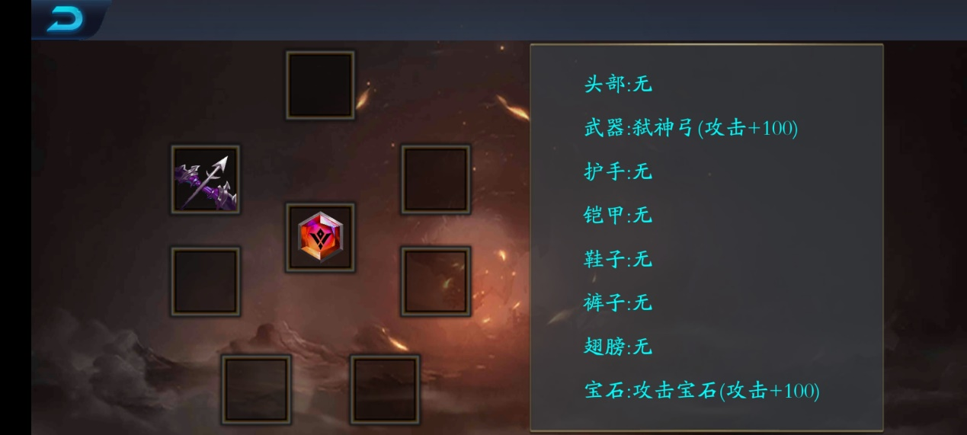

图 3.1.9

3.1.10 背包界面功能设计

背包界面用于管理角色所拥有的物品，可以通过点击黄色按钮进行出售，也可以点击蓝色按钮进行穿戴，同时也会有很多文本用于显示物品信息，例如背包格子中如果有物品且数量大于1，则物品右下角会有一个文本显示当前物品的数量，同时每个背包格子都是一个开关（Toggle）控件，因此我们点击背包格子时会出现一个选中的高亮框，这是因为组件设置了唯一选择，只能与一件物品进行交互，如图3.1.10所示。

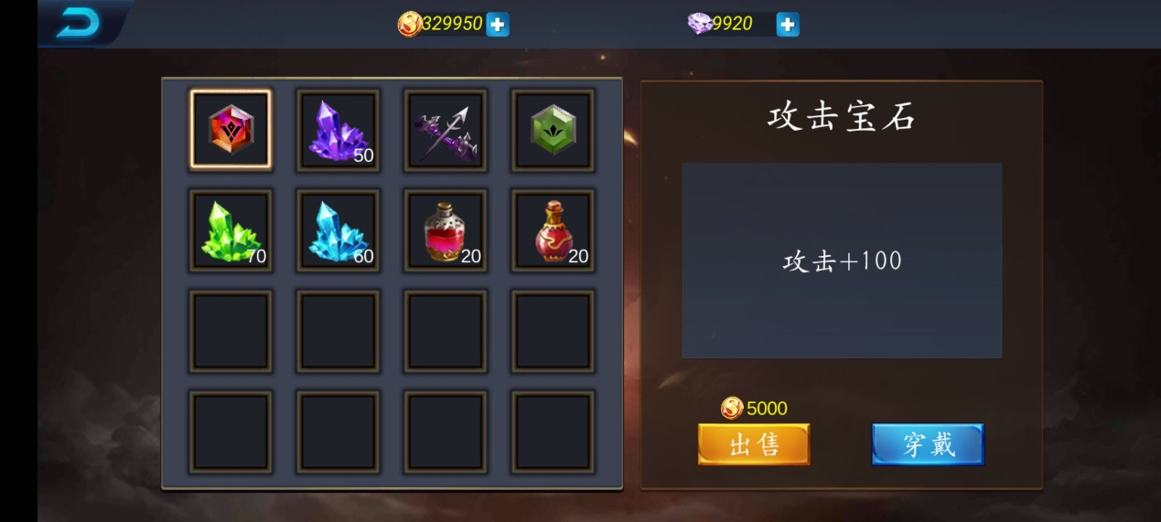

图 3.1.10

3.1.11 商店界面功能设计

商店界面用于展示游戏可购买物品的详细信息，每件商品都是一个按钮（Button）控件，商品格子有文本（Text）控件和图片（Image）控件，用于显示详细信息，当玩家点击某件商品时，就会触发按钮，按钮响应附带在商品格子上的C#脚本，程序会读取相应的商品信息并通过对话框的形式显示出来，同时商店的物品也有分类，有装备、药品、材料，玩家可根据提示切换商品列表，同时列表也可以进行上下滑动浏览，如图3.1.11所示。

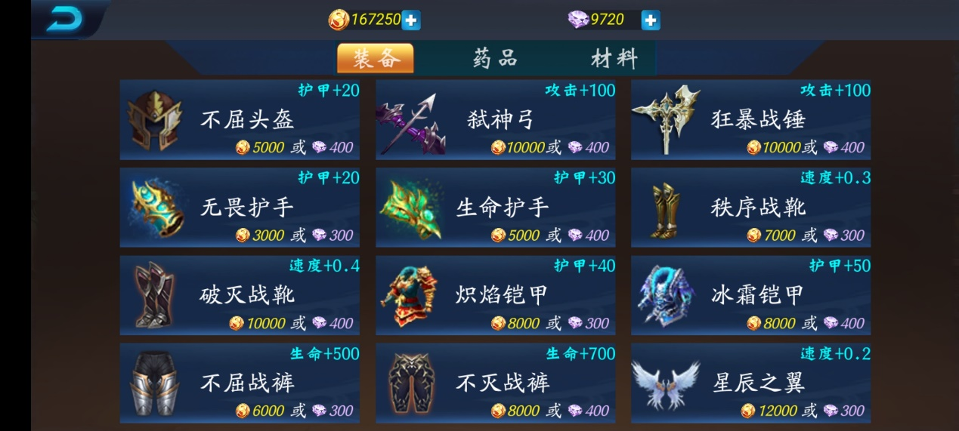

图 3.1.11

3.1.12 设置界面功能设计

设置界面用于对相关功能进行自定义控制，界面布置有调节声音大小的滑动条（Slider）控件和静音开关，可实时控制游戏声音，同时也设置了三个选项框，用于调节游戏的画质，主要影响的是游戏的特效和场景的光照效果，如图3.1.12所示。

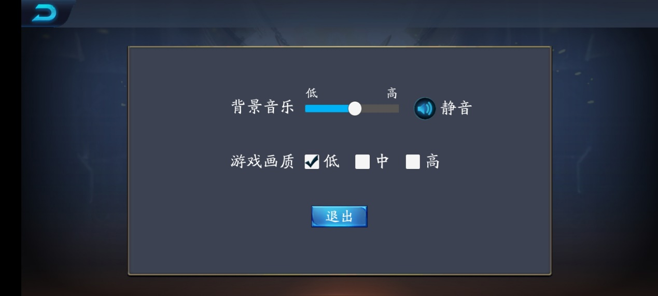

图 3.1.12

3.1.13 游戏界面功能设计

游戏界面用于与战斗系统进行交互，例如玩家可通过拖动遥感进行人物移动、通过点击技能按钮进行技能释放、点击道具栏中的物品进行使用等等，右上角有一个倒计时的文本，玩家必须在规定的时间内通过，否则会被判定为失败，左上角则为游戏角色的属性信息，用于实时显示角色的血量、经验值和等级，如图3.1.13所示。

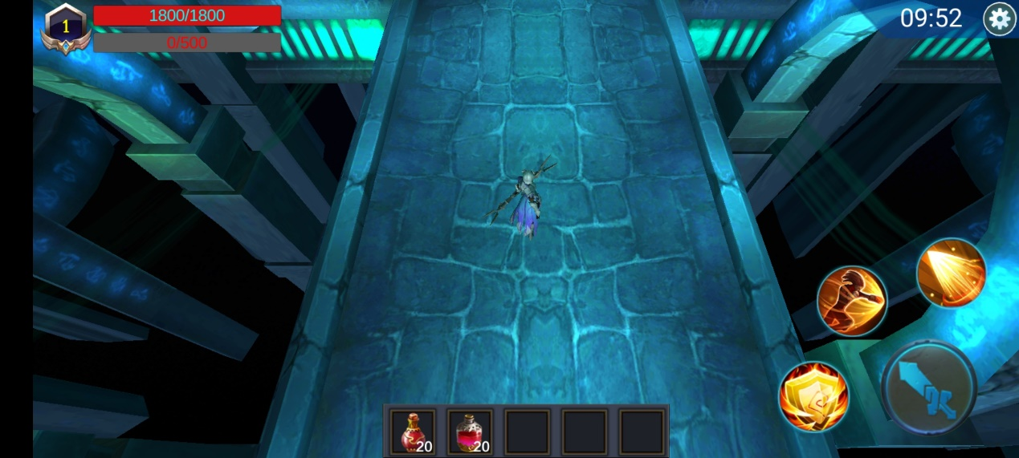

图 3.1.13

3.2 地图设计

游戏地图的设计至关重要，因为本款游戏是运行在移动端上的，我们在设计地图时，要考虑地图模型带给手机的性能消耗，考虑其在移动端是否能流畅运行，避免发生卡顿的现象，因此，我们要严格地选择游戏地图并且设置地图参数。

3.2.1 地图1-炼狱十字

本款游戏目前开放了两个地图，其中地图1的地形为一个十字形状，场景较小，同时也是低模的，场景里小物件非常少，对游戏性能影响不大，建筑风格符合地图名字，给人一种阴森恐怖之感，图3.2.1所示为地图轮廓图，图3.2.2为玩家视角。

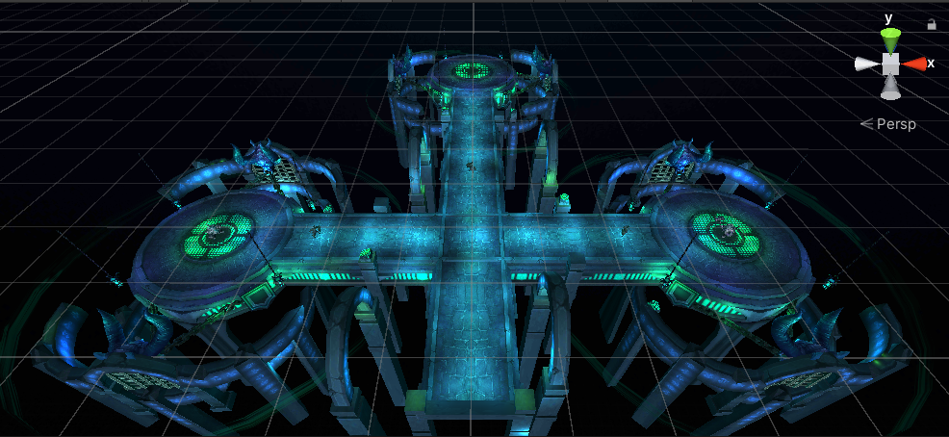

图3.2.1

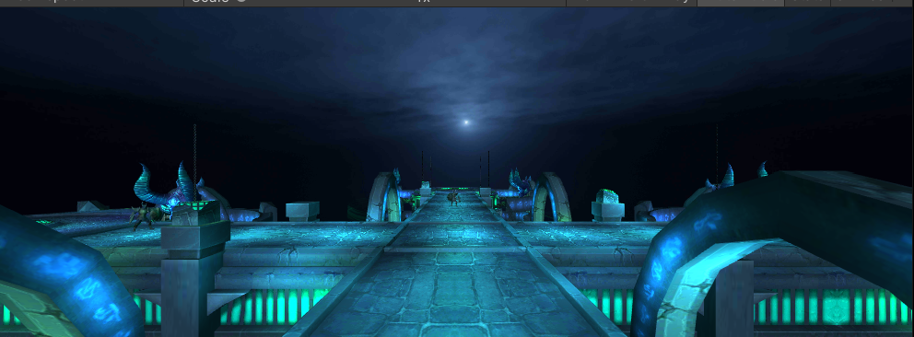

图 3.2.2

3.2.2 地图2-云顶天宫

不同的地图通关难度也会有所不同，地图2在设定上要比地图1要简单，因此怪物聚集不能太密集，这注定了地图2是要比地图1要大，同时地图场景的氛围也不一样，因此地图2的整体结构是一个宫殿，为了符合地图名字，我们把宫殿设置在天上，同时添加了相应的雾效，用于模拟大气层的雾气效果，同时天空也设置成了晴天，让宫殿看起来比较神圣，如图3.2.3为轮廓图，图3.2.4为玩家视角。

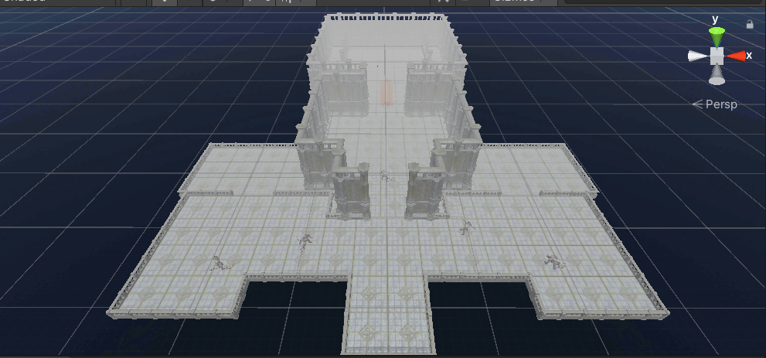

图 3.2.3

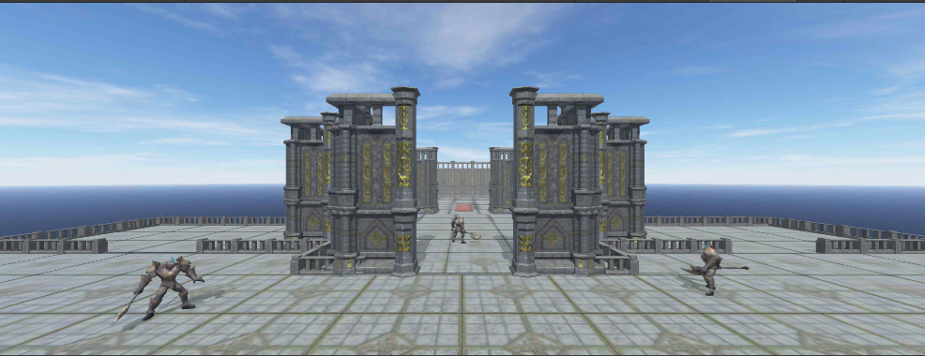

图 3.2.4

3.2.2 环境光设计

一个场景，如果它的风格或者所处的环境是难以看清的，但我们需要有一定的可见性，例如有月光的夜晚，那么我们就需要人为地给场景添加光照，让场景清晰起来，在本游戏中，我们采用的是Unity中的点光源对场景进行打光，如图3.2.5所示，点光源的作用域是一个球形，在这个范围内，物体会受到光照影响，灯光组件如3.2.6所示，其中Range控制灯光影响范围，Color控制灯光颜色，通关添加类型这种点光源，就可以做出图3.2.5的场景，给玩家一种好的视觉体验。

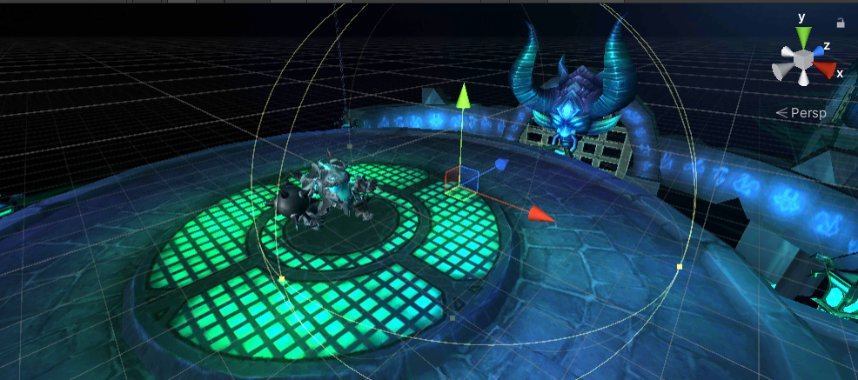

图 3.2.5

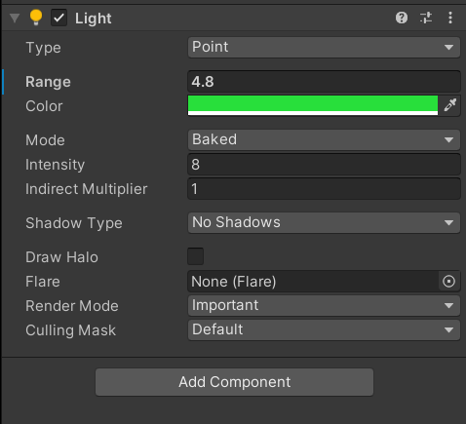

图 3.2.6

3.3 战斗系统设计

一款游戏能否给玩家带来好的体验，战斗系统占很大的比重，在本款游戏中，将使用Unity自带的Animator动画系统去实现战斗逻辑。

3.3.1 动画控制器

旧版本的Unity通关使用的Animation组件给物体添加动画，但在新的Unity版本里，Unity官方推荐使用Animator组件去给物体添加动画，因为其功能强大，更灵活和方便地实现动画的相关功能，因此在本款游戏中，将使用Animator动画系统去做动画。而一个人物想展现某一个动作，就必须要创建一个动画控制器，在Unity中名为Animator Controller，如图3.3.1所示。

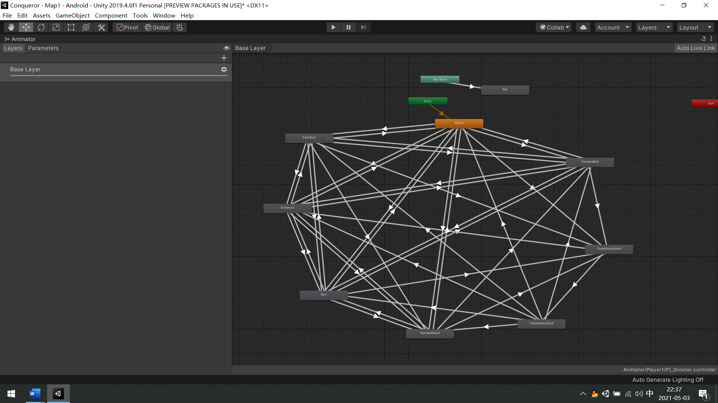

图 3.3.1

创建完动画控制器后，需要把控制器添加进Animator组件里，如图3.3.2所示，其中属性Controller就是创建的动画控制器，到此，动画播放所需要的控件已经添加完毕。

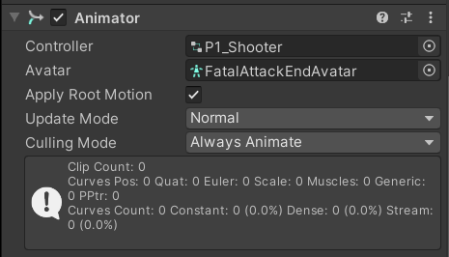

3.3.2 动画状态机

添加了动画播放所需的控件之后，就需要添加人物动画，而每一个人物动画为一个动画状态机，它们的连线则视为过渡，箭头所指向的状态机则被视为可直接过渡，未指向的状态机则不能直接过渡，如图3.3.2所示。

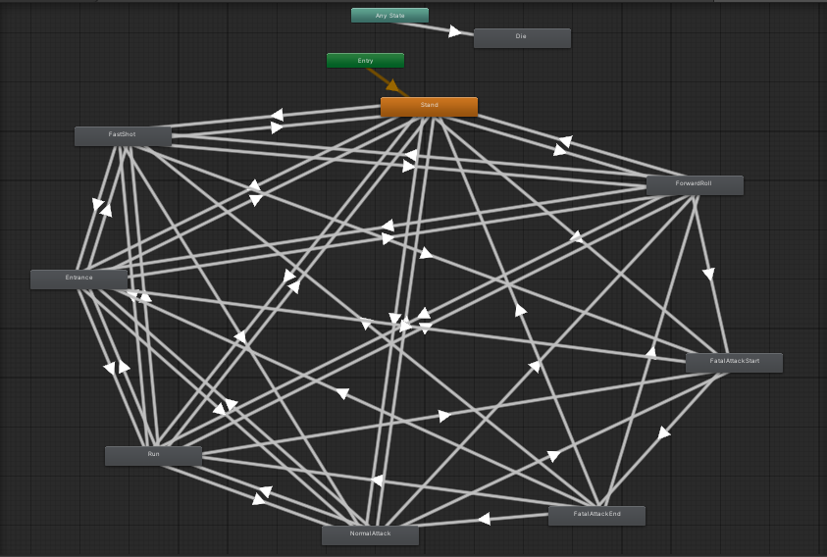

图 3.3.2

此布局代表了各种人物动画的切换流畅，每个长方形存储着一种动画，最好我们将通过代码去控制其切换，而切换动画的依据是参数，如图3.3.3所示，图中设置了两个参数State（整型）和Die（布尔型），State用于标志各种状态信息，例如1代表人物站立，2代表人物奔跑，而Die代表人物是否死亡，值只能是是或者否，而设置完参数之后，就要给箭头添加参数，如图3.3.4所示。图中所展示的是由Stand站立动画过渡到Run奔跑动画所需条件为State参数等于3的情况，依据此种方法在每一条线上设置好过渡条件之后，我们就可以通过代码去设置参数的值，最终实现动画的控制，人物的动画系统除代码部分也将到此搭建完成。

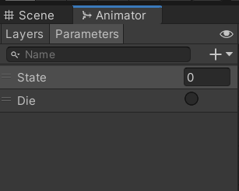 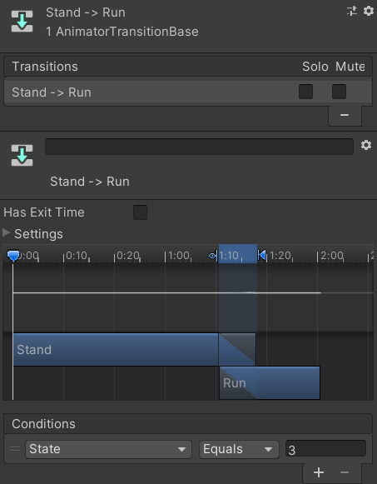

图 3.3.3 图 3.3.4

3.7 主角设计

游戏人物主角作为游戏封面的另一种表现方式，需要进行精心的设计，让玩家觉得他帅或者她美，让玩家更想去接触他。同时相关职业角色的属性也伴随着职业的不同而有所差异，由此可见，游戏人物的职业定位设计是非常重要的。

战士职业作为一个近战的职业，其特点是攻击高，灵活性低，防御力高，参照这一特点，本款游戏的战士职业则是拿着战锤的男姓角色，其中人物角色不仅添加了动画控制器，还添加了角色控制器，这个组件可让人物角色拥有物理特性，如碰撞和重力，人物的移动主要就是通过它来实现，组件详细信息如图3.7.1所示。同时射手职业同样如此，射手职业的特点是灵活性高，但防御力低，善于拉扯远程消耗，针对这种形象，本款游戏的射手职业定位为一个拿着弓箭的女性角色，其所带组件和战士职业一样。

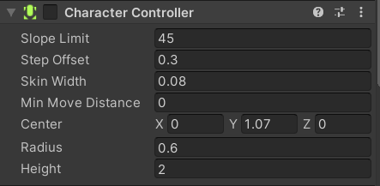

图 3.7.1

3.8 怪物设计

怪物的设计与主角设计相似，但不同的是，主角是通过摇杆来控制，而怪物需要有一定的智慧，例如智能地寻找玩家位置，避过障碍物，对玩家进行追击，这也是寻路系统的设计，其核心组件是NavMeshAgent（导航网格代理），其可以通过烘培场景元素，最终生成一个网格，怪物可根据网格的信息找到最优路径去寻找物体，此项技术将在下一章进行详解，组件的详细信息如图3.8所示。其中Speed属性为自动导航寻路的速度，Angular Speed为怪物旋转的角速度，怪物的行为将会受到这些参数的影响，通过这些参数和之前所说的Animator动画控制，可以设计好一个怪物的基本行为。

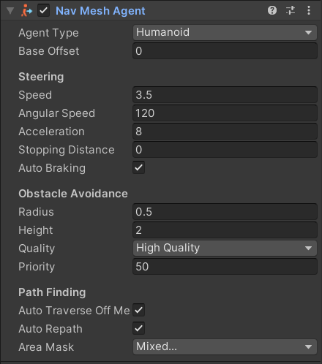

图 3.8

第四章 游戏相关技术

4.1 导航网格寻路

寻路系统普遍运用在很多的网游上，本款游戏同样使用了寻路系统，可以让怪物变得比较智能，以下将讲解该项技术是如何部署到游戏中去的。

4.1.1 寻路网格的烘培

游戏中怪物移动行为使用的是导航网格寻路技术，该技术用于避开地图障碍物，智能地寻找目标，网上有很多游戏同样采用了这种技术，例如玩家鼠标点击某个区域，游戏角色就会移动到目标点，电脑版的《英雄联盟》就是采用的这种方式。而在Unity中，封装了此种技术，我们需要使用此种技术的时候，需要对游戏中的物体进行设置，在游戏物体的属性面板中，点击Static右边的下拉框并勾选对物体的网格烘焙选项，如图4.1.1所示。

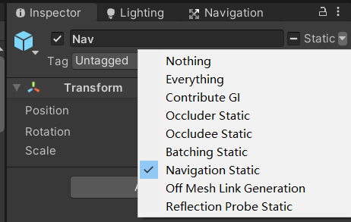

图 4.1.1

勾选此选项，Unity将会标记此物体，把它加入网格烘焙组中，等待开发者进行烘焙。接下来我们需要打开网格烘培面板并点击右下角的Bake（烘培），如图4.1.2所示，点击Bake之后Unity将会烘培网格并生成一份网格烘培文件并把烘培好的网格显示在场景中，如图4.1.3所示，图中所显示的蓝色区域就是烘培的网格，此网格代表了怪物所能寻找的路线，在此网格范围内，怪物可以智能避开图中所遇到的障碍物，但要实现寻路我们不仅需要有网格，还需要有导航组件，这在上一章中有讲到，参考图3.8。在烘培完网格之后，如果我们对结果不满意，可以调节烘焙参数，例如Step Height参数，如果场景中存在阶梯，阶梯比较高，则需要调高该参数，否则阶梯将不满足烘培条件生成不了网格，怪物也就不能登上阶梯。通过反复条件烘培参数，直到烘培出想要的网格即可。

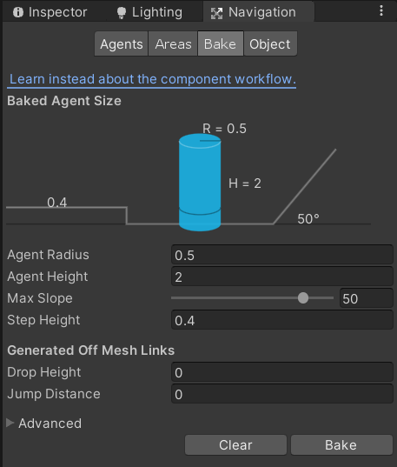

图 4.1.2

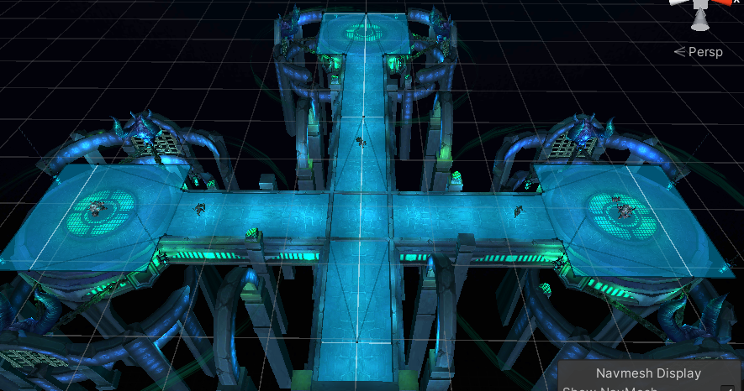

图4.1.3

4.1.2 网格寻路原理

导航系统在Unity开发技术文档中有相关介绍，该系统需要自己的数据来表示游戏场景中的可行走区域，从场景中的几何体自动构建可行走区域。然后将这些位置连接到位于场景几何体顶部的曲面。该曲面称为导航网格（NavMesh），导航网格存储为凸多边形，因为多边形内的任意两点之间没有障碍物，除了多边形边界之外，还存储关于哪些多边形彼此相邻的信息，如图4.1.4所示。

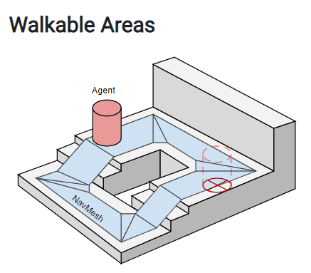

图 4.1.4

在有了寻路网格这之后，Unity将会找到场景中两个位置之间的网格路径，然后我们从起始位置开始搜索，访问所有邻居，直到到达目标多边形。跟踪访问的多边形可以让我们找到从起点到终点的多边形序列。找到路径的一个常用算法是A*（A-Start），A*算法是一种静态路网中求解最短路径最有效的直接搜索方法，也是解决许多搜索问题的有效算法。算法中的距离估算值与实际值越接近，最终搜索速度越快，如图4.1.5所示，我们从Start开始位置移动到Destination目标位置，那么就要经过5个多边形网格，找出最短路径，最终达到目标点。

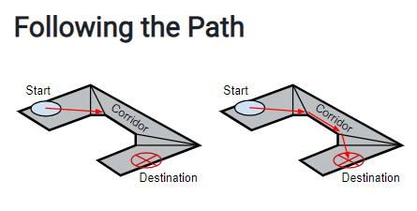

图 4.1.5

在Unity中，我们直接使用了烘培网格的方式去实现自动寻路，使用的是引擎内部系统去完成，当然如果有特殊的需求，也可以自己通过代码去写一套寻路系统，在本款游戏中，使用的是Unity内部引擎提供的寻路系统，其寻路原理综上所述，有了此套方案，怪物的AI也就能轻易实现。

4.1.3 寻路系统的优化处理

Unity的寻路系统中，当一个物体移动到目标点的过程中，该物体会发生转向，其转向的结果是面向目标点，但Unity的寻路系统转向速度非常慢且其存在一个转向速度最大值，该转向速度最大值也不能解决该问题，当寻路目标点是动态的，例如怪物寻找玩家，玩家是在移动的时候，怪物的转向将跟不上玩家角色。为了解决这个问题，我们把寻路组件NavMeshAgent中的Angular Speed设置为0，不设置其角速度，而是通过代码的形式去完成转向。通过代码的形式主要使用的是数学中的向量知识，准确地说是向量的减法法则。运用向量的减法，我们可以得到目标的方位，如图4.1.6所示，假设A为原点，在Unity中是世界坐标原点，如果玩家处于B点，怪物处于D点，怪物需要知道玩家角色的方位，我们就可以通过a向量减去b向量获得，得到的向量为DB向量，然后在Unity中进行归一化，归一化后的向量为单位向量，一般用于表示方向而不是长度，得到了玩家的方向之后，就需要判断怪物正前方向量与该单位向量的夹角是否小于一定的角度，使用Vector3.Angel方法可以进行判断，例如角度小于0度，则表示面朝玩家角色，如果不是0度，就需要怪物去转向，知道了玩家角色的方位，就可以通过四元素旋转中的Quaternion.LookRotation方法去实现旋转，该方法能产生一个偏转角，怪物只需要旋转该角度即可面朝玩家角色，而转向速度我们就可以灵活地设置，从而让怪物转向更加流畅，最终实现怪物AI行为。

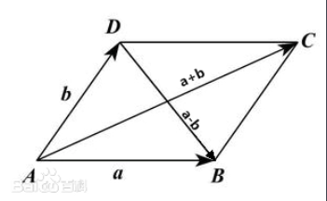

图 4.1.6

4.2 场景的烘培

游戏因为是运行在移动平台上，为了保证游戏画质良好的同时又不会影响游戏的正常运行，本款游戏采用了场景烘培技术去解决该问题。

4.2.1 Unity的灯光模式

在Unity中，有三种灯光模式，如图4.2.1所示，分别为Realtime（实时光照模式）、Mixed（混合灯光模式）、Baked（烘培灯光模式），实时光代表着场景中的灯光会实时计算灯光信息，性能消耗是最大的，例如一个静态物体的阴影，它会一直计算它的阴影信息；而混合灯光代表着动态的物体会使用实时光的方式去计算，静态的物体将会使用烘培的方式去计算；最后是烘培灯光的方式，它是性能消耗最小的方式，但只适用于静态物体。在本款游戏中，场景是静态的，而玩家角色是动态的，会实时移动，因此我们采用的灯光模式为Mixed混合灯光。

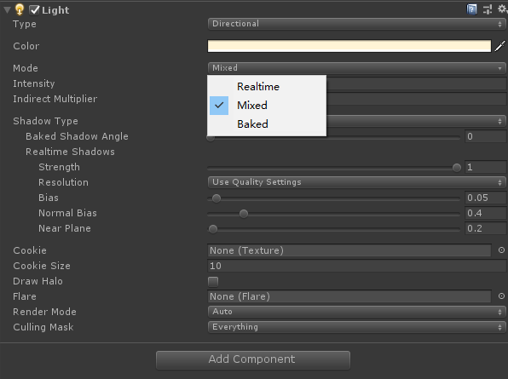

图 4.2.1

4.2.2 光照贴图

光照贴图是预先计算场景中曲面亮度的过程，并将结果存储在称为光照贴图的纹理中供以后使用。通俗来说，光照贴图就是一份数据，这份数据存储了场景中的光照信息，例如阴影的大小和角度。通过这种方法，我们可以换取性能的潜在提高，以适应诸如移动平台等功能较弱的硬件。

4.2.3 生成光照贴图

在Unity中，我们需要在物体的属性面板Static右侧点击下三角按钮，勾选Contribute GI选项，这样能标记该物体，Unity将会把它加入到灯光烘培组中，如图4.2.3所示，在勾选了该选项之后，需要打开Lighting面板，在该面板中，有很多烘培参数需要注意，如图4.2.4所示，其中Lightmap Resolution代表光照贴图的分辨率，该项会直接英雄烘培的质量，值越大烘培时间越长，同时画质也越好，另外还有一个需要的属性参数需要注意，那就是Lightmap Size，该项会影响光照贴图的文件大小，1024代表了用该尺寸去存储光照贴图，如果超过该尺寸则会再生成一张该尺寸的贴图存储，直到存储完所有的光照信息。设置完参数之后，点击右下角的Generated Lighting就会开始生成光照贴图，经过一段时间的烘培之后，将会生成光照贴图文件，如图4.2.5所示，该贴图包含了直接光照和间接光照信息，直接光是指太阳直接照射到的光照信息，间接光照是指反光或折射造成的光照信息，有了这些光照贴图，我们就不需要实时地去计算静态物体的光照信息了，直接用该贴图的数据即可，这极大地提高了性能，特别是在移动平台上，现如今的手机3D游戏基本都会用到该技术。

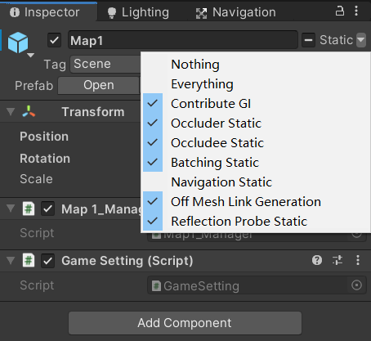

图 4.2.3

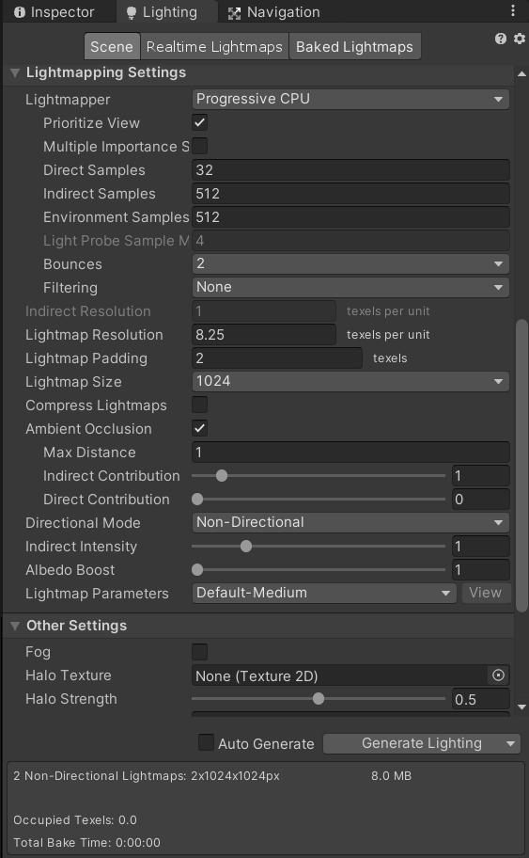

图 4.2.4

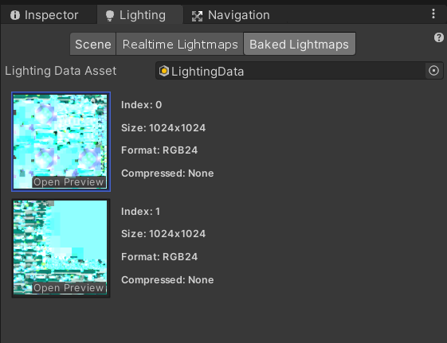

图 4.2.5

4.3 数据持久化技术

在本游戏中，一直没有提到数据是如何存储的，本款游戏不使用数据库进行数据的存储，而是使用的是本地数据，因为是单机的游戏，因此只需要把数据存储于本地文件即可。在PC端，数据将会存储于注册表中，如图4.3.1所示；而在移动端，数据是存储在手机内部文件中的，这就是为什么，很多单机游戏如果清楚了应用数据，游戏也将会重置的原因。而在Unity里，可以通过接口PlayerPrefabs来存档和读档，举个例子，可以使用PlayerPrefabs.SetInt去设置相关的值，然后通过PlayerPrefabs.GetInt就能获取到想要的值，以此类推，就能实现数据的持久化，而有些开发者，会把这种形式的数据写进SD卡，但无论是哪种方式，其基本原理都相差不大。

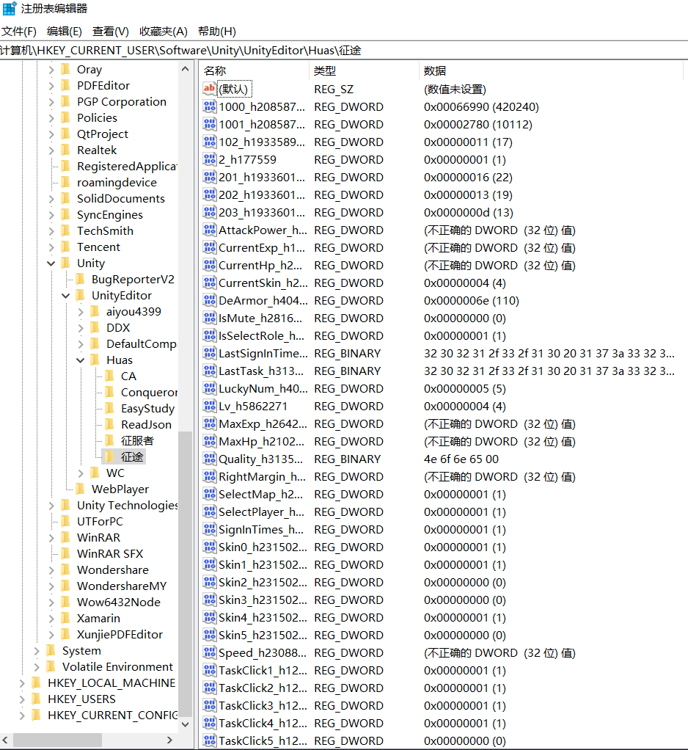

图 4.3.1

第五章 游戏测试

测试环境

Unity环境测试、安卓平台测试。

5.1 Unity环境测试

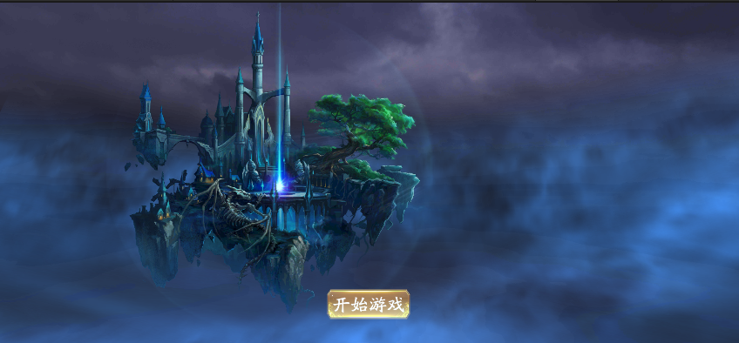

**5.1 游戏开始界面**

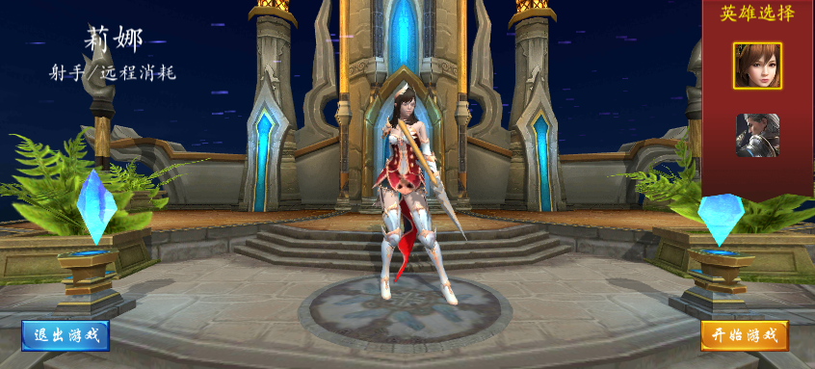

**5.2 英雄选择界面**

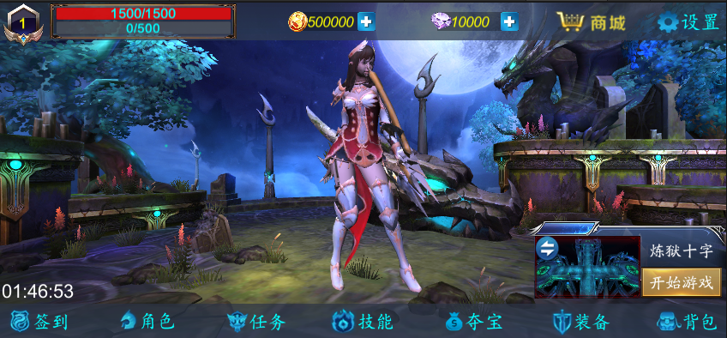

**5.3 大厅界面**

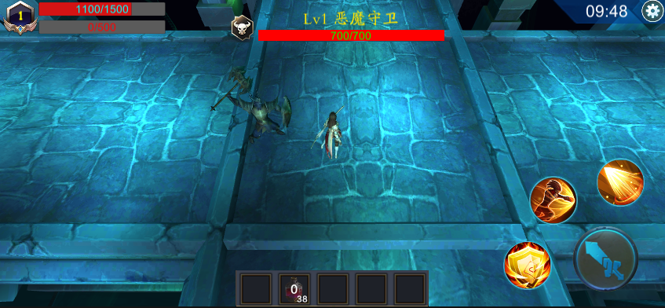

**5.4 游戏界面**

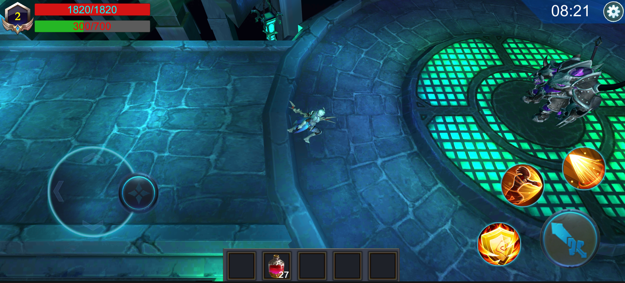

**5.5 游戏界面**

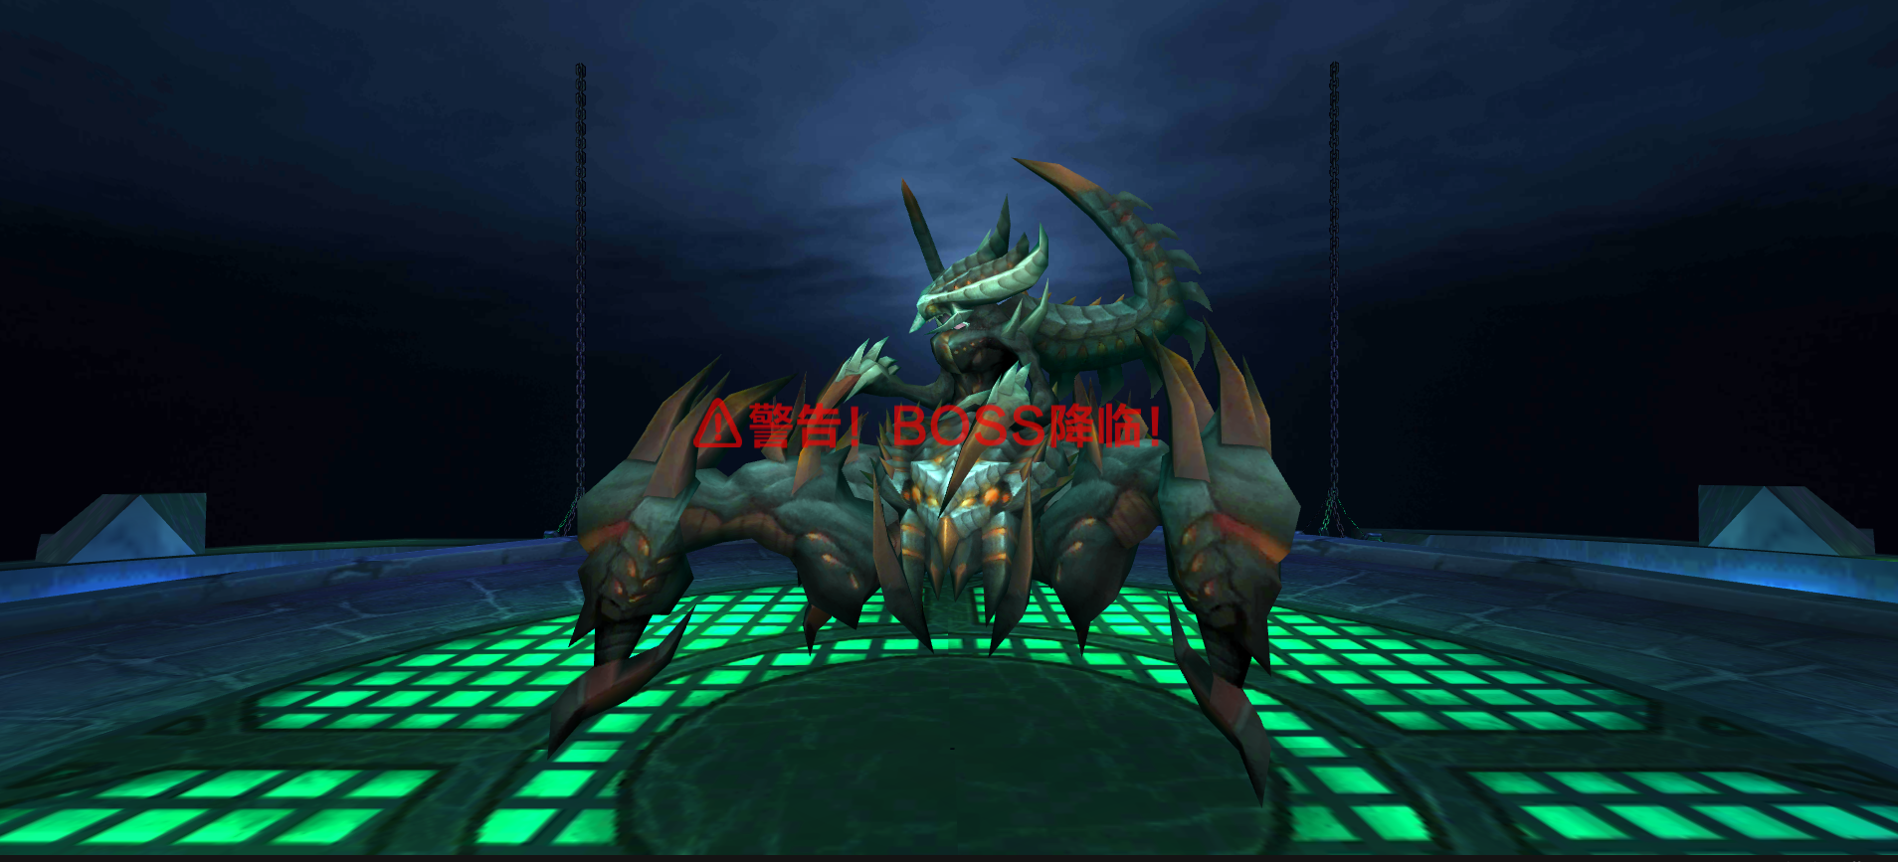

**5.6 游戏界面**

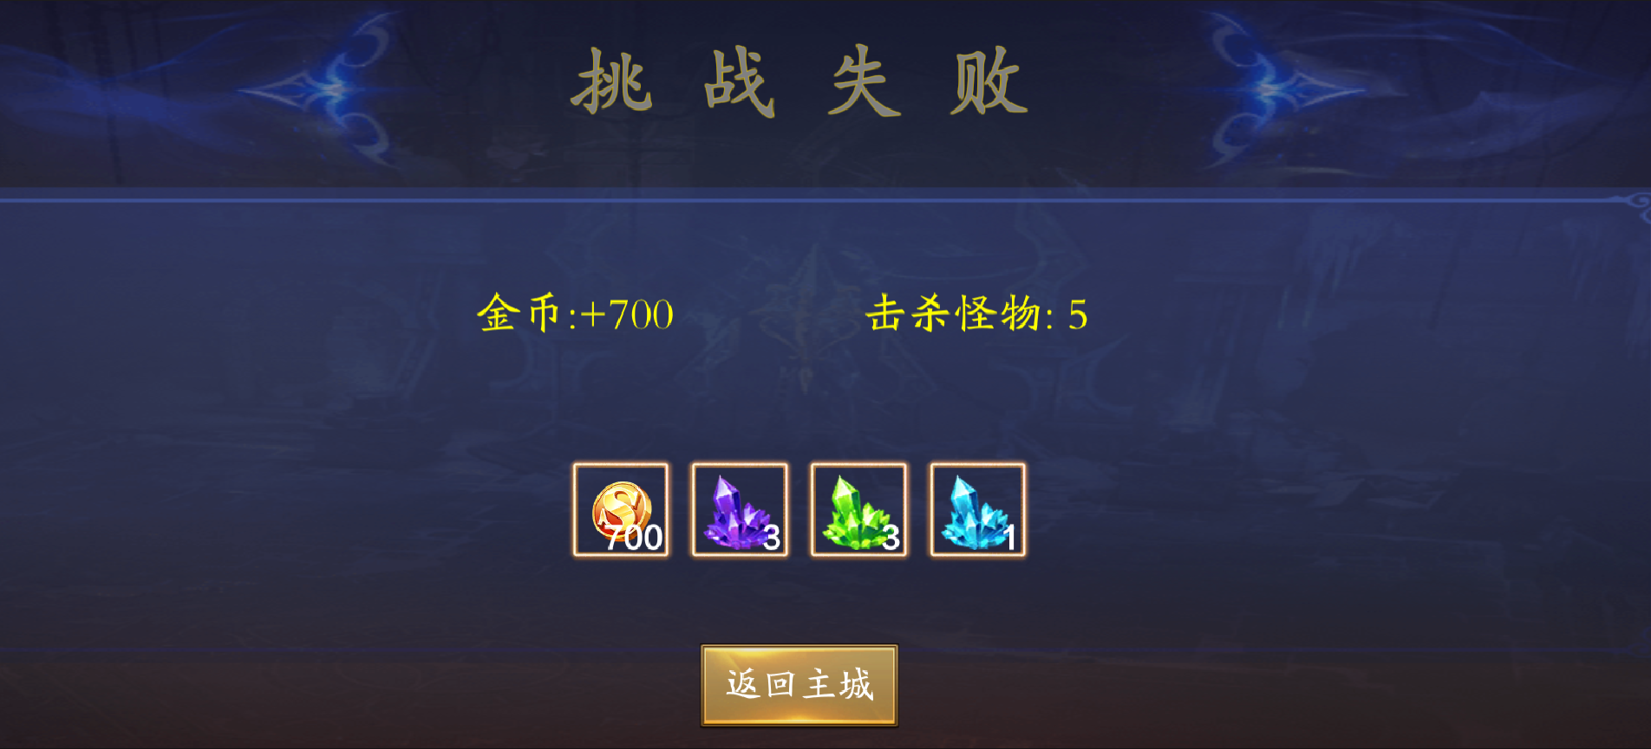

**5.7 结算界面**

经过一轮游戏运行测试，无控制台输出错误，Unity环境测试通过。

5.2 移动端发布测试

5.2.1 安卓平台发布

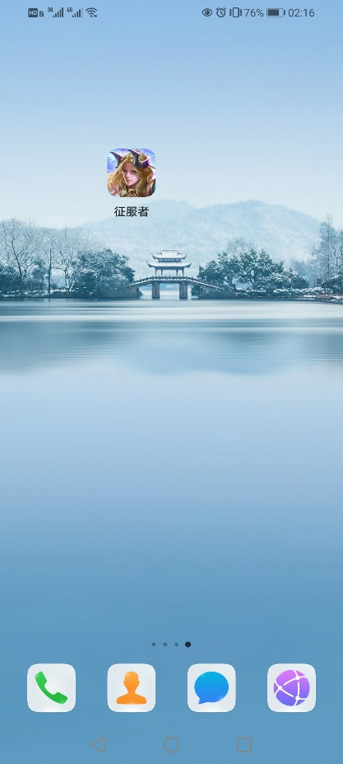

**5.8 安卓发布完成**

5.2.2 安卓屏幕自适应测试

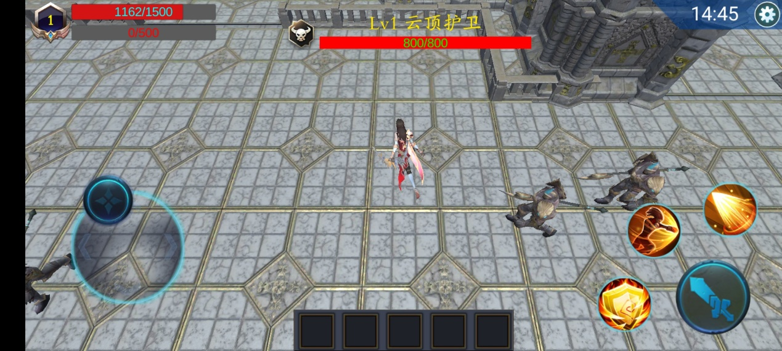

**5.9 屏幕长宽比20:9**

5.2.3 游戏运行测试

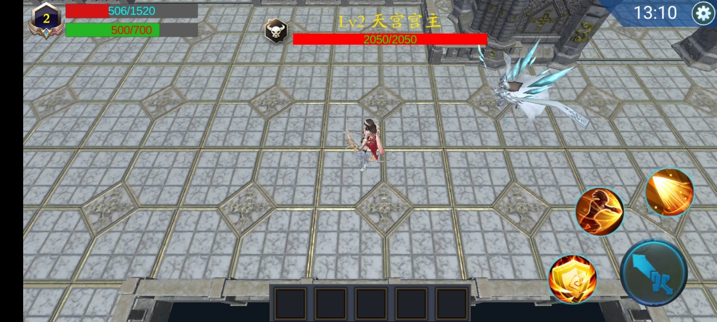

总结

本游戏项目创建于2020年4月22日，到如今已有一年多，但实际开发周期只有半年左右，期间停止过几个月，因为技术难题，去学习了相关技术之后回归继续开发，游戏升级过几次版本，每次升级都修改巨大，最主要的变化是模型，因为某些方面的问题，模型不够精美，但不影响这款游戏的整体玩法。在此期间，我边开发边学习技术，学到了很多知识，下面我将用简短的语言概括我收获的方方面面。

（1）在游戏开发之初，我并没有做太多分析，就按自己兴趣去做，怎么好玩怎么来，所以直接就上手代码了，但是后来我发现，没有搭建好的代码结构是多么难维护，直到后来重写了很多代码，最终才能发布出来，同时，也让我知道了代码高内聚，低耦合的重要性，代码规范不是说说而已，其大有深意，只有亲身体验过，你才能感受得到其真正的含义。因此在开发过程中，为了效率，我们应该注重去搭建框架，以便能高效率开发。

（2）在开发过程中，难免会遇到问题，从我入门到现在，我解决问题的方法流程是先百度搜索，如果搜索结果不是你想要的，那么第二步你就需要观察其是否是引擎的内部技术，如果是，那么直接去找引擎开发文档，如果不是，那么你应该去群里问大家，和大家相互讨论该技术的相关问题，直到有了一些思路之后，你还是不知道具体该如何做，那么该问题将不是普通的问题了，你就需要去淘宝或者腾讯课堂等平台上购买相关的技术视频，然后学会它。最终解决该问题。在本游戏开发期间，我曾放弃过，因为太多的技术不知道如何实现，我也曾怀疑过自己，一个人开发一款游戏是不是太勉强了。有时候你需要的美术资源，例如图片，你就要去学Photoshop，然后掌握如何修图，最终变成你的UI界面。开发一款软件需要做很多工作，但只要你一直保持乐观态度，成功只是时间问题。

（3）在整个游戏开发过程中，我深刻地感受到了游戏开发是非常有技术性的，特别是3D游戏中，会用到很多的数学知识，例如向量、点乘和叉乘，都可以用来计算方位，又有如坐标的转换，例如屏幕坐标（2D）转换为世界坐标（3D）是用矩阵转换来实现的，是线性代数的知识点，还有如华丽的特效，是计算机底层图形学的知识。游戏是一种非常吃性能的软件，因此对于技术的要求也很严格，能开发出游戏的人不一定厉害，但懂得性能优化的人一定是非常厉害的，这是一位老师跟我说过的话，因为游戏涉及到很多底层的知识，只有懂得计算机底层，才能优化它。

（4）游戏发布在移动平台上时，会发生很多问题，例如不同的手机型号和屏幕，会使游戏界面发生变化，同时还有支持电脑的点光源，到了移动端或者不同手机就会失效，导致场景亮度丢失，这些问题都是需要注意的，因此平台的差异性需要在开发的过程中着重考虑。

参考文献

1. Unity5.x从入门到精通 Unity Technologies 北京:中国铁道出版社,2016.1.
2. C#从入门到精通(第二版) 王小科,徐薇 北京:清华大学出版社,2010.7.
3. Unity游戏优化(第二版) [英]Chris Dickinson 北京:清华大学出版社,2020.5.
4. 王瑾.基于Unity3D手机游戏性能优化技术的研究[J].现代工业经济和信息化,2015,5(22).
5. 区泽宇,李晶,魏菊霞,严道葵,陈灿,许皓然.基于Unity3D游戏的设计与开发[J].无线互联科技,2019,16(23).
6. 李兵川.基于Unity3D游戏开发流程分析[J].山东工业技术,2018(07).
7. 陈阳.基于Unity3D的游戏开发[J].电子技术与软件工程,2020(09).
8. 王志岗.基于Unity3D的自动寻路导航系统的研究[J].电脑知识与技术,2019,15(36).
9. Design and Implementation of Sleigh Game Content based on Physical Force using Unity3D Game Engine[J]. 강성윤,박기홍. 한국디지털콘텐츠학회 논문지,2019,20(12).
10. Farouk Messaoudi,Adlen Ksentini,Gwendal Simon,Philippe Bertin. Performance Analysis of Game Engines on Mobile and Fixed Devices[J]. ACM Transactions on Multimedia Computing, Communications, and Applications (TOMM),2017,13(4).

致 谢

本文是由我的校内导师李妩可老师指导下完成的，在此特别感谢她，在此期间，老师指出了我的很多缺陷，让我可以完善我自己，最终顺利地完成本次论文的撰写。

即将毕业，回想起我们同学一起学习的时光，回想起当初辅导过我学习的同学，我由衷地感谢他们，还有帮助过我的老师们，从我什么都不会到现在学有学成，还记得当初问老师一些很简单的问题，现在回想起来真是跟个小孩子一样，不会百度找找资料吗，虽然当时很笨，但老师还是告诉我如何去解决难题，在这段大学生涯中，幸好有你们，感谢四年以来对我的关心和照顾。

附录（部分代码）

（1）场景异步加载代码

using System.Collections;

using System.Collections.Generic;

using UnityEngine;

using UnityEngine.SceneManagement;

using UnityEngine.UI;

//异步加载

public class UI_ProgressLoad : MonoBehaviour

{

//要加载的场景

protected string scene;

// 进度条

protected Slider loadingSlider;

//显示加载进度的文本

private Text progressText;

// 场景加载类的对象

protected AsyncOperation asy;

// 加载进度

protected float progress;

public string Scene

{

set { scene = value; }

}

protected virtual void Awake()

{

loadingSlider = transform.Find("Loading/PrSlider").GetComponent<Slider>();

progressText = transform.Find("Loading/PrText").GetComponent<Text>();

}

virtual protected void Start()

{

StartCoroutine(AsyncLoadingScene());

}

virtual protected void Update()

{

progress = asy.progress;

if (asy.progress >= 0.9f)

{

progress = 1.0f;

}

if (progress != loadingSlider.value)

{

// 插值运算（进度条向当前加载进度趋近）

loadingSlider.value = Mathf.Lerp(loadingSlider.value, progress, Time.deltaTime);

// 避免插值运算一直进行

if (Mathf.Abs(loadingSlider.value - progress) < 0.01f)

{

loadingSlider.value = progress;

}

}

// 显示加载百分比

progressText.text = "正在加载......" + (int)(loadingSlider.value * 100) + "%";

}

// 异步加载场景

IEnumerator AsyncLoadingScene()

{

asy = SceneManager.LoadSceneAsync(scene);

// 阻止当加载完成自动切换

asy.allowSceneActivation = false;

yield return asy;

}

}

（2）选择职业界面管理脚本

using DG.Tweening;

using HedgehogTeam.EasyTouch;

using System.Collections;

using System.Collections.Generic;

using UnityEngine;

using UnityEngine.SceneManagement;

using UnityEngine.UI;

/*

描述:选择界面管理

挂载位置:SelectManager空物体

*/

public class SelectManager : MonoBehaviour

{

private Text occupationNameText;

private int selectPlayer = 1;//选择职业的索引

private AudioSource audioSource;//声音组件

private Transform platform;//人物生成平台

private Vector3 originRotation;//开始的旋转

private string[] occupationName = { "莉娜\n<size=55>射手/远程消耗</size>", "凯尔\n<size=55>战士/近战爆发</size>" };

private Transform canvas;

private GameObject toggleOutLine1;

private GameObject toggleOutLine2;

private GameObject player1, player2;

private GameObject loadingPanel;

//UI

private Toggle selectP1Toggle;//选择角色1开关

private Toggle selectP2Toggle;//选择角色2开关

private Button startGameBtn;

private Button exitBtn;

private void Awake()

{

platform = transform.Find("Platform").transform;

player1 = platform.Find("Player1").gameObject;

player2 = platform.Find("Player2").gameObject;

originRotation = platform.eulerAngles;

player1.SetActive(true);

player2.SetActive(false);

canvas = GameObject.FindGameObjectWithTag(Tags.Canvas).transform;

audioSource = transform.GetComponent<AudioSource>();

canvas.Find("LoadingPanel/BG").GetComponent<UI_ProgressLoad_Tips>().Scene = Tags.HallScene;

occupationNameText = canvas.Find("playerDes/DesText").GetComponent<Text>();

selectP1Toggle = canvas.Find("Select/SelectP1").GetComponent<Toggle>();

selectP2Toggle = canvas.Find("Select/SelectP2").GetComponent<Toggle>();

toggleOutLine1 = selectP1Toggle.transform.Find("OutLine").gameObject;

toggleOutLine2 = selectP2Toggle.transform.Find("OutLine").gameObject;

startGameBtn = canvas.Find("StartBtn").GetComponent<Button>();

exitBtn=canvas.Find("ExitBtn").GetComponent<Button>();

loadingPanel = canvas.Find("LoadingPanel").gameObject;

selectP1Toggle.onValueChanged.AddListener(OnSelectPlayer1Toggle);

selectP2Toggle.onValueChanged.AddListener(OnSelectPlayer2Toggle);

startGameBtn.onClick.AddListener(OnClickStartGameBtn);

exitBtn.onClick.AddListener(OnClickExitButton);

occupationNameText.text = occupationName[0];

}

/// <summary>

/// 实例化角色

/// </summary>

/// <param name="path">路径</param>

/// <param name="pos">位置</param>

/// <param name="scale">大小</param>

private GameObject InitPlayer(string path,Vector3 scale)

{

GameObject player = Instantiate(Resources.Load<GameObject>(path));

player.transform.localScale = scale;

player.transform.SetParent(platform);

player.transform.position = Vector3.zero;

return player;

}

//选择玩家1

private void OnSelectPlayer1Toggle(bool isOn)

{

player1.gameObject.SetActive(isOn);

toggleOutLine1.SetActive(isOn);

if (isOn == false)

{

platform.eulerAngles = originRotation;

}

else

{

selectPlayer = Tags.Shooter;

occupationNameText.text = occupationName[selectPlayer - 1];

audioSource.Play();

}

}

//选择玩家2

private void OnSelectPlayer2Toggle(bool isOn)

{

player2.gameObject.SetActive(isOn);

toggleOutLine2.SetActive(isOn);

if (isOn == false)

{

platform.eulerAngles = originRotation;

}

else

{

selectPlayer = Tags.Warrior;

occupationNameText.text = occupationName[selectPlayer - 1];

audioSource.Play();

}

}

//退出按钮点击事件

private void OnClickExitButton()

{

Application.Quit();

}

//开始游戏按钮点击事件

private void OnClickStartGameBtn()

{

PlayerPrefs.SetInt("IsSelectRole", 1);

PlayerPrefs.SetInt("SelectPlayer", selectPlayer);

startGameBtn.GetComponent<AudioSource>().Play();

loadingPanel.SetActive(true);

}

}

（3）大厅界面管理脚本

using System;

using System.Collections;

using System.Collections.Generic;

using UnityEngine;

using UnityEngine.UI;

/*

描述:界面管理

挂载位置:Canvas

*/

public class InterfaceManager : MonoBehaviour

{

private string[] mapName = { "炼狱十字", "云顶天宫","葬龙荒野", "极寒之地", "羯锣幻境" };

private Sprite[] maps=new Sprite[2];//地图数组

private int mapIndex = 0;//地图的索引值

private int currentMapIndex = 0;//当前的地图索引

private UI_ProgressLoad_Tips progressLoad_Tips;

private Transform _UIBarUp;

private Transform _UIBarDown;

private Transform _PlayerInfo;

private Transform _Start;

private Transform _Map;//地图面板

private Transform _LoadScenePanel;

private GameObject _Mask;

private GameObject _TaskTips;//显示任务可以领取的数量父物体

private Slider _BloodSlider;//玩家血条滑动条

private Slider _ExpSlide;//玩家经验值滑动条

private Text _MoneyTe;

private Text _DiamondTe;

private Text _LvTe;

private Text _BloodTe;//血条文本

private Text _ExpTe;//经验值文本

private Text _MapTitleTe;//地图标题

private Text _UIMapTe;//UI界面地图显示文本

private Text _TimeTe;

private Text _TaskTipsTe;////显示任务可以领取的数量

private Button _StartGameBtn;

private Button _EnsureBtn;//地图面板确定按钮

private Button _SwitchMapBtn;//切换地图按钮

private Button _CloseBtn;//关闭地图面板按钮

private Image _MapShowImg;

public string SetMoneyTe

{

set { _MoneyTe.text = value; }

}

public string SetDiamondTe

{

set { _DiamondTe.text = value; }

}

private void Awake()

{

_LoadScenePanel = GameObject.FindGameObjectWithTag(Tags.Scene).transform.Find("Canvas1/LoadScenePanel");

_Mask = transform.Find("Mask").gameObject;

_Map = transform.Find("Map");

_UIBarUp = transform.Find("UIBarUp");

_UIBarDown = transform.Find("UIBarDown");

_PlayerInfo = _UIBarUp.Find("PlayerInfo");

_Start = _UIBarDown.Find("Start");

_TaskTips = _UIBarDown.Find("TaskBtn/TaskTips").gameObject;

progressLoad_Tips = _LoadScenePanel.GetComponent<UI_ProgressLoad_Tips>();

//UI控件

_BloodSlider = _PlayerInfo.Find("Info/BloodSlider").GetComponent<Slider>();

_ExpSlide = _PlayerInfo.Find("Info/ExpSlide").GetComponent<Slider>();

_LvTe = _PlayerInfo.Find("BG/LvTe").GetComponent<Text>();

_MoneyTe = _UIBarUp.Find("Money/MoneyTe").GetComponent<Text>();

_DiamondTe = _UIBarUp.Find("Diamond/DiamondTe").GetComponent<Text>();

_BloodTe = _BloodSlider.transform.Find("FillArea/BloodTe").GetComponent<Text>();

_ExpTe = _ExpSlide.transform.Find("FillArea/ExpTe").GetComponent<Text>();

_TimeTe=_UIBarDown.Find("TimeTe").GetComponent<Text>();

_MapTitleTe=_Map.Find("MapTitleTe").GetComponent<Text>();

_UIMapTe=_Start.Find("UIMapTe").GetComponent<Text>();

_TaskTipsTe= _TaskTips.transform.Find("TaskTipsTe").GetComponent<Text>();

_MapShowImg =_Start.Find("MapShowImg").GetComponent<Image>();

_StartGameBtn =_Start.Find("StartGameBtn").GetComponent<Button>();

_EnsureBtn = _Map.Find("EnsureBtn").GetComponent<Button>();

_SwitchMapBtn = _MapShowImg.transform.Find("SwitchMapBtn").GetComponent<Button>();

_CloseBtn=_Map.Find("CloseBtn").GetComponent<Button>();

_StartGameBtn.onClick.AddListener(OnClickStartGameBtn);

_EnsureBtn.onClick.AddListener(OnClickEnsureBtn);

_SwitchMapBtn.onClick.AddListener(OnClickSwitchMapBtn);

_CloseBtn.onClick.AddListener(OnClickCloseBtn);

}

private void Start()

{

//处理地图

for (int i = 1; i <= maps.Length; i++)

{

maps[i-1] = Resources.Load<Sprite>(Tags.Map+i);

}

mapIndex = PlayerPrefs.GetInt(Tags.SelectMap, 0);

currentMapIndex = mapIndex;

_MapShowImg.sprite = maps[mapIndex];

_MapTitleTe.text = mapName[mapIndex];

_UIMapTe.text = mapName[mapIndex];

CheckSelectMap();

}

private void OnEnable()

{

_LvTe.text = GameServer.gameServer.Lv.ToString();

_MoneyTe.text = GameServer.gameServer.Money.ToString();

_DiamondTe.text = GameServer.gameServer.Diamond.ToString();

_BloodSlider.maxValue = GameServer.gameServer.MaxHp;

_BloodSlider.value = GameServer.gameServer.CurrentHp;

_ExpSlide.maxValue = GameServer.gameServer.MaxExp;

_ExpSlide.value = GameServer.gameServer.CurrentExp;

_BloodTe.text = GameServer.gameServer.HpState;

_ExpTe.text = GameServer.gameServer.ExpState;

int count = 0;

for (int i = 1; i <= 7; i++)

{

if (PlayerPrefs.GetInt(Tags.TaskClick + i, 0)==1&& PlayerPrefs.GetInt(Tags.TaskFinish + i, 0)==0)

{

count++;

}

}

if (count>0)

{

_TaskTipsTe.text = count.ToString();

_TaskTips.SetActive(true);

}

else

{

_TaskTips.SetActive(false);

}

}

private void Update()

{

_TimeTe.text = DateTime.Now.ToLocalTime().ToString("HH:mm:ss");

}

//开始游戏按钮点击事件

private void OnClickStartGameBtn()

{

_LoadScenePanel.gameObject.SetActive(true);

}

#region 地图相关

//关闭地图面板按钮点击事件

private void OnClickCloseBtn()

{

_Map.gameObject.SetActive(false);

_Mask.SetActive(false);

}

//切换地图按钮点击事件

private void OnClickSwitchMapBtn()

{

_Map.gameObject.SetActive(true);

_Mask.SetActive(true);

}

//确认按钮点击事件

private void OnClickEnsureBtn()

{

if (currentMapIndex != mapIndex)

{

_MapShowImg.sprite = maps[mapIndex];

_UIMapTe.text = mapName[mapIndex];

PlayerPrefs.SetInt(Tags.SelectMap, mapIndex);

currentMapIndex = mapIndex;

CheckSelectMap();

}

_Map.gameObject.SetActive(false);

_Mask.SetActive(false);

}

//检查当前所选的地图

private void CheckSelectMap()

{

switch (currentMapIndex)

{

case 0:

progressLoad_Tips.Scene = Tags.Map1;

break;

case 1:

progressLoad_Tips.Scene = Tags.Map2;

break;

case 2:

progressLoad_Tips.Scene = Tags.Map3;

break;

}

}

//地图选择界面页面改动

public void MapSelectChange(int index)

{

mapIndex = index;

_MapTitleTe.text = mapName[index];

switch (index)

{

case 0:

case 1:

_EnsureBtn.interactable = true;

break;

case 2:

case 3:

case 4:

_EnsureBtn.interactable = false;

break;

}

}

#endregion

}

（4）装备界面管理脚本

using System.Collections;

using System.Collections.Generic;

using UnityEngine.UI;

using UnityEngine;

using UnityEngine.EventSystems;

using System;

public class EquipmentManager : MonoBehaviour

{

private KnapsackManager knapsackManager;

private Transform _EquipmentBG;

private Transform _Equipment;//装备格子父物体

private Transform _Info;//是否卸下装备

private Transform _AttributeInfo;

private GameObject _Mask;

private EquipmentItem[] equipmentItems;//存储装备格子数据的数组

private EquipmentItem eqItem;//记录当前格子的信息

private Button _YesBtn;

private Text _HeadTe;

private Text _WeaponTe;

private Text _HandTe;

private Text _ArmorTe;

private Text _ShoesTe;

private Text _PantsTe;

private Text _WingTe;

private Text _GemstoneTe;

private Text _TipsTe;

private void Awake()

{

knapsackManager = transform.parent.Find("KnapsackPanel").GetComponent<KnapsackManager>();

_EquipmentBG = transform.Find("BG");

_Equipment = _EquipmentBG.Find("Equipment");

_AttributeInfo = _EquipmentBG.Find("Attribute/AttributeInfo");

_Info = _EquipmentBG.Find("Info");

_Mask = _EquipmentBG.Find("Mask").gameObject;

_YesBtn = _Info.Find("YesBtn").GetComponent<Button>();

_TipsTe = _EquipmentBG.Find("TipsTe").GetComponent<Text>();

_HeadTe = _AttributeInfo.Find("HeadTe").GetComponent<Text>();

_WeaponTe = _AttributeInfo.Find("WeaponTe").GetComponent<Text>();

_HandTe = _AttributeInfo.Find("HandTe").GetComponent<Text>();

_ArmorTe = _AttributeInfo.Find("ArmorTe").GetComponent<Text>();

_ShoesTe = _AttributeInfo.Find("ShoesTe").GetComponent<Text>();

_PantsTe = _AttributeInfo.Find("PantsTe").GetComponent<Text>();

_WingTe = _AttributeInfo.Find("WingTe").GetComponent<Text>();

_GemstoneTe = _AttributeInfo.Find("GemstoneTe").GetComponent<Text>();

_YesBtn.onClick.AddListener(OnClickYesBtn);

int length = _Equipment.childCount;

equipmentItems = new EquipmentItem[length];

for (int i = 0; i < length; i++)

{

Transform child = _Equipment.GetChild(i);

equipmentItems[i] = child.GetComponent<EquipmentItem>();

child.GetComponent<Button>().onClick.AddListener(OnClickEqItemBtn);

}

gameObject.SetActive(false);

}

private void Start()

{

for (int i = 0; i < equipmentItems.Length; i++)

{

string parName = equipmentItems[i].partName.ToString();

if (PlayerPrefs.GetInt(parName, 0) > 0)

{

InstanEquipment(PlayerPrefs.GetInt(parName), true);

}

}

}

//是按钮点击事件(卸下)

private void OnClickYesBtn()

{

_Info.gameObject.SetActive(false);

_Mask.SetActive(false);

if (knapsackManager.KnapsackHasSlot())

{

Transform tr = eqItem.transform;

for (int i = 0; i < tr.childCount; i++)

{

Destroy(tr.GetChild(i).gameObject);

}

eqItem.IsHasObject = false;

//更新文本

PutOffEquipment(eqItem.partName, eqItem.ID);

//背包物品加一

knapsackManager.InstantiateItems(eqItem.ID);

}

else

{

//提示错误信息

GameServer.gameServer.ShowAndHideText(_TipsTe.gameObject,1f);

}

}

//装备格子点击事件

private void OnClickEqItemBtn()

{

eqItem = EventSystem.current.currentSelectedGameObject.GetComponent<EquipmentItem>();

if (eqItem!=null)

{

if (eqItem.IsHasObject)

{

_Mask.SetActive(true);

_Info.gameObject.SetActive(true);

}

}

}

/// <summary>

/// 判断当前部位是否已穿戴装备，未穿戴则穿戴

/// </summary>

/// <param name="partName">部位</param>

/// <returns></returns>

public bool CanPutOn(Purpose partName)

{

for (int i = 0; i < equipmentItems.Length; i++)

{

if (equipmentItems[i].partName == partName)

{

if (equipmentItems[i].IsHasObject)

{

return false;

}

else

{

return true;

}

}

}

return false;

}

/// <summary>

/// 实例化装备

/// </summary>

/// <param name="id">装备ID</param>

/// <param name="isInitial">是否是初始化,是初始化则只还原装备不对属性做处理，不是初始化则对装备进行处理(穿戴行为)</param>

public void InstanEquipment(int id,bool isInitial)

{

Purpose purpose = GameServer.gameServer.GetValue(id).purpose;

for (int i = 0; i < equipmentItems.Length; i++)

{

if (equipmentItems[i].partName == purpose)

{

EquipmentItem item = equipmentItems[i];

item.IsHasObject = true;

item.ID = id;

GameObject go = Instantiate(Resources.Load<GameObject>(Tags.Equipments));

go.transform.SetParent(item.transform);

//加载精灵

go.GetComponent<Image>().sprite = Resources.Load<Sprite>(Tags.Sprites + id);

go.transform.localPosition = Vector3.zero;

go.transform.localScale = new Vector3(1.2f, 1.2f, 1.2f);

PutOnEquipment(purpose, id, isInitial);

PlayerPrefs.SetInt(purpose.ToString(), id);

}

}

}

/// <summary>

/// 装上装备

/// </summary>

/// <param name="parName">穿戴部位</param>

/// <param name="id">装备</param>

/// <param name="isInitial">是否是初始化,是初始化则只还原装备不对属性做处理，不是初始化则对装备进行处理(穿戴行为)</param>

private void PutOnEquipment(Purpose parName, int id, bool isInitial)

{

ObjectInfo info = GameServer.gameServer.GetValue(id);

string te = info.itemName + "(" + info.describe + ")";

switch (parName)

{

case Purpose.Head:

_HeadTe.text = "头部:" + te;

break;

case Purpose.Weapon:

_WeaponTe.text = "武器:" + te;

break;

case Purpose.Hand:

_HandTe.text = "护手:" + te;

break;

case Purpose.Armor:

_ArmorTe.text = "铠甲:" + te;

break;

case Purpose.Shoes:

_ShoesTe.text = "鞋子:" + te;

break;

case Purpose.Pants:

_PantsTe.text = "裤子:" + te;

break;

case Purpose.Wing:

_WingTe.text = "翅膀:" + te;

break;

case Purpose.Gemstone:

_GemstoneTe.text = "宝石:" + te;

break;

}

if (!isInitial)

{

float oldBlood = GameServer.gameServer.MaxHp;

switch (id)

{

case 1:

GameServer.gameServer.DeArmor += 20;

break;

case 2:

GameServer.gameServer.AttackPower += 100;

break;

case 3:

GameServer.gameServer.AttackPower += 100;

break;

case 4:

GameServer.gameServer.DeArmor += 20;

break;

case 5:

GameServer.gameServer.DeArmor += 30;

break;

case 6:

GameServer.gameServer.Speed += 0.3f;

break;

case 7:

GameServer.gameServer.Speed += 0.4f;

break;

case 8:

GameServer.gameServer.DeArmor += 40;

break;

case 9:

GameServer.gameServer.DeArmor += 50;

break;

case 10:

GameServer.gameServer.MaxHp += 500;

break;

case 11:

GameServer.gameServer.MaxHp += 700;

break;

case 12:

GameServer.gameServer.Speed += 0.2f;

break;

case 13:

GameServer.gameServer.Speed += 0.3f;

break;

case 14:

GameServer.gameServer.MaxHp += 500;

break;

case 15:

GameServer.gameServer.DeArmor += 50;

break;

case 16:

GameServer.gameServer.Speed += 0.3f;

break;

case 17:

GameServer.gameServer.AttackPower += 100;

break;

}

float newBlood = GameServer.gameServer.MaxHp;

if (newBlood>oldBlood)

{

float temp = newBlood - oldBlood;

GameServer.gameServer.CurrentHp += temp;

}

}

}

/// <summary>

/// 卸下装备

/// </summary>

/// <param name="parName">部位</param>

/// <param name="id">装备</param>

private void PutOffEquipment(Purpose parName, int id)

{

switch (parName)

{

case Purpose.Head:

_HeadTe.text = "头部:无";

break;

case Purpose.Weapon:

_WeaponTe.text = "武器:无";

break;

case Purpose.Hand:

_HandTe.text = "护手:无";

break;

case Purpose.Armor:

_ArmorTe.text = "铠甲:无";

break;

case Purpose.Shoes:

_ShoesTe.text = "鞋子:无";

break;

case Purpose.Pants:

_PantsTe.text = "裤子:无";

break;

case Purpose.Wing:

_WingTe.text = "翅膀:无";

break;

case Purpose.Gemstone:

_GemstoneTe.text = "宝石:无";

break;

}

float oldBlood = GameServer.gameServer.MaxHp;

switch (id)

{

case 1:

GameServer.gameServer.DeArmor -= 20;

break;

case 2:

GameServer.gameServer.AttackPower -= 100;

break;

case 3:

GameServer.gameServer.AttackPower -= 100;

break;

case 4:

GameServer.gameServer.DeArmor -= 20;

break;

case 5:

GameServer.gameServer.DeArmor -= 30;

break;

case 6:

GameServer.gameServer.Speed -= 0.3f;

break;

case 7:

GameServer.gameServer.Speed -= 0.4f;

break;

case 8:

GameServer.gameServer.DeArmor -= 40;

break;

case 9:

GameServer.gameServer.DeArmor -= 50;

break;

case 10:

GameServer.gameServer.MaxHp -= 500;

break;

case 11:

GameServer.gameServer.MaxHp -= 700;

break;

case 12:

GameServer.gameServer.Speed -= 0.2f;

break;

case 13:

GameServer.gameServer.Speed -= 0.3f;

break;

case 14:

GameServer.gameServer.MaxHp -= 500;

break;

case 15:

GameServer.gameServer.DeArmor -= 50;

break;

case 16:

GameServer.gameServer.Speed -= 0.3f;

break;

case 17:

GameServer.gameServer.AttackPower -= 100;

break;

}

float newBlood = GameServer.gameServer.MaxHp;

if (newBlood<oldBlood)

{

float temp = oldBlood - newBlood;

GameServer.gameServer.CurrentHp -= temp;

}

PlayerPrefs.SetInt(parName.ToString(), 0);

}

}

（5）背包界面管理脚本

using System;

using System.Collections;

using System.Collections.Generic;

using UnityEngine;

using UnityEngine.EventSystems;

using UnityEngine.UI;

public class KnapsackManager : MonoBehaviour

{

private EquipmentManager equipmentManager;

private int controCount = 1;//控制个数，默认是1开始

private const int totalGridCount = 36;//背包格子总数量

private int currentExistItem = 0;//当前占用格子数量

private InventoryGrid[] inventorySlot;//格子所带属性脚本的数组

private InventoryGrid gridInfo;//存储当前选择物体的信息

private bool isUseItem = true;

private Transform _KnapsackBG;//背包面板背景

private Transform _DescribeBG;//描述信息面板

private Transform _Knapsack;

private Transform _Dialog;//对话框

private GameObject _SellInfo;//出售信息面板

private GameObject _SkillPanel;//技能界面

private GameObject _Mask;

private Button _SureBtn;//确定按钮

private Button _CancelBtn;//取消按钮

private Button _UseBtn;//使用按钮

private Button _SellBtn;//出售按钮

private Text _ItemInfoTe;//物品信息文本

private Text _TipsTe;//提示信息文本

private Text _CountTe;//对话框个数显示文本

private Text _DialogTitleTe;//对话框标题

private Text _Title;//物品名字

private Text _SellGetTe;//出售价格显示

private Text _MoneyTe;

private Text _DiamondTe;

private Text _UseBtnTe;

private Slider _CountSlider;//控制个数的滑动条

private void Awake()

{

equipmentManager = transform.parent.Find("EquipmentPanel").GetComponent<EquipmentManager>();

_KnapsackBG = transform.Find("BG");

_Mask = _KnapsackBG.Find("Mask").gameObject;

_DescribeBG = _KnapsackBG.Find("DescribeBG");

_SellInfo = _DescribeBG.Find("SellInfo").gameObject;

_Dialog = _KnapsackBG.Find("Dialog");

_Knapsack = _KnapsackBG.Find("KnapsackBG/ScrollRect/Knapsack");

_SkillPanel = transform.parent.Find("SkillPanel").gameObject;

_SellBtn = _DescribeBG.Find("SellBtn").GetComponent<Button>();

_UseBtn = _DescribeBG.Find("UseBtn").GetComponent<Button>();

_CancelBtn = _Dialog.Find("CancelBtn").GetComponent<Button>();

_SureBtn = _Dialog.Find("SureBtn").GetComponent<Button>();

_DialogTitleTe = _Dialog.Find("DIalogTitleTe").GetComponent<Text>();

_CountTe = _Dialog.Find("Control/CountTe").GetComponent<Text>();

_MoneyTe = _KnapsackBG.Find("Top/Money/MoneyTe").GetComponent<Text>();

_DiamondTe = _KnapsackBG.Find("Top/Diamond/DiamondTe").GetComponent<Text>();

_ItemInfoTe = _DescribeBG.Find("DesBG/ItemInfoTe").GetComponent<Text>();

_TipsTe = _KnapsackBG.Find("TipsTe").GetComponent<Text>();

_Title = _DescribeBG.Find("Title").GetComponent<Text>();

_SellGetTe = _SellInfo.transform.Find("SellGetTe").GetComponent<Text>();

_UseBtnTe = _UseBtn.transform.Find("UseBtnTe").GetComponent<Text>();

_CountSlider = _Dialog.Find("Control/CountSlider").GetComponent<Slider>();

_CountSlider.onValueChanged.AddListener(OnCountSliderChange);

_SureBtn.onClick.AddListener(OnClickSureBtn);

_CancelBtn.onClick.AddListener(OnClickCancelBtn);

_UseBtn.onClick.AddListener(OnClickUseBtn);

_SellBtn.onClick.AddListener(OnClickSellBtn);

int length = _Knapsack.childCount;

inventorySlot = new InventoryGrid[length];

for (int i = 0; i < length; i++)

{

inventorySlot[i] = _Knapsack.GetChild(i).GetComponent<InventoryGrid>();

_Knapsack.GetChild(i).GetComponent<Toggle>().onValueChanged.AddListener(OnKnapsackToggleChange);

}

gridInfo = inventorySlot[0];

}

private void OnEnable()

{

_MoneyTe.text = GameServer.gameServer.Money.ToString();

_DiamondTe.text = GameServer.gameServer.Diamond.ToString();

ChangeShowInfo();

SetDesText();

}

private void Update()

{

if (Input.GetKeyDown(KeyCode.B))

{

inventorySlot[0].GetComponent<Toggle>().isOn = true;

}

}

private void Start()

{

for (int i = 1; i <= 17; i++)

{

if (PlayerPrefs.GetInt(i.ToString(),0) > 0)

{

InstantiateItems(i, PlayerPrefs.GetInt(i.ToString()));

}

}

for (int i = 101; i <= 102; i++)

{

if (PlayerPrefs.GetInt(i.ToString(),0) > 0)

{

InstantiateItems(i, PlayerPrefs.GetInt(i.ToString()));

}

}

for (int i = 201; i <= 203; i++)

{

if (PlayerPrefs.GetInt(i.ToString(),0) > 0)

{

InstantiateItems(i, PlayerPrefs.GetInt(i.ToString()));

}

}

gameObject.SetActive(false);

}

#region 事件

//出售按钮点击事件

private void OnClickSellBtn()

{

if (gridInfo.IsHasObject)

{

isUseItem = false;

_CountSlider.maxValue = gridInfo.Count;

_CountSlider.value = 1;

_DialogTitleTe.text = "出售物品";

_Mask.SetActive(true);

_Dialog.gameObject.SetActive(true);

}

}

//确定按钮点击事件

private void OnClickSureBtn()

{

int useId = gridInfo.ID;

if (isUseItem)

{

if (useId == 101)

{

//加血

GameServer.gameServer.CurrentHp += controCount * Tags.SmallBlood;

}

else if (useId == 102)

{

//加血

GameServer.gameServer.CurrentHp += controCount * Tags.MiddleBlood;

}

_Dialog.gameObject.SetActive(false);

UpdateItemsInfo(controCount);

}

else

{

GameServer.gameServer.Money += GameServer.gameServer.GetValue(useId).sell * controCount;

_MoneyTe.text = GameServer.gameServer.Money.ToString();

UpdateItemsInfo(controCount);

_Dialog.gameObject.SetActive(false);

}

_Mask.SetActive(false);

}

//对话框滑动条改变事件

private void OnCountSliderChange(float value)

{

controCount = (int)value;

_CountTe.text = controCount.ToString();

}

//背包开关改变事件

private void OnKnapsackToggleChange(bool isOn)

{

if (isOn)

{

gridInfo = EventSystem.current.currentSelectedGameObject.GetComponent<InventoryGrid>();

//if (gridInfo == null)

//{

// gridInfo = inventorySlot[0];

//}

SetDesText();

ChangeShowInfo();

}

}

//使用按钮点击事件

private void OnClickUseBtn()

{

isUseItem = true;

//有物品

if (gridInfo.IsHasObject)

{

int id = gridInfo.ID;

ObjectInfo info = GameServer.gameServer.GetValue(id);

switch (info.type)

{

case InfoType.equipment:

//判断是否装备有相同的物品

if (!equipmentManager.CanPutOn(info.purpose))

{

//显示不能穿戴

_TipsTe.text = "该部位已穿戴物件，穿戴失败!";

GameServer.gameServer.ShowAndHideText(_TipsTe.gameObject,1.5f);

}

else

{

UpdateItemsInfo();

equipmentManager.InstanEquipment(id,false);

}

break;

case InfoType.drugs:

//如果为药品且其作用于血量

if (info.purpose == Purpose.Blood)

{

if (GameServer.gameServer.CurrentHp == GameServer.gameServer.MaxHp)

{

_TipsTe.text = "血量已满!";

GameServer.gameServer.ShowAndHideText(_TipsTe.gameObject, 1.5f);

}

else

{

if (id == 101)

{

controCount= CheckactualCount(Tags.SmallBlood);

}

else if (id == 102)

{

controCount = CheckactualCount(Tags.MiddleBlood);

}

_DialogTitleTe.text = "使用物品";

_Mask.SetActive(true);

_Dialog.gameObject.SetActive(true);

}

}

break;

case InfoType.Material:

//否则为材料且其作用于技能

if (info.purpose == Purpose.Skill)

{

_SkillPanel.SetActive(true);

gameObject.SetActive(false);

}

break;

}

}

}

//取消按钮点击事件

private void OnClickCancelBtn()

{

_Dialog.gameObject.SetActive(false);

}

#endregion

/// <summary>

/// 实例化物品

/// </summary>

/// <param name="id"></param>

/// <param name="count"></param>

public void InstantiateItems(int id, int count = 1)

{

//遍历每一个格子

foreach (InventoryGrid item in inventorySlot)

{

//如果不是空格子

if (item.IsHasObject)

{

//如果有相同的物品，则累加

if (item.ID == id)

{

item.Count += count;

PlayerPrefs.SetInt(id.ToString(), item.Count);

break;

}

}

//如果当前格子为空

else

{

//实例化物体，设置相应图片，相应位置，相应大小，匹配格子

GameObject go = Instantiate(Resources.Load<GameObject>(Tags.Equipments));

go.transform.SetParent(item.transform);

//加载精灵

go.GetComponent<Image>().sprite = Resources.Load<Sprite>(Tags.Sprites + id);

go.transform.localPosition = Vector3.zero;

go.transform.localScale = new Vector3(1.2f, 1.2f, 1.2f);

go.transform.SetAsFirstSibling();

item.IsHasObject = true;

item.ID = id;

item.Count = count;

currentExistItem++;

PlayerPrefs.SetInt(id.ToString(), item.Count);

break;

}

}

}

/// <summary>

/// 检测实际用多少瓶血瓶，算出实际需要扣多少瓶

/// </summary>

/// <param name="bloodPercent"></param>

/// <returns></returns>

private int CheckactualCount(int blood)

{

float temp = GameServer.gameServer.MaxHp - GameServer.gameServer.CurrentHp;

int actualNeed;

if (temp % blood!=0)

{

actualNeed = (int)(temp / blood) + 1;

}

else

{

actualNeed = (int)(temp / blood);

}

int currentCount = gridInfo.Count;

if (currentCount <= actualNeed)

{

actualNeed = currentCount;

}

_CountSlider.maxValue = actualNeed;

_CountSlider.value = actualNeed;

return actualNeed;

}

/// <summary>

/// 消耗了物品更新物品信息

/// </summary>

/// <param name="count"></param>

private void UpdateItemsInfo(int count = 1)

{

int n = gridInfo.Count - count;

PlayerPrefs.SetInt(gridInfo.ID.ToString(), n);

gridInfo.UpdateCount(n);

//如果物品个数为0

if (n == 0)

{

gridInfo.DestroyItem();

Swap();

currentExistItem--;

SetDesText();

}

}

/// <summary>

/// 交换物品更新改变位置

/// </summary>

private void Swap()

{

for (int i = 0; i < totalGridCount; i++)

{

//找到第一个空格子

if (!inventorySlot[i].IsHasObject)

{

//如果只有一件物品或删的是最后一个，不做处理

if (currentExistItem == 1|| i == currentExistItem - 1)

{

break;

}

else

{

//清楚标志位，设置为空格子

inventorySlot[i].IsHasObject = true;

}

//第一个空物品后面的物品全部往前挪一位

for (int j = i + 1; j < currentExistItem; j++)

{

InventoryGrid grid1 = inventorySlot[j - 1];

//找到后面一个的物体和前面的一个物体

Transform backOne = inventorySlot[j].transform.Find(Tags.Equipment + "(Clone)").transform;

//把后面一个的物体给前面

backOne.SetParent(grid1.transform);

backOne.SetAsFirstSibling();

//交换数据

grid1.ID = inventorySlot[j].ID;

grid1.UpdateCount(inventorySlot[j].Count);

backOne.GetComponent<RectTransform>().anchoredPosition = Vector2.zero;

//最后一个

if (j == currentExistItem - 1)

{

//最后那一个设置为空

InventoryGrid grid2 = inventorySlot[j];

grid2.IsHasObject = false;

grid2.UpdateCount(0);

break;

}

}

break;

}

}

}

/// <summary>

/// 减去升级时使用的材料个数

/// </summary>

/// <param name="id"></param>

/// <param name="count"></param>

public void UpdateCrystal(int id, int count)

{

foreach (InventoryGrid item in inventorySlot)

{

if (item.IsHasObject)

{

//找到对应物品

if (item.ID == id)

{

gridInfo = item;

UpdateItemsInfo(count);

}

}

}

}

//判断背包是否满了

public bool KnapsackHasSlot()

{

if (currentExistItem < totalGridCount)

{

return true;

}

else

{

return false;

}

}

//设置描述信息文本

private void SetDesText()

{

if (gridInfo.IsHasObject)

{

ObjectInfo info = GameServer.gameServer.GetValue(gridInfo.ID);

_Title.text = info.itemName;

_ItemInfoTe.text = info.describe;

_SellGetTe.text = info.sell.ToString();

}

else

{

_Title.text = "";

_ItemInfoTe.text = "";

_SellGetTe.text = "";

}

}

//改变显示

private void ChangeShowInfo()

{

if (gridInfo.IsHasObject)

{

_SellInfo.SetActive(true);

switch (GameServer.gameServer.GetValue(gridInfo.ID).type)

{

case InfoType.equipment:

_UseBtnTe.text = "穿戴";

break;

case InfoType.drugs:

case InfoType.Material:

_UseBtnTe.text = "使用";

break;

}

}

else

{

_SellInfo.SetActive(false);

}

}

}

（6）角色界面管理脚本

using System.Collections;

using System.Collections.Generic;

using UnityEngine;

using UnityEngine.UI;

using UnityEngine.EventSystems;

using System;

using HedgehogTeam.EasyTouch;

public class RoleManager : MonoBehaviour

{

private QuickSwipe quickSwipe;//旋转组件

private int useSkinIndex;//使用的皮肤下标索引

private Vector3 originRotate;//初始的旋转

private int pageIndex;//当前选项卡的页索引

private string[,] playerSkinData;//皮肤信息数组

private GameObject[] playerSkin;

private Transform _HallScene;

private Transform platform;//旋转的父物体

private Transform _RoleAttribute;//角色属性面板

private Transform _SkinPricesInfo;//皮肤价格面板

private Transform _UnLock;//解锁面板

private Transform _Content;//显示皮肤的列表

private Transform _Top;

private Button _WearBtn;//穿戴按钮

private Button _CloseBtn;//关闭解锁面板按钮

private Button _GoldCoinBtn;//金币解锁按钮

private Button _DiamondBtn;//钻石解锁按钮

private Button _UnlockBtn;//解锁按钮

private Text _MoneyTe;//金钱数量的Text

private Text _DiamondTe;//钻石数量的Text

private Text _AggrTe;//角色属性显示

private Text _SpeedTe;//速度文本

private Text _MaxHpTe;//生命文本

private Text _Armor;//免伤文本

private Text _SkinNameTe;//皮肤名称文本

private Text _SkinDesTe;//皮肤属性描述文本

private Text _NeedGoldTe;//金币价格面板

private Text _NeedDiamondTe;//钻石价格面板

private Text _GoldPayTe;//解锁面板所显示的金钱

private Text _DiamondPayTe;//解锁面板所显示的钻石

private Text _TipsTe;//提示文本信息

private Text _WearTe;//已穿戴文本

private void Awake()

{

//获取面板

_HallScene = GameObject.FindGameObjectWithTag(Tags.Scene).transform;

platform = _HallScene.Find("Platform");

_RoleAttribute = transform.Find("RoleAttribute");

_SkinPricesInfo = transform.Find("SkinPricesInfo");

_UnLock = transform.Find("UnLock");

_Content = transform.Find("PlayerView/SV/VP/Content").transform;

_Top = transform.Find("Top");

//获取组件

quickSwipe = platform.GetComponent<QuickSwipe>();

//获取UI控件

_WearBtn = transform.Find("SkinState/WearBtn").GetComponent<Button>();

_CloseBtn = _UnLock.Find("CloseBtn").GetComponent<Button>();

_GoldCoinBtn = _UnLock.Find("GoldCoinBtn").GetComponent<Button>();

_DiamondBtn = _UnLock.Find("DiamondBtn").GetComponent<Button>();

_UnlockBtn = _SkinPricesInfo.Find("UnlockBtn").GetComponent<Button>();

_AggrTe = _RoleAttribute.Find("AggrTe").GetComponent<Text>();

_SpeedTe = _RoleAttribute.Find("SpeedTe").GetComponent<Text>();

_MaxHpTe = _RoleAttribute.Find("MaxHpTe").GetComponent<Text>();

_Armor = _RoleAttribute.Find("ArmorTe").GetComponent<Text>();

_SkinNameTe = transform.Find("SkinDes/SkinNameTe").GetComponent<Text>();

_SkinDesTe = transform.Find("SkinDes/SkinDesTe").GetComponent<Text>();

_NeedGoldTe = _SkinPricesInfo.Find("NeedGoldTe").GetComponent<Text>();

_NeedDiamondTe = _SkinPricesInfo.Find("NeedDiamondTe").GetComponent<Text>();

_GoldPayTe = _UnLock.Find("GoldCoinBtn/GoldPayTe").GetComponent<Text>();

_DiamondPayTe = _UnLock.Find("DiamondBtn/DiamondPayTe").GetComponent<Text>();

_WearTe = transform.Find("SkinState/WearTe").GetComponent<Text>();

_TipsTe = _UnLock.Find("TipsTe").GetComponent<Text>();

_MoneyTe=_Top.Find("Money/MoneyTe").GetComponent<Text>();

_DiamondTe = _Top.Find("Diamond/DiamondTe").GetComponent<Text>();

//注册事件

_CloseBtn.onClick.AddListener(OnClickCloseBtn);

_WearBtn.onClick.AddListener(OnClickWearBtn);

_GoldCoinBtn.onClick.AddListener(OnClickGoldCoinBtn);

_DiamondBtn.onClick.AddListener(OnClickDiamondBtn);

_UnlockBtn.onClick.AddListener(OnClickUnlockBtn);

originRotate = platform.eulerAngles;

InitialSkin();

gameObject.SetActive(false);

}

private void OnEnable()

{

platform.eulerAngles = originRotate;

_MoneyTe.text = GameServer.gameServer.Money.ToString();

_DiamondTe.text = GameServer.gameServer.Diamond.ToString();

RefreshAttribute();

}

private void OnDisable()

{

ShowSkin();

}

#region 按钮点击事件

//解锁面板关闭按钮点击事件

private void OnClickCloseBtn()

{

_UnLock.gameObject.SetActive(false);

quickSwipe.enabled = true;

}

//穿戴按钮点击事件

public void OnClickWearBtn()

{

_WearBtn.gameObject.SetActive(false);

_WearTe.gameObject.SetActive(true);

SwitchSkin();

}

//金币解锁按钮点击事件

public void OnClickGoldCoinBtn()

{

int cost = int.Parse(playerSkinData[pageIndex, 2]);

if (GameServer.gameServer.Money>=cost)

{

//解锁成功

GameServer.gameServer.Money-=cost;

_MoneyTe.text = GameServer.gameServer.Money.ToString();

UnLockSucceed();

}

else

{

//金币不足

_TipsTe.text = "金币不足!";

GameServer.gameServer.ShowAndHideText(_TipsTe.gameObject, 1f);

}

}

//钻石解锁按钮点击事件

public void OnClickDiamondBtn()

{

int cost = int.Parse(playerSkinData[pageIndex, 3]);

if (GameServer.gameServer.Diamond>=cost)

{

GameServer.gameServer.Diamond-=cost;

_DiamondTe.text = GameServer.gameServer.Diamond.ToString();

UnLockSucceed();

}

else

{

//钻石不足

_TipsTe.text = "钻石不足!";

GameServer.gameServer.ShowAndHideText(_TipsTe.gameObject, 1f);

}

}

//解锁按钮点击事件

private void OnClickUnlockBtn()

{

_UnLock.gameObject.SetActive(true);

quickSwipe.enabled = false;

}

#endregion

/// <summary>

/// 实例化玩家

/// </summary>

/// <param name="index">实例化数字的索引</param>

/// <param name="path">路径</param>

/// <param name="scale">人物大小</param>

private void InitPlayer(int index, string path, Vector3 scale)

{

GameObject player = Instantiate(Resources.Load<GameObject>(path), platform.position, Quaternion.identity);

player.transform.localScale = scale;

player.transform.SetParent(platform);

playerSkin[index] = player;

if (index == 0)

{

PlayerPrefs.SetInt(Tags.Skin + index, 1);

}

else

{

PlayerPrefs.SetInt(Tags.Skin + index, PlayerPrefs.GetInt(Tags.Skin + index, 0));

}

}

#region 关于皮肤

//初始化皮肤信息

private void InitialSkin()

{

//判断选择了哪个角色

switch (GameServer.gameServer.SelectPlayer)

{

case Tags.Shooter:

playerSkin = new GameObject[Tags.Player1SkinNum];

playerSkinData = new string[Tags.Player1SkinNum, 4] { { "莉娜", "无属性加成", "", "" }, { "风箭速影", "攻击强度+20\n移动速度+0.3\n护甲强度+20\n最大生命+300", "40000", "3000" }, { "魅影之箭", "攻击强度+30\n移动速度+0.1\n护甲强度+10", "35000", "2500" }, { "青春丽影", "攻击强度+10\n护甲强度+20\n最大生命+200", "35000", "2500" }, { "清凉一夏", "移动速度+0.2\n护甲强度+10\n最大生命+300", "37000", "2700" }, { "圣诞狂欢", "攻击强度+10\n移动速度+0.1\n护甲强度+30", "35000", "2500" } };

//还原拥有的皮肤记录

for (int i = 0; i < playerSkin.Length; i++)

{

InitPlayer(i, Tags.Player1Prefabs + i, new Vector3(0.57f, 0.57f, 0.57f));

InitShowSkinSprite(Tags.Player1SkinImage + i);

}

break;

case Tags.Warrior:

playerSkin = new GameObject[Tags.Player2SkinNum];

playerSkinData = new string[Tags.Player2SkinNum, 4] { { "凯尔", "无属性加成", "", "" }, { "圣骑士", "攻击强度+20\n移动速度+0.3\n护甲强度+20\n最大生命+300", "40000", "3000" }, { "裁决之力", "攻击强度+30\n移动速度+0.1\n护甲强度+10", "35000", "2500" }, { "勇者无畏", "攻击强度+10\n护甲强度+20\n最大生命+200", "35000", "2500" }, { "绝地反击", "移动速度+0.2\n护甲强度+10\n最大生命+300", "37000", "2700" }, { "常胜将军", "攻击强度+10\n移动速度+0.1\n护甲强度+30", "35000", "2500" } };

//还原拥有的皮肤记录

for (int i = 0; i < playerSkin.Length; i++)

{

InitPlayer(i, Tags.Player2Prefabs + i, new Vector3(1.14f, 1.14f, 1.14f));

InitShowSkinSprite(Tags.Player2SkinImage + i);

}

break;

}

//存储当前使用的皮肤的下标

useSkinIndex = PlayerPrefs.GetInt(Tags.CurrentSkin, 0);

ShowSkin();

PlayerPrefs.SetInt(Tags.CurrentSkin, useSkinIndex);

pageIndex = useSkinIndex;

IsHasSkin(useSkinIndex);

_SkinNameTe.text = playerSkinData[useSkinIndex, 0];

_SkinDesTe.text = playerSkinData[pageIndex, 1];

}

//切换皮肤

public void RoleSkinChange(int index)

{

pageIndex = index;

for (int i = 0; i < playerSkin.Length; i++)

{

if (i == index)

{

_SkinNameTe.text = playerSkinData[i, 0];

_SkinDesTe.text = playerSkinData[i, 1];

_NeedGoldTe.text = playerSkinData[i, 2];

_GoldPayTe.text = playerSkinData[i, 2];

_NeedDiamondTe.text = playerSkinData[i, 3];

_DiamondPayTe.text = playerSkinData[i, 3];

IsHasSkin(index);

platform.eulerAngles = originRotate;

playerSkin[i].SetActive(true);

}

else

{

playerSkin[i].SetActive(false);

}

}

}

//判断当前是否拥有此皮肤

public void IsHasSkin(int index)

{

if (PlayerPrefs.GetInt(Tags.Skin + index) == 1)

{

if (useSkinIndex == index)

{

//拥有皮肤并已穿戴

_WearBtn.gameObject.SetActive(false);

_WearTe.gameObject.SetActive(true);

}

else

{

//拥有皮肤但并未穿戴

_WearTe.gameObject.SetActive(false);

_WearBtn.gameObject.SetActive(true);

}

_SkinPricesInfo.gameObject.SetActive(false);

}

else

{

_SkinPricesInfo.gameObject.SetActive(true);

_WearTe.gameObject.SetActive(false);

_WearBtn.gameObject.SetActive(false);

}

}

//切换皮肤时更新属性

private void SwitchSkin()

{

float oldBlood = GameServer.gameServer.MaxHp;

//脱下之前装备的皮肤的属性

switch (useSkinIndex)

{

case 0:

break;

case 1:

GameServer.gameServer.AttackPower = GameServer.gameServer.AttackPower - 20;

GameServer.gameServer.Speed = GameServer.gameServer.Speed - 0.3f;

GameServer.gameServer.DeArmor = GameServer.gameServer.DeArmor - 20;

GameServer.gameServer.MaxHp = GameServer.gameServer.MaxHp - 300;

break;

case 2:

GameServer.gameServer.AttackPower = GameServer.gameServer.AttackPower - 30;

GameServer.gameServer.Speed = GameServer.gameServer.Speed - 0.1f;

GameServer.gameServer.DeArmor = GameServer.gameServer.DeArmor - 10;

break;

case 3:

GameServer.gameServer.AttackPower = GameServer.gameServer.AttackPower - 10;

GameServer.gameServer.DeArmor = GameServer.gameServer.DeArmor - 20;

GameServer.gameServer.MaxHp = GameServer.gameServer.MaxHp - 200;

break;

case 4:

GameServer.gameServer.Speed = GameServer.gameServer.Speed - 0.2f;

GameServer.gameServer.DeArmor = GameServer.gameServer.DeArmor - 10;

GameServer.gameServer.MaxHp = GameServer.gameServer.MaxHp - 300;

break;

case 5:

GameServer.gameServer.AttackPower = GameServer.gameServer.AttackPower - 10;

GameServer.gameServer.Speed = GameServer.gameServer.Speed - 0.1f;

GameServer.gameServer.DeArmor = GameServer.gameServer.DeArmor - 30;

break;

}

useSkinIndex = pageIndex;

PlayerPrefs.SetInt(Tags.CurrentSkin, useSkinIndex);

//装备新的装备

switch (pageIndex)

{

case 0:

break;

case 1:

GameServer.gameServer.AttackPower = GameServer.gameServer.AttackPower + 20;

GameServer.gameServer.Speed = GameServer.gameServer.Speed + 0.3f;

GameServer.gameServer.DeArmor = GameServer.gameServer.DeArmor + 20;

GameServer.gameServer.MaxHp = GameServer.gameServer.MaxHp + 300;

break;

case 2:

GameServer.gameServer.AttackPower = GameServer.gameServer.AttackPower + 30;

GameServer.gameServer.Speed = GameServer.gameServer.Speed + 0.1f;

GameServer.gameServer.DeArmor = GameServer.gameServer.DeArmor + 10;

break;

case 3:

GameServer.gameServer.AttackPower = GameServer.gameServer.AttackPower + 10;

GameServer.gameServer.DeArmor = GameServer.gameServer.DeArmor + 20;

GameServer.gameServer.MaxHp = GameServer.gameServer.MaxHp + 200;

break;

case 4:

GameServer.gameServer.Speed = GameServer.gameServer.Speed + 0.2f;

GameServer.gameServer.DeArmor = GameServer.gameServer.DeArmor + 10;

GameServer.gameServer.MaxHp = GameServer.gameServer.MaxHp + 300;

break;

case 5:

GameServer.gameServer.AttackPower = GameServer.gameServer.AttackPower + 10;

GameServer.gameServer.Speed = GameServer.gameServer.Speed + 0.1f;

GameServer.gameServer.DeArmor = GameServer.gameServer.DeArmor + 30;

break;

}

float newBlood = GameServer.gameServer.MaxHp;

if (newBlood>oldBlood)

{

float temp = newBlood - oldBlood;

GameServer.gameServer.CurrentHp += temp;

}

else if (newBlood<oldBlood)

{

float temp = oldBlood - newBlood;

GameServer.gameServer.CurrentHp -= temp;

}

RefreshAttribute();

}

//刷新属性

private void RefreshAttribute()

{

_AggrTe.text = GameServer.gameServer.AttackPower.ToString();

_SpeedTe.text = GameServer.gameServer.Speed.ToString("F1");

_MaxHpTe.text = GameServer.gameServer.MaxHp.ToString();

_Armor.text = GameServer.gameServer.DeArmor.ToString();

}

//关闭角色界面返回主界面时显示当前使用的皮肤

private void ShowSkin()

{

for (int i = 0; i < playerSkin.Length; i++)

{

if (i == useSkinIndex)

{

playerSkin[i].SetActive(true);

platform.eulerAngles = originRotate;

}

else

{

playerSkin[i].SetActive(false);

}

}

pageIndex = useSkinIndex;

}

//皮肤解锁成功后做的事情

private void UnLockSucceed()

{

_WearTe.gameObject.SetActive(true);

_SkinPricesInfo.gameObject.SetActive(false);

_TipsTe.transform.parent.gameObject.SetActive(false);

PlayerPrefs.SetInt(Tags.Skin + pageIndex, 1);

quickSwipe.enabled = true;

SwitchSkin();

ShowSkin();

}

//显示皮肤精灵

private void InitShowSkinSprite(string path)

{

Image image = new GameObject("go").AddComponent<Image>();

image.transform.SetParent(_Content);

image.sprite = Resources.Load<Sprite>(path);

}

#endregion

}

（7）设置界面管理脚本

using System;

using System.Collections;

using System.Collections.Generic;

using UnityEngine;

using UnityEngine.UI;

public class SettingManager : MonoBehaviour

{

#region 组件

private Light drLight;//方向光，控制场景质量

private AudioSource backgroundMusic;//背景音乐声音组件

private AudioSource buttonSound;//按钮声音组件声音组件

#endregion

#region 面板和物体

private Transform _RoutinePanel;//常规面板

private Transform _BGMSetup;//背景音乐设置面板

private Transform _QualitySetup;//画质设置面板

#endregion

#region UI控件

private Button _ExitBtn;//退出游戏按钮

private Slider _VolumeSlider;//调节声音的滑动条

private Toggle _MuteToggle;//静音开关

private Toggle _LowToggle;//低画质

private Toggle _MiddleToggle;//中画质

private Toggle _HighToggle;//高画质

#endregion

private void Awake()

{

_RoutinePanel= transform.Find("BG/RoutinePanel");

_BGMSetup = _RoutinePanel.Find("BGMSetup");

_QualitySetup = _RoutinePanel.Find("QualitySetup");

drLight = GameObject.FindGameObjectWithTag(Tags.GameController).GetComponent<Light>();

_ExitBtn = _RoutinePanel.Find("ExitBtn").GetComponent<Button>();

_VolumeSlider = _BGMSetup.Find("VolumeSlider").GetComponent<Slider>();

_MuteToggle = _BGMSetup.Find("MuteToggle").GetComponent<Toggle>();

_LowToggle = _QualitySetup.Find("LowToggle").GetComponent<Toggle>();

_MiddleToggle = _QualitySetup.Find("MiddleToggle").GetComponent<Toggle>();

_HighToggle = _QualitySetup.Find("HighToggle").GetComponent<Toggle>();

backgroundMusic = Camera.main.GetComponent<AudioSource>();

buttonSound = GameObject.FindGameObjectWithTag(Tags.Scene).GetComponent<AudioSource>();

_ExitBtn.onClick.AddListener(OnClickExitExitBtn);

_VolumeSlider.onValueChanged.AddListener(OnVolumeSliderChange);

_MuteToggle.onValueChanged.AddListener(OnMuteToggleChange);

_LowToggle.onValueChanged.AddListener(OnLowToggleChange);

_MiddleToggle.onValueChanged.AddListener(OnMiddleToggleChange);

_HighToggle.onValueChanged.AddListener(OnHighToggleChange);

}

private void Start()

{

//设置声音

bool isOn = PlayerPrefs.GetInt(Tags.IsMute, 0) == 1 ? true : false;

_MuteToggle.isOn = !isOn;

backgroundMusic.mute = isOn;

buttonSound.mute = isOn;

_VolumeSlider.value = PlayerPrefs.GetFloat(Tags.VolumeSize, 0.5f);

backgroundMusic.volume = _VolumeSlider.value;

switch (PlayerPrefs.GetString(Tags.Quality, "None"))

{

case "None":

drLight.shadows = LightShadows.None;

_LowToggle.isOn = true;

break;

case "Hard":

drLight.shadows = LightShadows.Hard;

_MiddleToggle.isOn = true;

break;

case "Soft":

drLight.shadows = LightShadows.Soft;

_HighToggle.isOn = true;

break;

}

gameObject.SetActive(false);

}

#region 事件

//退出按钮

private void OnClickExitExitBtn()

{

Application.Quit();

}

//设置声音大小

private void OnVolumeSliderChange(float value)

{

backgroundMusic.volume = value;

PlayerPrefs.SetFloat(Tags.VolumeSize, value);

}

//设置静音

private void OnMuteToggleChange(bool isOn)

{

backgroundMusic.mute = !isOn;

buttonSound.mute = !isOn;

PlayerPrefs.SetInt(Tags.IsMute, !isOn == true ? 1 : 0);

}

//设置低画质

private void OnLowToggleChange(bool isOn)

{

if (isOn)

{

SetQuality(LightShadows.None);

}

}

//设置中等画质

private void OnMiddleToggleChange(bool isOn)

{

if (isOn)

{

SetQuality(LightShadows.Hard);

}

}

//设置高画质

private void OnHighToggleChange(bool isOn)

{

if (isOn)

{

SetQuality(LightShadows.Soft);

}

}

#endregion

//设置画质

private void SetQuality(LightShadows lightShadows)

{

drLight.shadows = lightShadows;

PlayerPrefs.SetString(Tags.Quality, lightShadows.ToString());

}

}

（8）商店界面管理脚本

using System;

using System.Collections;

using System.Collections.Generic;

using UnityEngine;

using UnityEngine.EventSystems;

using UnityEngine.UI;

/*

描述:商店管理

*/

public class ShopManager : MonoBehaviour

{

private KnapsackManager knapsackManager;

//变量

//private int itemID;//交易商品ID

private ShopItem shopItem;

private int buyCount = 1;//默认购买个数为1

#region 面板和物体

private Transform _ShopPanelBG;//商店面板

private Transform _ShopInfo;//物品购买信息面板

private Transform _EqItemBorder;//装备列表父物体

private Transform _MeItemBorder;//药品列表父物体

private Transform _MatItemBorder;//材料面板父物体

private GameObject _Mask;//遮罩

#endregion

#region UI控件

private Button _CoinBuyBtn;

private Button _DiamondBuyBtn;

private Button _Plus1Btn;

private Button _Plus10Btn;

private Button _Sub1Btn;

private Button _Sub10Btn;

private Button _CloseBtn;

private Text _TipsTe;//购买结果提示信息

private Text _BuyCountTe;//购买商品的个数文本

private Text _ItemInfoTe;//购买商品的描述信息

private Text _MoneyTe;//商店金钱显示文本

private Text _DiamondTe;//商店钻石显示文本

#endregion

private void Awake()

{

knapsackManager = transform.parent.Find("KnapsackPanel").GetComponent<KnapsackManager>();

_ShopPanelBG = transform.Find("BG");

_ShopInfo = _ShopPanelBG.transform.Find("ShopInfo");

_Mask = _ShopPanelBG.Find("Mask").gameObject;

_EqItemBorder = _ShopPanelBG.Find("EqItem/EqItemBorder");

_MeItemBorder= _ShopPanelBG.Find("MeItem/MeItemBorder");

_MatItemBorder= _ShopPanelBG.Find("MatItem/MatItemBorder");

//获取UI控件

_CoinBuyBtn = _ShopInfo.Find("CoinBuyBtn").GetComponent<Button>();

_DiamondBuyBtn = _ShopInfo.Find("DiamondBuyBtn").GetComponent<Button>();

_Plus1Btn = _ShopInfo.Find("BuyCount/Plus1Btn").GetComponent<Button>();

_Plus10Btn = _ShopInfo.Find("BuyCount/Plus10Btn").GetComponent<Button>();

_Sub1Btn = _ShopInfo.Find("BuyCount/Sub1Btn").GetComponent<Button>();

_Sub10Btn = _ShopInfo.Find("BuyCount/Sub10Btn").GetComponent<Button>();

_CloseBtn=_ShopInfo.Find("CloseBtn").GetComponent<Button>();

_TipsTe = _ShopPanelBG.Find("TipsTe").GetComponent<Text>();

_BuyCountTe = _ShopInfo.Find("BuyCount/BuyCountTe").GetComponent<Text>();

_ItemInfoTe = _ShopInfo.Find("ItemInfoTe").GetComponent<Text>();

_MoneyTe = _ShopPanelBG.Find("Top/Money/MoneyTe").GetComponent<Text>();

_DiamondTe= _ShopPanelBG.Find("Top/Diamond/DiamondTe").GetComponent<Text>();

//注册事件

_CoinBuyBtn.onClick.AddListener(OnClickCoinBuyBtn);

_DiamondBuyBtn.onClick.AddListener(OnClickDiamondBuyBtn);

_Plus1Btn.onClick.AddListener(OnClickPlus1Btn);

_Plus10Btn.onClick.AddListener(OnClickPlus10Btn);

_Sub1Btn.onClick.AddListener(OnClickSub1Btn);

_Sub10Btn.onClick.AddListener(OnClickSub10Btn);

_CloseBtn.onClick.AddListener(OnClickCloseBtn);

for (int i = 0; i < _EqItemBorder.childCount; i++)

{

_EqItemBorder.GetChild(i).GetComponent<Button>().onClick.AddListener(OnClickShopItem);

}

for (int i = 0; i < _MeItemBorder.childCount; i++)

{

_MeItemBorder.GetChild(i).GetComponent<Button>().onClick.AddListener(OnClickShopItem);

}

for (int i = 0; i < _MatItemBorder.childCount; i++)

{

_MatItemBorder.GetChild(i).GetComponent<Button>().onClick.AddListener(OnClickShopItem);

}

gameObject.SetActive(false);

}

private void OnEnable()

{

_MoneyTe.text = GameServer.gameServer.Money.ToString();

_DiamondTe.text = GameServer.gameServer.Diamond.ToString();

}

#region 按钮点击事件

//点击减少购买减十

private void OnClickSub10Btn()

{

if (buyCount - 10 < 1)

{

buyCount = 1;

}

else

{

buyCount -= 10;

}

_BuyCountTe.text = buyCount.ToString();

}

//点击减少购买减一

private void OnClickSub1Btn()

{

if (buyCount == 1)

{

return;

}

else

{

buyCount--;

}

_BuyCountTe.text = buyCount.ToString();

}

//点击追加购买加十

private void OnClickPlus10Btn()

{

if (buyCount == 1)

{

buyCount += 9;

}

else

{

buyCount += 10;

}

_BuyCountTe.text = buyCount.ToString();

}

//点击追加购买加一

private void OnClickPlus1Btn()

{

buyCount++;

_BuyCountTe.text = buyCount.ToString();

}

// 点击金币购买物品

public void OnClickCoinBuyBtn()

{

int cost = shopItem.GoldPrices*buyCount;

if (GameServer.gameServer.Money>=cost)

{

//够钱、职业符合、背包未满

if (CanBuy())

{

GameServer.gameServer.Money -= cost;

_MoneyTe.text = GameServer.gameServer.Money.ToString();

}

}

else

{

ResultTextShow("金币不足", Color.red);

}

}

// 点击钻石购买物品

public void OnClickDiamondBuyBtn()

{

int cost =shopItem.DiamondPrices * buyCount;

if (GameServer.gameServer.Diamond>=cost)

{

//够钻石、职业符合、背包未满

if (CanBuy())

{

GameServer.gameServer.Diamond -= cost;

_DiamondTe.text = GameServer.gameServer.Diamond.ToString();

}

}

else

{

ResultTextShow("钻石不足", Color.red);

}

}

//物品购买信息面板关闭按钮点击事件

private void OnClickCloseBtn()

{

_ShopInfo.gameObject.SetActive(false);

_Mask.SetActive(false);

}

//商店物品按钮点击事件

private void OnClickShopItem()

{

shopItem = EventSystem.current.currentSelectedGameObject.GetComponent<ShopItem>();

if (shopItem!=null)

{

buyCount = 1;

_BuyCountTe.text = buyCount.ToString();

_ItemInfoTe.text = shopItem.ObjectName + "\n\n作用:" + shopItem.Describe;

_Mask.SetActive(true);

_ShopInfo.gameObject.SetActive(true);

}

}

#endregion

/// <summary>

/// 购买物品

/// </summary>

/// <param name="isBuyGoldCoin">是否金币购买</param>

/// <param name="cost">花费的金额</param>

private bool CanBuy()

{

//如果当前有空格子可以存放物品

if (knapsackManager.KnapsackHasSlot())

{

//检查职业是否可以买

if (CheckOccupation())

{

_ShopInfo.gameObject.SetActive(false);

_ShopInfo.gameObject.SetActive(false);

_Mask.SetActive(false);

//实例化商品

knapsackManager.InstantiateItems(shopItem.id, buyCount);

return true;

}

else

{

ResultTextShow("购买失败，当前职业不能购买该物品", Color.red);

return false;

}

}

else

{

ResultTextShow("购买失败，背包已满",Color.red);

return false;

}

}

//购买物品时检查职业是否正确

private bool CheckOccupation()

{

int playerID = shopItem.Occupation;

switch (GameServer.gameServer.SelectPlayer)

{

case Tags.Shooter:

if (playerID == Tags.Shooter || playerID == Tags.General)

{

return true;

}

else

{

return false;

}

case Tags.Warrior:

if (playerID == Tags.Warrior || playerID == Tags.General)

{

return true;

}

else

{

return false;

}

default:

return false;

}

}

//购买结果显示的文本信息

private void ResultTextShow(string info,Color color)

{

_TipsTe.text = info;

GameServer.gameServer.ShowAndHideText(_TipsTe.gameObject,1.3f);

}

}

（9）签到界面管理脚本

using System;

using System.Collections;

using System.Collections.Generic;

using UnityEngine;

using UnityEngine.UI;

/*

描述:签到功能管理

*/

public class SignInManager : MonoBehaviour

{

private InterfaceManager interfaceManager;

private KnapsackManager knapsackManager;

private Transform _ItemList;//签到列表父物体

private Button[] buttons;//存储按钮

private Text[] texts;//存储文本

//奖励的信息

private int[,] rewardItem = new int[14, 2] { { 1000, 500 }, { 1000, 600 }, { 1000, 700 }, { 1000, 800 }, { 1000, 900 }, { 1000, 1000 }, { 1000, 1100 }, { 201, 20 }, { 202, 25 }, { 203, 30 }, { 1001, 50 }, { 101, 15 }, { 102, 20 }, { 1000, 5000 } };

private int signInTimes;//签到次数

private const int itemCount = 14;//签到的物品个数

private DateTime today;//今日日期

private DateTime lastDay;//上次签到日期

private void Awake()

{

interfaceManager = GameObject.FindGameObjectWithTag(Tags.Scene).transform.Find("Canvas2/InterfacePanel").GetComponent<InterfaceManager>();

knapsackManager = transform.parent.Find("KnapsackPanel").GetComponent<KnapsackManager>();

_ItemList = transform.Find("ListBG/ItemList");

buttons = new Button[itemCount];

texts = new Text[itemCount];

for (int i = 0; i < itemCount; i++)

{

Button button = _ItemList.GetChild(i).GetComponent<Button>();

texts[i] = button.transform.Find("Draw/Text").GetComponent<Text>();

button.onClick.AddListener(OnClickSignIn);

buttons[i] = button;

}

if (IsCanSignIn())

{

gameObject.SetActive(true);

}

else

{

gameObject.SetActive(false);

}

}

private void OnEnable()

{

signInTimes = PlayerPrefs.GetInt(Tags.SignInTimes, 0);//获取签到次数

for (int i = 0; i < itemCount; i++)//1

{

if (i < signInTimes)

{

texts[i].text = "已领取";

texts[i].color = Color.gray;

buttons[i].interactable = false;

}

else if (i == signInTimes)

{

texts[i].text = "领取";

if (IsCanSignIn())

{

buttons[i].interactable = true;

texts[i].color = Color.yellow;

}

else

{

texts[i].color = Color.gray;

buttons[i].interactable = false;

}

}

else

{

texts[i].text = "领取";

texts[i].color = Color.gray;

buttons[i].interactable = false;

}

}

}

//签到按钮点击事件

private void OnClickSignIn()

{

int index = signInTimes % itemCount;

buttons[index].interactable = false;

texts[index].text = "已领取";

texts[index].color = Color.gray;

signInTimes++;

lastDay = today;

PlayerPrefs.SetString(Tags.LastSignInTime, today.ToString());//存储签到时间

if (signInTimes >= itemCount)

{

signInTimes = 0;

}

PlayerPrefs.SetInt(Tags.SignInTimes, signInTimes);//存储签到次数

//奖励

switch (index)

{

case 0:

case 1:

case 2:

case 3:

case 4:

case 5:

case 6:

case 13:

GameServer.gameServer.Money+=rewardItem[index, 1];

interfaceManager.SetMoneyTe=GameServer.gameServer.Money.ToString();

break;

case 10:

GameServer.gameServer.Diamond+=rewardItem[index, 1];

interfaceManager.SetDiamondTe = GameServer.gameServer.Diamond.ToString();

break;

case 7:

case 8:

case 9:

case 11:

case 12:

knapsackManager.InstantiateItems(rewardItem[index, 0], rewardItem[index, 1]);

break;

}

}

//判断是否可以签到

private bool IsCanSignIn()

{

today = DateTime.Now;

lastDay = DateTime.Parse(PlayerPrefs.GetString(Tags.LastSignInTime, DateTime.MinValue.ToString()));

if (lastDay.Year == today.Year && lastDay.Month == today.Month && lastDay.Day == today.Day)

{

//签过到情况

return false;

}

if (DateTime.Compare(lastDay, today) < 0)

{

//如果今天的日期大于上次签到的日期

return true;

}

return false;

}

}

（10）技能界面管理脚本

using System.Collections;

using System.Collections.Generic;

using UnityEngine;

using UnityEngine.UI;

/*

描述:技能管理

*/

public class SkillManager : MonoBehaviour

{

private KnapsackManager knapsackManager;

private int selectPlayer;

private int needAmethystNum;//需要的紫水晶个数

private int needGreenNum;

private int needBlueNum;

private int skill1Upgrade;//技能加强进度

private int skill2Upgrade;

private int skill3Upgrade;

private int amethystNum = 0;//水晶的数量

private int greenCrystalNum = 0;

private int blueCrystalNum = 0;

#region 面板

private Transform _SkillPanelBG;

private Transform _Top;//上面显示的面板

private Transform _S1Info;//技能显示内容面板

private Transform _S2Info;

private Transform _S3Info;

#endregion

#region UI控件

private Button _US1Btn;//技能升级按钮

private Button _US2Btn;

private Button _US3Btn;

private Image _S1Logo;//技能图标

private Image _S2Logo;

private Image _S3Logo;

private Text _S1DesTe;//技能描述信息

private Text _S2DesTe;

private Text _S3DesTe;

private Text _S1NeedTe;//升级需要紫水晶的个数文本

private Text _S2NeedTe;

private Text _S3NeedTe;

private Text _S1ProTe;//技能升级进度文本

private Text _S2ProTe;

private Text _S3ProTe;

private Text _AmethystTe;//水晶文本

private Text _GreenCrystalTe;

private Text _BlueCrystalTe;

private Text _TipsTe;//提示信息

#endregion

private void Awake()

{

knapsackManager = transform.parent.Find("KnapsackPanel").GetComponent<KnapsackManager>();

_SkillPanelBG = transform.Find("SkillPanelBG");

_Top = _SkillPanelBG.Find("Top");

_S1Info = _SkillPanelBG.Find("SkillShow/S1Info");

_S2Info = _SkillPanelBG.Find("SkillShow/S2Info");

_S3Info = _SkillPanelBG.Find("SkillShow/S3Info");

_US1Btn = _S1Info.Find("US1Btn").GetComponent<Button>();

_US2Btn = _S2Info.Find("US2Btn").GetComponent<Button>();

_US3Btn = _S3Info.Find("US3Btn").GetComponent<Button>();

_S1Logo = _S1Info.Find("S1Logo").GetComponent<Image>();

_S2Logo = _S2Info.Find("S2Logo").GetComponent<Image>();

_S3Logo = _S3Info.Find("S3Logo").GetComponent<Image>();

_AmethystTe = _Top.Find("Amethyst/AmethystTe").GetComponent<Text>();

_GreenCrystalTe = _Top.Find("GreenCrystal/GreenCrystalTe").GetComponent<Text>();

_BlueCrystalTe = _Top.Find("BlueCrystal/BlueCrystalTe").GetComponent<Text>();

_S1DesTe = _S1Info.Find("S1DesTe").GetComponent<Text>();

_S2DesTe = _S2Info.Find("S2DesTe").GetComponent<Text>();

_S3DesTe = _S3Info.Find("S3DesTe").GetComponent<Text>();

_S1NeedTe = _S1Info.Find("Crystal/S1NeedTe").GetComponent<Text>();

_S2NeedTe = _S2Info.Find("Crystal/S2NeedTe").GetComponent<Text>();

_S3NeedTe = _S3Info.Find("Crystal/S3NeedTe").GetComponent<Text>();

_S1ProTe = _S1Info.Find("S1ProTe").GetComponent<Text>();

_S2ProTe = _S2Info.Find("S2ProTe").GetComponent<Text>();

_S3ProTe = _S3Info.Find("S3ProTe").GetComponent<Text>();

_TipsTe = _SkillPanelBG.Find("TipsTe").GetComponent<Text>();

_US1Btn.onClick.AddListener(OnClickUS1Btn);

_US2Btn.onClick.AddListener(OnClickUS2Btn);

_US3Btn.onClick.AddListener(OnClickUS3Btn);

}

private void OnEnable()

{

amethystNum = PlayerPrefs.GetInt("201", 0);

greenCrystalNum = PlayerPrefs.GetInt("202", 0);

blueCrystalNum = PlayerPrefs.GetInt("203", 0);

_AmethystTe.text = amethystNum.ToString();

_GreenCrystalTe.text = greenCrystalNum.ToString();

_BlueCrystalTe.text = blueCrystalNum.ToString();

}

private void Start()

{

selectPlayer = GameServer.gameServer.SelectPlayer;

//设置数据

skill1Upgrade = PlayerPrefs.GetInt(Tags.Skill1Upgrade, 0);

skill2Upgrade = PlayerPrefs.GetInt(Tags.Skill2Upgrade, 0);

skill3Upgrade = PlayerPrefs.GetInt(Tags.Skill3Upgrade, 0);

_S1ProTe.text = "(" + skill1Upgrade + "/" + Tags.SkillLimit + ")";

_S2ProTe.text = "(" + skill2Upgrade + "/" + Tags.SkillLimit + ")";

_S3ProTe.text = "(" + skill3Upgrade + "/" + Tags.SkillLimit + ")";

needAmethystNum = PlayerPrefs.GetInt(Tags.NeedAmethystNum, 5);

needGreenNum = PlayerPrefs.GetInt(Tags.NeedGreenNum, 5);

needBlueNum = PlayerPrefs.GetInt(Tags.NeedBlueNum, 5);

_S1NeedTe.text = needAmethystNum.ToString();

_S2NeedTe.text = needGreenNum.ToString();

_S3NeedTe.text = needBlueNum.ToString();

string path = "";

switch (selectPlayer)

{

case Tags.Shooter:

path = Tags.Player1SkillImage;

_S1DesTe.text = "不灭箭意:激发箭意,在接下来的10秒内,攻击力和防御力提升<b><color=yellow>" + GameServer.gameServer.S1EnhancePercent +"%</color></b>";

_S2DesTe.text = "翻滚躲避:向正前方翻滚并强化下一次普攻,普攻将连续发射7支箭,每支箭造成<b><color=yellow>" + GameServer.gameServer.S2EnhancePercent+"%</color></b>基础攻击力的伤害";

_S3DesTe.text = "致命一击:经过短暂蓄力,对目标发射致命一箭,箭支造成<b><color=yellow>" + GameServer.gameServer.S3EnhancePercent+"%</color></b>基础攻击力的伤害";

break;

case Tags.Warrior:

path = Tags.Player2SkillImage;

_S1DesTe.text = "不灭斗志:激发斗志,在接下来的10秒内,攻击力和速度提升<b><color=yellow>" + GameServer.gameServer.S1EnhancePercent + "%</color></b>";

_S2DesTe.text = "旋转打击:拿着战锤进行旋转,每0.5秒对周围敌人造成<b><color=yellow>" + GameServer.gameServer.S2EnhancePercent + "%</color></b>基础攻击力的伤害";

_S3DesTe.text = "致命一击:拿起战锤连续劈砍三次,前两次造成<b><color=yellow>" + GameServer.gameServer.S3EnhancePercent + "%</color></b>基础攻击力的伤害,最后一次造成<b><color=yellow> " + GameServer.gameServer.S3EnhancePercent + "%*2</color></b> 基础攻击力的伤害";

break;

}

ShowSkillLogo(path);

ShowSkillInfo();

gameObject.SetActive(false);

}

//点击升级技能1，消耗紫水晶

public void OnClickUS1Btn()

{

//可以升级

if (amethystNum >= needAmethystNum)

{

skill1Upgrade++;

PlayerPrefs.SetInt(Tags.Skill1Upgrade, skill1Upgrade);

//更新水晶

amethystNum -= needAmethystNum;

PlayerPrefs.SetInt("201", amethystNum);

_AmethystTe.text = amethystNum.ToString();

knapsackManager.UpdateCrystal(201, needAmethystNum);

_S1ProTe.text = "(" + skill1Upgrade + "/" + Tags.SkillLimit + ")";

if (skill1Upgrade == 10)

{

ShowMaxed(_US1Btn, _S1NeedTe);

}

else

{

//未满级，可以升级

needAmethystNum += 5;

_S1NeedTe.text = needAmethystNum.ToString();

PlayerPrefs.SetInt(Tags.NeedAmethystNum, needAmethystNum);

}

GameServer.gameServer.S1EnhancePercent += 1;

switch (selectPlayer)

{

case Tags.Shooter:

_S1DesTe.text = "不灭箭意:激发箭意,在接下来的10秒内,攻击力和防御力提升<b><color=yellow>" + GameServer.gameServer.S1EnhancePercent + "%</color></b>";

break;

case Tags.Warrior:

_S1DesTe.text = "不灭斗志:激发斗志,在接下来的10秒内,攻击力和速度提升<b><color=yellow>" + GameServer.gameServer.S1EnhancePercent + "%</color></b>";

break;

}

}

else

{

GameServer.gameServer.ShowAndHideText(_TipsTe.gameObject, 1.5f);

}

}

//点击升级技能2，消耗绿水晶

public void OnClickUS2Btn()

{

//可以升级

if (greenCrystalNum >= needGreenNum)

{

skill2Upgrade++;

PlayerPrefs.SetInt(Tags.Skill2Upgrade, skill2Upgrade);

//更新水晶

greenCrystalNum -= needGreenNum;

PlayerPrefs.SetInt("202", greenCrystalNum);

_GreenCrystalTe.text = greenCrystalNum.ToString();

knapsackManager.UpdateCrystal(202, needGreenNum);

_S2ProTe.text = "(" + skill2Upgrade + "/" + Tags.SkillLimit + ")";

if (skill2Upgrade == 10)

{

ShowMaxed(_US2Btn, _S2NeedTe);

}

else

{

//未满级，可以升级

needGreenNum += 5;

_S2NeedTe.text = needGreenNum.ToString();

PlayerPrefs.SetInt(Tags.NeedGreenNum, needGreenNum);

}

GameServer.gameServer.S2EnhancePercent += 10;

switch (selectPlayer)

{

case Tags.Shooter:

_S2DesTe.text = "翻滚躲避:向正前方翻滚并强化下一次普攻,普攻将连续发射7支箭,每支箭造成<b><color=yellow>" + GameServer.gameServer.S2EnhancePercent + "%</color></b>基础攻击力的伤害";

break;

case Tags.Warrior:

_S2DesTe.text = "旋转打击:拿着战锤进行旋转,每0.5秒对周围敌人造成<b><color=yellow>" + GameServer.gameServer.S2EnhancePercent + "%</color></b>基础攻击力的伤害";

break;

}

}

else

{

GameServer.gameServer.ShowAndHideText(_TipsTe.gameObject, 1.5f);

}

}

//点击升级技能3，消耗蓝水晶

public void OnClickUS3Btn()

{

//可以升级

if (blueCrystalNum >= needBlueNum)

{

skill3Upgrade++;

PlayerPrefs.SetInt(Tags.Skill3Upgrade, skill3Upgrade);

//更新水晶

blueCrystalNum -= needBlueNum;

PlayerPrefs.SetInt("203", blueCrystalNum);

_BlueCrystalTe.text = blueCrystalNum.ToString();

knapsackManager.UpdateCrystal(203, needBlueNum);

_S3ProTe.text = "(" + skill3Upgrade + "/" + Tags.SkillLimit + ")";

if (skill3Upgrade == 10)

{

ShowMaxed(_US3Btn, _S3NeedTe);

}

else

{

//未满级可以升级

needBlueNum += 5;

_S3NeedTe.text = needBlueNum.ToString();

PlayerPrefs.SetInt(Tags.NeedBlueNum, needBlueNum);

}

GameServer.gameServer.S3EnhancePercent += 10;

switch (selectPlayer)

{

case Tags.Shooter:

_S3DesTe.text = "致命一击:经过短暂蓄力,对目标发射致命一箭,箭支造成<b><color=yellow>" + GameServer.gameServer.S3EnhancePercent + "%</color></b>基础攻击力的伤害";

break;

case Tags.Warrior:

_S3DesTe.text = "致命一击:拿起战锤连续劈砍三次,前两次造成<b><color=yellow>" + GameServer.gameServer.S3EnhancePercent + "%</color></b>基础攻击力的伤害,最后一次造成<b><color=yellow> " + GameServer.gameServer.S3EnhancePercent + "%*2</color></b> 基础攻击力的伤害";

break;

}

}

else

{

GameServer.gameServer.ShowAndHideText(_TipsTe.gameObject, 1.5f);

}

}

//显示已满级

private void ShowMaxed(Button btn, Text text)

{

btn.interactable = false;

Text t = btn.transform.GetComponentInChildren<Text>();

t.text = "已满级";

t.color = Color.yellow;

text.transform.parent.gameObject.SetActive(false);

}

//显示更新技能面板数值

private void ShowSkillInfo()

{

//判断是否满级

if (skill1Upgrade == 10)

{

ShowMaxed(_US1Btn, _S1NeedTe);

}

if (skill2Upgrade == 10)

{

ShowMaxed(_US2Btn, _S2NeedTe);

}

if (skill3Upgrade == 10)

{

ShowMaxed(_US3Btn, _S3NeedTe);

}

//_S1DesTe.text = "不灭意志：短暂激发潜能，在接下来的<b><color=yellow>" + skill1CurrenDuration +

// "</color></b>秒内提高移动速度，同时技能和普通攻击所造成的伤害增加<b><color=yellow>" + skill1CurrenDamagePercent * 100 + "%</color></b>";

}

//显示技能图标

private void ShowSkillLogo(string path)

{

_S1Logo.sprite = Resources.Load<Sprite>(path + 1);

_S2Logo.sprite = Resources.Load<Sprite>(path + 2);

_S3Logo.sprite = Resources.Load<Sprite>(path + 3);

}

}

（11）任务界面管理脚本

using System;

using System.Collections;

using System.Collections.Generic;

using UnityEngine;

using UnityEngine.AI;

using UnityEngine.EventSystems;

using UnityEngine.UI;

public class TaskManager : MonoBehaviour

{

private Text _MoneyTe;

private Text _DiamondTe;

private DateTime toDay;

private DateTime lastDay;

private void Awake()

{

_MoneyTe = transform.Find("BG/Top/Money/MoneyTe").GetComponent<Text>();

_DiamondTe = transform.Find("BG/Top/Diamond/DiamondTe").GetComponent<Text>();

}

private void Start()

{

gameObject.SetActive(false);

}

private void OnEnable()

{

if (IsRefreshTask())

{

//已经过了晚上十二点,刷新每日任务

for (int i = 1; i <= 5; i++)

{

PlayerPrefs.SetInt(Tags.TaskFinish + i, 0);

PlayerPrefs.SetInt(Tags.TaskClick + i, 0);

}

}

_MoneyTe.text = GameServer.gameServer.Money.ToString();

_DiamondTe.text = GameServer.gameServer.Diamond.ToString();

}

//判断是否刷新每日任务

private bool IsRefreshTask()

{

toDay = DateTime.Now;

lastDay = DateTime.Parse(PlayerPrefs.GetString(Tags.LastTask, DateTime.MinValue.ToString()));

if (lastDay.Year == toDay.Year && lastDay.Month == toDay.Month && lastDay.Day == toDay.Day)

{

return false;

}

if (DateTime.Compare(lastDay, toDay) < 0)

{

//如果今天的日期大于上次签到的日期

PlayerPrefs.SetString(Tags.LastTask, toDay.ToString());

return true;

}

return false;

}

}

（12）抽奖界面管理脚本

using System;

using System.Collections;

using UnityEngine;

using UnityEngine.UI;

/*

描述:夺宝功能

*/

public class TreasureManager : MonoBehaviour

{

#region 组件和变量

private KnapsackManager knapsackManager;

private int luckyNum;//幸运值

private int currentIndex = 0;//抽奖结束停留的物品下标

private const int takeOneCost=50;//抽一次奖需要的花费

private const int takeFiveCost = 200;//抽五次奖需要的花费

#endregion

#region 数据结构

private Transform[] treasurePos;//寻宝物品的位置信息

//寻宝奖励数组

private int[,] treasureArray = new int[22, 2] { { 9, 1 }, { 201, 2 }, { 202, 2 }, { 1000, 300 }, { 1000, 500 }, { 1000, 1500 }, { 101, 3 }, { 1001, 10 }, { 1001, 50 }, { 1001, 100 }, { 203, 10 }, { 17, 1 }, { 201, 10 }, { 202, 10 }, { 1000, 200 }, { 1000, 150 }, { 1000, 100 }, { 102, 5 }, { 1001, 10 }, { 1001, 50 }, { 1001, 100 }, { 203, 2 }, };

#endregion

#region 面板和物体

private Transform _TreasurePanelBG;//面板背景

private Transform _ItemBG;//夺宝面板

private Transform _Top;//上面的面板

private Transform _GetResult;//抽奖奖励显示面板

private Transform _GetShow;//抽奖显示列表

private Transform _TreasureItem;//奖品面板

private Transform _Outline;//抽中显示框

private GameObject _Mask;

#endregion

#region UI控件

private Button _TakeOneBtn;//抽一次按钮

private Button _TakeFiveBtn;//抽五次按钮

private Button _OKBtn;//显示物品面板关闭按钮

private Text _LuckyNumText;//幸运值显示文本

private Text _MoneyTe;//金币显示文本

private Text _DiamondTe;//钻石显示文本

private Text _TipsTe;//提示信息文本

private Image _FullIStar;//星星填充图片

#endregion

private void Awake()

{

knapsackManager = transform.parent.Find("KnapsackPanel").GetComponent<KnapsackManager>();

_TreasurePanelBG = transform.Find("BG");

_ItemBG = _TreasurePanelBG.Find("ItemBG");

_Top = _TreasurePanelBG.Find("Top");

_GetResult = _TreasurePanelBG.Find("GetResult");

_GetShow = _GetResult.Find("GetShow");

_TreasureItem = _ItemBG.Find("TreasureItem");

_Outline = _ItemBG.transform.Find("Outline");

_Mask = _TreasurePanelBG.Find("Mask").gameObject;

_TakeOneBtn = _ItemBG.transform.Find("TakeOne/TakeOneBtn").GetComponent<Button>();

_TakeFiveBtn = _ItemBG.transform.Find("TakeFive/TakeFiveBtn").GetComponent<Button>();

_OKBtn = _GetResult.Find("OKBtn").GetComponent<Button>();

_LuckyNumText = _ItemBG.transform.Find("Lucky/LuckyNumText").GetComponent<Text>();

_MoneyTe=_Top.Find("Money/MoneyTe").GetComponent<Text>();

_DiamondTe = _Top.Find("Diamond/DiamondTe").GetComponent<Text>();

_TipsTe= _TreasurePanelBG.Find("TipsTe").GetComponent<Text>();

_FullIStar = _ItemBG.transform.Find("Lucky/Star/FullIStar").GetComponent<Image>();

_TakeOneBtn.onClick.AddListener(OnClickTakeOneBtn);

_TakeFiveBtn.onClick.AddListener(OnClickTakeFiveBtn);

_OKBtn.onClick.AddListener(OnClickOKBtn);

}

private void OnEnable()

{

_MoneyTe.text = GameServer.gameServer.Money.ToString();

_DiamondTe.text = GameServer.gameServer.Diamond.ToString();

}

private void Start()

{

SetLuckyInfo(PlayerPrefs.GetInt(Tags.LuckyNum, 0));

int count = _TreasureItem.childCount;

treasurePos = new Transform[count];

for (int i = 0; i < count; i++)

{

treasurePos[i] = _TreasureItem.GetChild(i).transform;

}

gameObject.SetActive(false);

}

#region 按钮点击事件

//抽一次按钮点击事件

private void OnClickTakeOneBtn()

{

if (GameServer.gameServer.Diamond>=takeOneCost)

{

GameServer.gameServer.Diamond -= takeOneCost;

StartCoroutine("TakeItems", 1);

}

else

{

GameServer.gameServer.ShowAndHideText(_TipsTe.gameObject,1f);

}

}

//抽五次按钮点击事件

private void OnClickTakeFiveBtn()

{

if (GameServer.gameServer.Diamond>=takeFiveCost)

{

GameServer.gameServer.Diamond-=takeFiveCost;

StartCoroutine("TakeItems", 5);

}

else

{

GameServer.gameServer.ShowAndHideText(_TipsTe.gameObject, 1f);

}

}

//点击确定按钮事件

private void OnClickOKBtn()

{

_GetShow.BroadcastMessage("DestroyMe");

_GetResult.gameObject.SetActive(false);

_Mask.SetActive(false);

}

#endregion

/// <summary>

/// 抽奖协程

/// </summary>

/// <param name="times">次数</param>

/// <returns></returns>

IEnumerator TakeItems(int times)

{

_OKBtn.interactable = false;

_DiamondTe.text = GameServer.gameServer.Diamond.ToString();

_Mask.SetActive(true);

_TakeOneBtn.interactable = false;

_TakeFiveBtn.interactable = false;

_Outline.gameObject.SetActive(true);

SetLuckyInfo(luckyNum + times >= 100 ? 100 : luckyNum + times);

int endNumber = 101 - luckyNum;

int count = treasurePos.Length;//22

int index = 0;

int[] itemIndex = new int[times];

for (int j = 0; j < times; j++)

{

if (UnityEngine.Random.Range(0, endNumber) == 0)

{

index = 23;

SetLuckyInfo(0);

}

else

{

index = UnityEngine.Random.Range(count + 2, count * 2 + 1);

}

for (int i = currentIndex; i < index; i++)

{

_Outline.position = treasurePos[i % count].position;

yield return new WaitForSeconds(0.01f);

}

currentIndex = (index - 1) % count;

switch (currentIndex)

{

case 0:

case 1:

case 2:

case 6:

case 10:

case 11:

case 12:

case 13:

case 17:

case 21:

//抽到物品

knapsackManager.InstantiateItems(treasureArray[currentIndex, 0], treasureArray[currentIndex, 1]);

break;

case 3:

case 4:

case 5:

case 14:

case 15:

case 16:

//抽到金币

GameServer.gameServer.Money += treasureArray[currentIndex, 1];

break;

case 7:

case 8:

case 9:

case 18:

case 19:

case 20:

//抽到钻石

GameServer.gameServer.Diamond += treasureArray[currentIndex, 1];

break;

}

itemIndex[j] = currentIndex;

yield return new WaitForSeconds(0.3f);

}

_MoneyTe.text = GameServer.gameServer.Money.ToString();

_DiamondTe.text = GameServer.gameServer.Diamond.ToString();

_Outline.gameObject.SetActive(false);

PlayerPrefs.SetInt(Tags.LuckyNum, luckyNum);

_GetResult.gameObject.SetActive(true);

for (int i = 0; i < itemIndex.Length; i++)

{

int itIndex = itemIndex[i];

GameServer.gameServer.LoadRewardItem(treasureArray[itIndex, 0], treasureArray[itIndex, 1], _GetShow);

yield return new WaitForSeconds(0.3f);

}

_OKBtn.interactable = true;

_TakeOneBtn.interactable = true;

_TakeFiveBtn.interactable = true;

}

//设置显示幸运值

private void SetLuckyInfo(int value)

{

luckyNum = value;

_FullIStar.fillAmount = luckyNum / 100f >= 1f ? 1f : luckyNum / 100f;

_LuckyNumText.text = "当前幸运值:" + luckyNum;

}

}

（13）玩家代码（基类）

/*

Describe:玩家脚本

*/

using System;

using System.Collections;

using System.Collections.Generic;

using UnityEngine;

using UnityEngine.EventSystems;

using UnityEngine.UI;

public class Player : MonoBehaviour

{

public static Player player;

//public AudioClip[] audioClip;//玩家角色声音信息

protected List<Enemy> enemyList = new List<Enemy>();

private Map_Manager manager;

//哈希ID

protected int die;

protected int state;

#region 组件引用

protected ETCJoystick joystick;

protected Animator animator;

protected CharacterController characterController;

protected bl_HUDText HUDRoot;

protected PlayerSkill playerSkill1;

protected PlayerSkill playerSkill2;

protected PlayerSkill playerSkill3;

protected AudioSource audioSource;

#endregion

#region 相关物体

protected GameObject _InDamage;//受伤红色全屏警告显示

protected GameObject attackRangeGo;//显示攻击范围的物体

protected GameObject healingEffect;//治疗特效

protected GameObject enhanceEffect;//增强特效

protected Transform canvas;//画布

protected Transform _PlayerInfoBG;//玩家信息面板

protected Transform skillPanel;//技能面板

protected Transform _EnemyInfo;//怪物面板

protected Transform _PropsBG;//道具栏背景

protected Transform interfaceUI;//界面显示的UI面板

protected Transform core;//人物中心点

#endregion

#region UI组件

//怪物UI

protected Slider _EnemyInfoSlider;

protected Text _EnemyNameTe;

protected Text _EnemyBloodTe;

//玩家UI

protected Slider _PBloodSlider;

protected Slider _PExpSlider;

protected Text _PlayerBloodTe;//血条文本

protected Text _PlayerExpTe;//经验文本

protected Text _LvTe;//等级文本

protected Text _PropsTipsTe;//道具栏提示信息

protected Button _NormalAttackBtn;//普通攻击按钮

protected Button _Skill1Btn;//技能1按钮

protected Button _Skill2Btn;//技能2按钮

protected Button _Skill3Btn;//技能3按钮

protected Image _Skill1BtnImg;

protected Image _Skill2BtnImg;

protected Image _Skill3BtnImg;

protected Image _Skill1BtnImgFilled;

protected Image _Skill2BtnImgFilled;

protected Image _Skill3BtnImgFilled;

#endregion

#region 玩家属性

protected int lv;//等级

protected int deArmor;//护甲

protected int skill1ColdTime;//技能一冷却时间

protected int skill2ColdTime;//技能二冷却时间

protected int skill3ColdTime;//技能三冷却时间

protected float attackPower;//攻击力

protected float maxHp;//最大生命

protected float currentHp;//当前生命

protected float maxExp;//需要升级的经验

protected float currentExp;//当前经验值

protected float speed;//移速

protected float rotaSpeed = 0.5f;//转身速度

protected float s1EntrancePercent;//技能一增强百分比

protected float s2EntrancePercent;//技能二增强百分比

protected float s3EntrancePercent;//技能三增强百分比

#endregion

#region 标志位

protected bool isInAttack = false;//是否在攻击

protected bool toLookAtEnemy = false;//是否面向敌方

protected bool isDie = false;//是否死亡

protected bool showAttackRange = true;//是否显示攻击范围

protected bool isInvincible = false;//是否无敌

#endregion

#region 属性访问器

public bool IsDie

{

get { return isDie; }

set { isDie = value; }

}

public int EnemyListCount

{

get { return enemyList.Count; }

}

public Vector3 Target

{

get { return enemyList[0].transform.position; }

}

public bool IsInvincible

{

set { isInvincible = value; }

}

#endregion

protected virtual void Awake()

{

player = this;

//获取相关物体

canvas = GameObject.FindGameObjectWithTag(Tags.Canvas).transform;

interfaceUI = canvas.Find("Interface");

skillPanel = interfaceUI.Find("SkillPanel");

_EnemyInfo = canvas.Find("EnemyInfo");

_PlayerInfoBG = interfaceUI.Find("PlayerInfo/BG");

attackRangeGo = transform.Find("AttackRange").gameObject;

core = transform.Find("Core").transform;

_InDamage = canvas.Find("InDamage").gameObject;

_PropsBG = interfaceUI.Find("Props/PropsBG");

//相关组件

animator = GetComponent<Animator>();

characterController = GetComponent<CharacterController>();

joystick = FindObjectOfType<ETCJoystick>();

HUDRoot = canvas.Find("HUDText").GetComponent<bl_HUDText>();

audioSource = GetComponent<AudioSource>();

//哈希ID

state = Animator.StringToHash("State");

die = Animator.StringToHash("Die");

//Slider组件

_EnemyInfoSlider = _EnemyInfo.Find("EnemyInfoSlider").GetComponent<Slider>();

_PBloodSlider = _PlayerInfoBG.Find("PBloodSlider").GetComponent<Slider>();

_PExpSlider = _PlayerInfoBG.Find("PExpSlider").GetComponent<Slider>();

//Text组件

_EnemyNameTe = _EnemyInfo.Find("EnemyNameTe").GetComponent<Text>();

_EnemyBloodTe = _EnemyInfoSlider.transform.Find("EnemyBloodTe").GetComponent<Text>();

_LvTe = _PlayerInfoBG.Find("Head/LvTe").GetComponent<Text>();

_PlayerBloodTe = _PBloodSlider.transform.Find("PlayerBloodTe").GetComponent<Text>();

_PlayerExpTe = _PExpSlider.transform.Find("PlayerExpTe").GetComponent<Text>();

_PropsTipsTe = _PropsBG.parent.Find("PropsTipsTe").GetComponent<Text>();

//Button组件

_NormalAttackBtn = skillPanel.Find("NormalAttackBtn").GetComponent<Button>();

_Skill1Btn = skillPanel.Find("Skill1Info/Skill1Btn").GetComponent<Button>();

_Skill2Btn = skillPanel.Find("Skill2Info/Skill2Btn").GetComponent<Button>();

_Skill3Btn = skillPanel.Find("Skill3Info/Skill3Btn").GetComponent<Button>();

_Skill1BtnImg = _Skill1Btn.GetComponent<Image>();

_Skill2BtnImg = _Skill2Btn.GetComponent<Image>();

_Skill3BtnImg = _Skill3Btn.GetComponent<Image>();

_Skill1BtnImgFilled = _Skill1Btn.transform.Find("Filled").GetComponent<Image>();

_Skill2BtnImgFilled = _Skill2Btn.transform.Find("Filled").GetComponent<Image>();

_Skill3BtnImgFilled = _Skill3Btn.transform.Find("Filled").GetComponent<Image>();

playerSkill1 = _Skill1Btn.GetComponent<PlayerSkill>();

playerSkill2 = _Skill2Btn.GetComponent<PlayerSkill>();

playerSkill3 = _Skill3Btn.GetComponent<PlayerSkill>();

//对道具栏进行初始化

for (int i = 101; i < 103; i++)

{

int count = PlayerPrefs.GetInt(i.ToString(), 0);

if (count > 0)

{

GameObject go = Instantiate(Resources.Load<GameObject>(Tags.Props));

go.transform.SetParent(_PropsBG.GetChild(i - 101));

go.GetComponent<RectTransform>().anchoredPosition = Vector2.zero;

go.GetComponent<RectTransform>().localScale = Vector3.one;

go.GetComponent<Image>().sprite = Resources.Load<Sprite>(Tags.Sprites + i);

go.transform.Find("Count").GetComponent<Text>().text = count.ToString();

go.GetComponent<Button>().onClick.AddListener(UseProps);

go.GetComponent<PlayerSkill>().SkillColdTime = 5;

}

}

//添加事件监听

_NormalAttackBtn.onClick.AddListener(OnClickNormalAttackBtn);

_Skill1Btn.onClick.AddListener(OnClickSkill1Btn);

_Skill2Btn.onClick.AddListener(OnClickSkill2Btn);

_Skill3Btn.onClick.AddListener(OnClickSkill3Btn);

}

protected virtual void Start()

{

//读取数值

lv = GameServer.gameServer.Lv;

currentHp = GameServer.gameServer.CurrentHp;

maxHp = GameServer.gameServer.MaxHp;

deArmor = GameServer.gameServer.DeArmor;

speed = GameServer.gameServer.Speed;

attackPower = GameServer.gameServer.AttackPower;

maxExp = GameServer.gameServer.MaxExp;

currentExp = GameServer.gameServer.CurrentExp;

s1EntrancePercent = GameServer.gameServer.S1EnhancePercent / 100f;

s2EntrancePercent = GameServer.gameServer.S2EnhancePercent / 100f;

s3EntrancePercent = GameServer.gameServer.S3EnhancePercent / 100f;

//显示数值

_LvTe.text = lv.ToString();

_PBloodSlider.maxValue = maxHp;

_PBloodSlider.value = currentHp;

_PlayerBloodTe.text = currentHp + "/" + maxHp;

_PExpSlider.maxValue = maxExp;

_PExpSlider.value = currentExp;

_PlayerExpTe.text = currentExp + "/" + maxExp;

healingEffect = Resources.Load<GameObject>(Tags.Healing);

enhanceEffect = Instantiate(Resources.Load<GameObject>(Tags.Enhance), transform.position + new Vector3(0, 0.1f, 0), Quaternion.identity);

enhanceEffect.transform.SetParent(transform);

enhanceEffect.SetActive(false);

}

protected virtual void Update()

{

if (isDie)

{

return;

}

if (toLookAtEnemy)

{

if (enemyList.Count > 0)

{

Vector3 dir = enemyList[0].transform.position - transform.position;

dir.y = 0;

if (Vector3.Angle(transform.forward, dir) > 0.1f)

{

Quaternion quaternion = Quaternion.LookRotation(dir);

transform.rotation = Quaternion.Lerp(transform.rotation, quaternion, rotaSpeed);

}

else

{

toLookAtEnemy = false;

}

}

}

if (!characterController.isGrounded)

{

characterController.Move(Vector3.down);

}

}

protected void OnTriggerEnter(Collider other)

{

if (other.gameObject.CompareTag(Tags.Enemy))

{

Enemy enemy = other.GetComponent<Enemy>();

if (!enemyList.Contains(enemy))

{

enemyList.Add(enemy);

}

if (enemyList.Count == 1)

{

ShowEnemyInfo();

}

}

}

protected virtual void OnTriggerExit(Collider other)

{

if (other.gameObject.CompareTag(Tags.Enemy))

{

Enemy enemy = other.GetComponent<Enemy>();

if (enemyList.Contains(enemy))

{

enemyList.Remove(enemy);

}

ShowEnemyInfo();

}

}

//玩家受伤

public void TakeDamage(float damage)

{

if (!isDie && !isInvincible)

{

int realDamage = (int)(damage - deArmor * 0.3f);

if (realDamage <= 0)

{

realDamage = 0;

}

HUDTextInfo info2 = new HUDTextInfo(transform, "- " + realDamage);

info2.Color = Color.red;

info2.Size = 70;

info2.Speed = UnityEngine.Random.Range(10, 20);

info2.VerticalAceleration = -1;

info2.VerticalFactorScale = UnityEngine.Random.Range(1.2f, 3);

info2.VerticalPositionOffset = 0.1f;

info2.Side = (UnityEngine.Random.Range(0, 2) == 1) ? bl_Guidance.RightDown : bl_Guidance.LeftDown;

HUDRoot.NewText(info2);

currentHp -= realDamage;

_PBloodSlider.value = currentHp;

GameServer.gameServer.ShowAndHideGo(_InDamage, 0.5f);

if (currentHp <= 0)

{

isDie = true;

_PlayerBloodTe.text = 0 + "/" + maxHp;

_PBloodSlider.value = 0;

characterController.enabled = false;

animator.SetTrigger(die);

audioSource.Play();

enabled = false;

currentHp = 100;

manager = GameObject.FindGameObjectWithTag(Tags.Scene).GetComponent<Map_Manager>();

manager.GameDefeat();

}

else

{

_PlayerBloodTe.text = currentHp + "/" + maxHp;

_PBloodSlider.value = currentHp;

}

GameServer.gameServer.CurrentHp = currentHp;

}

}

//更新经验值

public void UpdateExp(float value)

{

if (!isDie)

{

//如果达到升级条件

if (currentExp + value >= maxExp)

{

lv++;

GameServer.gameServer.Lv = lv;

//计算出当前需多少经验可以升级

float offset = maxExp - _PExpSlider.value;

//每升一级提高10点攻击力，20点最大生命

maxHp += 20f;

currentHp += 20f;

_PBloodSlider.maxValue = maxHp;

_PBloodSlider.value = currentHp;

GameServer.gameServer.MaxHp = maxHp;

GameServer.gameServer.CurrentHp = currentHp;

attackPower += 10;

GameServer.gameServer.AttackPower = attackPower;

_PlayerBloodTe.text = currentHp + "/" + maxHp;

//计算溢出的经验值再次调用此方法

float val = value - offset;

currentExp = 0;

//更改升级后的数值

maxExp += lv * 100;

_PExpSlider.maxValue = maxExp;

GameServer.gameServer.MaxExp = maxExp;

_LvTe.text = lv.ToString();

UpdateExp(val);

}

else

{

//未达到升级条件则加经验值

currentExp += value;

}

_PExpSlider.value = currentExp;

GameServer.gameServer.CurrentExp = currentExp;

_PlayerExpTe.text = currentExp + "/" + maxExp;

}

}

//显示和更新怪物信息

public void ShowEnemyInfo()

{

if (enemyList.Count > 0)

{

_EnemyInfo.gameObject.SetActive(true);

Enemy enemy = enemyList[0];

_EnemyNameTe.text = "Lv" + enemy.Lv + " " + enemy.enemyAttribute.name;

float maxHp = enemy.MaxHp;

float currentHp = enemy.CurrentHp;

_EnemyInfoSlider.maxValue = maxHp;

_EnemyInfoSlider.value = currentHp;

_EnemyBloodTe.text = currentHp + "/" + maxHp;

}

else

{

_EnemyInfo.gameObject.SetActive(false);

}

}

#region 相关事件

//普攻按钮点击事件

protected virtual void OnClickNormalAttackBtn()

{

if (isDie)

{

return;

}

if (enemyList.Count == 0)

{

if (showAttackRange)

{

StartCoroutine("ShowAttackRange");

}

}

}

//一技能按钮点击事件

protected virtual void OnClickSkill1Btn()

{

if (isDie)

{

return;

}

}

//二技能按钮点击事件

protected virtual void OnClickSkill2Btn()

{

if (isDie)

{

return;

}

}

//三技能按钮点击事件

protected virtual void OnClickSkill3Btn()

{

if (isDie)

{

return;

}

}

//道具按钮点击事件

private void UseProps()

{

if (!isDie)

{

//如果当前血量值是满的

if (currentHp >= maxHp)

{

GameServer.gameServer.ShowAndHideText(_PropsTipsTe.gameObject, 0.5f);

}

else

{

GameObject go = EventSystem.current.currentSelectedGameObject;

if (go != null)

{

go.GetComponent<PlayerSkill>().OnClickSkill();

Text countText = go.transform.Find("Count").GetComponent<Text>();

int count = int.Parse(countText.text);

count--;

if (count < 1)

{

Destroy(go);

}

else

{

countText.text = count.ToString();

}

//小型血瓶

if (go.transform.parent.name == "101")

{

currentHp += Tags.SmallBlood;

PlayerPrefs.SetInt("101", count);

}

else if (go.transform.parent.name == "102")

{

currentHp += Tags.MiddleBlood;

PlayerPrefs.SetInt("102", count);

}

if (currentHp > maxHp)

{

currentHp = maxHp;

}

_PBloodSlider.value = currentHp;

GameServer.gameServer.CurrentHp = currentHp;

//加血后更新血量数值

_PlayerBloodTe.text = currentHp + "/" + maxHp;

}

Destroy(Instantiate(healingEffect, core.position, Quaternion.identity), 3f);

}

}

}

//动画事件,结束攻击时触发

public virtual void CanMove()

{

isInAttack = false;

toLookAtEnemy = false;

}

#endregion

/// <summary>

/// 判断怪物是否在正前方视野

/// </summary>

/// <param name="angle">判断角度</param>

/// <returns></returns>

protected bool IsInForward(int angle)

{

if (Vector3.Angle(transform.forward, enemyList[0].transform.position - transform.position) < angle)

{

return true;

}

else

{

return false;

}

}

//显示攻击距离协程

protected IEnumerator ShowAttackRange()

{

showAttackRange = false;

attackRangeGo.SetActive(true);

yield return new WaitForSeconds(0.15f);

attackRangeGo.SetActive(false);

showAttackRange = true;

}

//删除怪物对象

public void DeleteEnemy(Enemy enemy)

{

if (enemyList.Contains(enemy))

{

enemyList.Remove(enemy);

}

}

}

（14）玩家技能代码

using System.Collections;

using System.Collections.Generic;

using UnityEngine;

using UnityEngine.UI;

/*

描述:玩家技能

挂载位置:

*/

public class PlayerSkill : MonoBehaviour

{

private Text _ColdTimeTe;//显示技能秒数的文本

private Image _Filled;//冷却填充图片

private Button skillBtn;//技能按钮

private int skillColdTime;//冷却时间

private float coldTimer = 0;//冷却计时器

private bool isInColdTime = false;//是否处于冷却状态

public int SkillColdTime

{

set { skillColdTime = value; }

}

private void Awake()

{

skillBtn = transform.GetComponent<Button>();

_ColdTimeTe = transform.Find("ColdTimeTe").GetComponent<Text>();

_Filled = transform.Find("Filled").GetComponent<Image>();

}

private void Update()

{

//如果处于冷却

if (isInColdTime)

{

//计算冷却时间

coldTimer += Time.deltaTime;

float t = skillColdTime - coldTimer;

_Filled.fillAmount = (t) / skillColdTime;

//保留一位小数

//skillColdTimeText.text = string.Format("{0:F1}", skillColdTime - time);

_ColdTimeTe.text = ((int)t).ToString();

if (coldTimer >= skillColdTime)

{

coldTimer = 0;

isInColdTime = false;

skillBtn.interactable = true;

_ColdTimeTe.gameObject.SetActive(false);

}

}

}

//技能按钮点击事件

public void OnClickSkill()

{

EnableCold();

}

//触发冷却

private void EnableCold()

{

isInColdTime = true;

skillBtn.interactable = false;

_ColdTimeTe.gameObject.SetActive(true);

}

}

（15）怪物代码（基类）

using System.Collections;

using System.Collections.Generic;

using UnityEngine;

using UnityEngine.AI;

public class Enemy : MonoBehaviour

{

protected bl_HUDText HUDRoot;

protected Transform player;

protected NavMeshAgent agent;

protected CharacterController character;

protected Map_Manager manager;

public EnemyAttribute enemyAttribute = new EnemyAttribute();

protected Animator animator;

protected AudioSource audioSource;

//哈希ID

protected int state;

protected int die;

#region 怪物属性

protected int taskID;//对应的任务ID

protected int lv;//等级

protected int attackDamage;//伤害

protected float maxHp;//最大血量

protected float currentHp;//当前血量

protected float attackDistance;//攻击距离

protected float rotaSpeed;//转身速度

protected float speed;//移动速度

protected float exp;//击杀获得经验值

protected float attackTime;//攻击速率

protected float timer;//攻击速率计时器

protected int goldCoin;//击杀掉落金币的数量

protected bool isBoss;//是否为BOSS

#endregion

protected bool isDie = false;//是否死亡

protected bool isInAttack = false;//是否处于攻击状态

protected bool pursuitPlayer = false;//是否追击玩家

//获取当前怪物生命值

public float CurrentHp

{

get { return currentHp; }

}

//获取当前怪物等级

public int Lv

{

get { return lv; }

}

//获取当前怪物最大生命值

public float MaxHp

{

get { return maxHp; }

}

private void Awake()

{

HUDRoot = GameObject.FindGameObjectWithTag(Tags.Canvas).transform.Find("HUDText").GetComponent<bl_HUDText>();

manager = GameObject.FindGameObjectWithTag(Tags.Scene).GetComponent<Map_Manager>();

animator = GetComponent<Animator>();

agent = GetComponent<NavMeshAgent>();

audioSource = GetComponent<AudioSource>();

character = GetComponent<CharacterController>();

}

protected virtual void Start()

{

player = GameObject.FindGameObjectWithTag(Tags.Player).transform;

audioSource.mute = PlayerPrefs.GetInt("IsMute", 0) == 1 ? true : false;

die = Animator.StringToHash("Die");

state = Animator.StringToHash("State");

isBoss = enemyAttribute.isBoss;

taskID = enemyAttribute.taskID;

lv = GameServer.gameServer.Lv;

maxHp = enemyAttribute.hp + (lv - 1) * 50f;

currentHp = maxHp;

attackDamage = enemyAttribute.attackDamage + (lv - 1) * 5;

attackDistance = enemyAttribute.attackDistance;

rotaSpeed = enemyAttribute.rotaSpeed;

speed = enemyAttribute.speed;

attackTime = enemyAttribute.attackTime;

timer = attackTime;

exp = enemyAttribute.monsterExp + (lv - 1) * 20f;

goldCoin = enemyAttribute.goldCoin + (lv - 1) * 10;

agent.speed = enemyAttribute.speed;

}

protected virtual void Update()

{

if (isDie)

{

return;

}

if (!character.isGrounded)

{

character.Move(Vector3.down *speed* Time.deltaTime);

}

}

/// <summary>

/// 怪物受伤

/// </summary>

/// <param name="damage">伤害数值</param>

public virtual void TakeDamage(float damage)

{

int da = (int)damage;

HUDTextInfo info2 = new HUDTextInfo(transform, "- " + da);

info2.Color = Color.red;

info2.Size = 70;

info2.Speed = Random.Range(10, 20);

info2.VerticalAceleration = -1;

info2.VerticalFactorScale = Random.Range(1.2f, 3);

info2.VerticalPositionOffset = 0.1f;

info2.Side = (Random.Range(0, 2) == 1) ? bl_Guidance.RightDown : bl_Guidance.LeftDown;

HUDRoot.NewText(info2);

//减血

currentHp -= da;

if (!pursuitPlayer)

{

pursuitPlayer = true;

}

//死亡处理

if (currentHp <= 0)

{

isDie = true;

enabled = false;

manager.GetMoneyNum += goldCoin;

Player.player.DeleteEnemy(this);

Player.player.UpdateExp(exp);

GameServer.gameServer.Money += goldCoin;

animator.SetTrigger(die);

PlaySound(enemyAttribute.clips.Length - 1);

agent.isStopped = true;

agent.enabled = false;

character.enabled = false;

manager.KillEnemyCount+=1;

if (isBoss)

{

Player.player.IsInvincible = true;

manager.GameVictory();

}

if (PlayerPrefs.GetInt(Tags.TaskClick+taskID,0)==0)

{

PlayerPrefs.SetInt(Tags.TaskClick + taskID, 1);

}

Destroy(gameObject, 2f);

}

Player.player.ShowEnemyInfo();

}

//朝向玩家

protected virtual void LookAtPlayer()

{

Vector3 dir = player.position - transform.position;

dir.y = 0;

if (Vector3.Angle(transform.forward, dir) > 10f)

{

Quaternion qua = Quaternion.LookRotation(dir);

transform.rotation = Quaternion.Lerp(transform.rotation, qua, rotaSpeed);

}

}

/// <summary>

/// 判断玩家是否处于正前方一定角度

/// </summary>

/// <param name="angle">角度大小</param>

/// <returns></returns>

protected virtual bool IsInForward(int angle)

{

if (Vector3.Angle(transform.forward, player.position - transform.position) < angle)

{

return true;

}

else

{

return false;

}

}

/// <summary>

/// 播放声音

/// </summary>

/// <param name="index"></param>

public void PlaySound(int index)

{

audioSource.clip = enemyAttribute.clips[index];

audioSource.Play();

}

/// <summary>

/// 是否在攻击距离内

/// </summary>

/// <returns></returns>

protected bool InAttackDistance()

{

if (Vector3.Distance(transform.position,player.position)<=attackDistance)

{

return true;

}

else

{

return false;

}

}

#region MyRegion

/// <summary>

/// 进入攻击状态

/// </summary>

public void SetInAttack()

{

isInAttack = true;

}

/// <summary>

/// 退出攻击状态

/// </summary>

public void SetNotInAttack()

{

isInAttack = false;

}

#endregion

}

（16）游戏设置

using UnityEngine;

using UnityEngine.UI;

using UnityEngine.SceneManagement;

using System;

public class GameSetting : MonoBehaviour

{

private Light directionLight;

private CameraControl cameraControl;//控制相机的脚本

private Transform canvas;//画布

private Transform enemyList;//怪物列表

private Transform settingPanel;//设置界面父物体

private GameObject mask;//遮罩,暂停时防止触碰

private float volumeTemp;//存储临时声音

//技能操作面板下的UI

private RectTransform skillRectTran;//技能操作面板

//设置界面UI控件和物体

private Transform settingPanelBG;

private Slider skillRControlSlider;//控制技能面板右边距滑动条

private Slider skillBControlSlider;//控制技能面板下边距滑动条

private Toggle muteToggle;//静音开关

private Slider cameraControlSlider;//相机镜头滑动条

private Slider bgmSlider;//背景音乐滑动条

private Button pauseBtn;//暂停按钮

private Button candlePauseBtn;//取消暂停按钮

private Button closeBtn;//关闭设置界面按钮

private AudioSource bgm;//背景音乐

private AudioSource playerSound;//主角声音组件

private AudioSource warming;//警报声音组件

private void Awake()

{

canvas = GameObject.FindGameObjectWithTag(Tags.Canvas).transform;

directionLight = GameObject.FindGameObjectWithTag(Tags.GameController).GetComponent<Light>();

skillRectTran = canvas.Find("Interface/SkillPanel").GetComponent<RectTransform>();

enemyList = transform.Find("EnemyList");

settingPanelBG = canvas.Find("SettingPanel/BG").transform;

cameraControl = Camera.main.GetComponent<CameraControl>();

settingPanel = settingPanelBG.parent;

mask = settingPanel.Find("Mask").gameObject;

candlePauseBtn = settingPanel.Find("CandlePauseBtn").GetComponent<Button>();

//查找UI组件

skillRControlSlider = settingPanelBG.Find("BottonSetup/RControlSlider").GetComponent<Slider>();

skillBControlSlider = settingPanelBG.Find("BottonSetup/BControlSlider").GetComponent<Slider>();

cameraControlSlider = settingPanelBG.Find("CameraSetup/CameraControlSlider").GetComponent<Slider>();

bgmSlider = settingPanelBG.Find("VoiceSetup/BGMSlider").GetComponent<Slider>();

muteToggle = settingPanelBG.Find("VoiceSetup/MuteToggle").GetComponent<Toggle>();

pauseBtn = settingPanelBG.Find("PauseBtn").GetComponent<Button>();

closeBtn = settingPanelBG.Find("CloseBtn").GetComponent<Button>();

//声音组件

bgm = Camera.main.GetComponent<AudioSource>();

playerSound = GameObject.FindGameObjectWithTag(Tags.Player).GetComponent<AudioSource>();

warming = canvas.Find("Warming").GetComponent<AudioSource>();

}

private void Start()

{

skillRControlSlider.onValueChanged.AddListener(OnSkillRCtrlValChange);

skillBControlSlider.onValueChanged.AddListener(OnSkillBCtrlValChange);

cameraControlSlider.onValueChanged.AddListener(OnCamCtrlValChange);

bgmSlider.onValueChanged.AddListener(BGMSliderValueChanged);

muteToggle.onValueChanged.AddListener(MuteToggleValueChanged);

pauseBtn.onClick.AddListener(OnClickPause);

closeBtn.onClick.AddListener(OnClickCloseBtn);

candlePauseBtn.onClick.AddListener(OnClickCandlePause);

ShowData();

}

/// <summary>

/// 还原保存的设置并显示

/// </summary>

private void ShowData()

{

cameraControlSlider.value = PlayerPrefs.GetFloat(Tags.CameraDistance, 9f);

cameraControl.SetDistance=cameraControlSlider.value;

//设置声音

bool isOn = PlayerPrefs.GetInt(Tags.IsMute, 0) == 1 ? true : false;

Mute(!isOn);

muteToggle.isOn = !isOn;

bgm.mute = isOn;

playerSound.mute = isOn;

warming.mute = isOn;

volumeTemp= PlayerPrefs.GetFloat(Tags.VolumeSize, 0.5f);

bgmSlider.value = volumeTemp;

bgm.volume = volumeTemp;

playerSound.volume = volumeTemp;

warming.volume = volumeTemp;

skillRControlSlider.value = PlayerPrefs.GetFloat(Tags.RightMargin, -358f);

skillBControlSlider.value = PlayerPrefs.GetFloat(Tags.BottomMargin, 290f);

skillRectTran.anchoredPosition = new Vector2(skillRControlSlider.value, skillBControlSlider.value);

switch (PlayerPrefs.GetString(Tags.Quality, "None"))

{

case "None":

directionLight.shadows = LightShadows.None;

break;

case "Hard":

directionLight.shadows = LightShadows.Hard;

break;

case "Soft":

directionLight.shadows = LightShadows.Soft;

break;

}

}

//暂停按钮点击事件

private void OnClickPause()

{

Time.timeScale = 0;

bgm.Pause();

candlePauseBtn.gameObject.SetActive(true);

mask.SetActive(true);

settingPanelBG.gameObject.SetActive(false);

candlePauseBtn.gameObject.SetActive(true);

}

//取消暂停按钮点击事件

private void OnClickCandlePause()

{

Time.timeScale = 1;

bgm.Play();

candlePauseBtn.gameObject.SetActive(false);

mask.SetActive(false);

settingPanel.gameObject.SetActive(false);

settingPanelBG.gameObject.SetActive(true);

}

//控制相机高度滑动条值改变事件

private void OnCamCtrlValChange(float value)

{

cameraControl.SetDistance=value;

PlayerPrefs.SetFloat(Tags.CameraDistance, value);

}

//控制技能面板右边距滑动条值改变事件

private void OnSkillRCtrlValChange(float value)

{

skillRectTran.anchoredPosition = new Vector2(value, skillRectTran.anchoredPosition.y);

PlayerPrefs.SetFloat(Tags.RightMargin, value);

}

//控制技能面板下边距滑动条值改变事件

private void OnSkillBCtrlValChange(float value)

{

skillRectTran.anchoredPosition = new Vector2(skillRectTran.anchoredPosition.x, value);

PlayerPrefs.SetFloat(Tags.BottomMargin, value);

}

//游戏声音滑动条改变事件

private void BGMSliderValueChanged(float value)

{

bgm.volume = value;

warming.volume = value;

playerSound.volume = value;

volumeTemp = value;

}

//设置静音

private void MuteToggleValueChanged(bool isOn)

{

Mute(isOn);

bgm.mute = !isOn;

warming.mute = !isOn;

playerSound.mute = !isOn;

PlayerPrefs.SetInt(Tags.IsMute, !isOn == true ? 1 : 0);

}

//全体携带声音组件的物体静音

private void Mute(bool isOn)

{

for (int i = 0; i < enemyList.childCount; i++)

{

enemyList.GetChild(i).GetComponent<AudioSource>().mute = !isOn;

}

playerSound.mute = !isOn;

}

//关闭设置界面按钮点击事件

private void OnClickCloseBtn()

{

settingPanel.gameObject.SetActive(false);

PlayerPrefs.SetFloat(Tags.VolumeSize, volumeTemp);

for (int i = 0; i < enemyList.childCount; i++)

{

enemyList.GetChild(i).GetComponent<AudioSource>().volume = volumeTemp;

}

playerSound.volume = volumeTemp;

}

}

（17）游戏管理脚本

using System.Collections;

using System.Collections.Generic;

using UnityEngine;

using UnityEngine.EventSystems;

public class CameraControl : MonoBehaviour

{

private float distance = 7f;//镜头离玩家的距离

private Transform target;//玩家

private Vector3 offset;//方向

private bool isFollow = true;

private Vector3 enemyBossPos;

public bool SetIsFollow

{

set { isFollow = value; }

}

public float SetDistance

{

set { distance = value; }

}

private void Start()

{

target = GameObject.FindGameObjectWithTag(Tags.Player).transform;

offset = transform.position - target.position;

}

private void LateUpdate()

{

if (isFollow)

{

transform.position = offset.normalized * distance + target.position;

transform.LookAt(target);

}

else

{

transform.position = Vector3.Lerp(transform.position, enemyBossPos, 0.05f);

}

}

public void LookAtEnemyBoss(Vector3 pos)

{

enemyBossPos = pos;

transform.rotation = Quaternion.identity;

isFollow = false;

}

}

（18）游戏服务器脚本

using System.Collections;

using System.Collections.Generic;

using System.Net.NetworkInformation;

using UnityEngine;

using UnityEngine.UI;

/*

描述:重要功能

*/

public class GameServer : MonoBehaviour

{

public static GameServer gameServer;

private TextAsset itemTextAsset;//存储物品信息的文本

private Dictionary<int, ObjectInfo> itemInfo = new Dictionary<int, ObjectInfo>();//存储物品信息

private float timer = 0;//物体显示和隐藏的持续时间

//玩家信息

private int selectPlayer;//选择的玩家角色

private int money;//金钱数量

private int diamond;//钻石数量

private int lv;//玩家等级

private int deArmor;//防御护甲

private float attackPower;//攻击力

private float maxHp;//最大生命

private float currentHp;//当前生命值

private float maxExp;//最大经验

private float currentExp;//当前经验值

private float speed;//速度

private int s1EnhancePercent;//玩家技能一增强百分比

private int s2EnhancePercent;//玩家一技能二增强百分比

private int s3EnhancePercent;//玩家一技能二增强百分比

private bool isInCoroutine = false;//是否开启了协程

#region 属性访问器

public int Lv

{

get { return lv; }

set

{

lv = value;

PlayerPrefs.SetInt(Tags.Lv, lv);

}

}

public float AttackPower

{

get { return attackPower; }

set

{

attackPower = value;

PlayerPrefs.SetFloat(Tags.AttackPower, attackPower);

}

}

public float CurrentHp

{

get { return currentHp; }

set

{

if (value >= maxHp)

{

currentHp = maxHp;

}

else

{

currentHp = value;

}

PlayerPrefs.SetFloat(Tags.CurrentHp, currentHp);

}

}

public float CurrentExp

{

get { return currentExp; }

set

{

currentExp = value;

PlayerPrefs.SetFloat(Tags.CurrentExp, currentExp);

}

}

public int Diamond

{

get { return diamond; }

set

{

diamond = value;

PlayerPrefs.SetInt(Tags.Diamond, diamond);

}

}

public int DeArmor

{

get { return deArmor; }

set

{

deArmor = value;

PlayerPrefs.SetInt(Tags.DeArmor, deArmor);

}

}

public string ExpState

{

get { return currentExp + "/" + maxExp; }

}

public string HpState

{

get { return currentHp + "/" + maxHp; }

}

public int Money

{

get { return money; }

set

{

money = value;

PlayerPrefs.SetInt(Tags.Money, money);

}

}

public float MaxHp

{

get { return maxHp; }

set

{

maxHp = value;

PlayerPrefs.SetFloat(Tags.MaxHp, maxHp);

}

}

public float MaxExp

{

get { return maxExp; }

set

{

maxExp = value;

PlayerPrefs.SetFloat(Tags.MaxExp, maxExp);

}

}

public int SelectPlayer

{

get { return selectPlayer; }

}

public float Speed

{

get { return speed; }

set

{

speed = value;

PlayerPrefs.SetFloat(Tags.Speed, speed);

}

}

public int S1EnhancePercent

{

get { return s1EnhancePercent; }

set { s1EnhancePercent = value;

PlayerPrefs.SetInt(Tags.EnhancedPercent, s1EnhancePercent);

}

}

public int S2EnhancePercent

{

get { return s2EnhancePercent; }

set { s2EnhancePercent = value;

PlayerPrefs.SetInt(Tags.P1S2EnPercent, s2EnhancePercent);

}

}

public int S3EnhancePercent

{

get { return s3EnhancePercent; }

set

{

s3EnhancePercent = value;

PlayerPrefs.SetInt(Tags.P1S3EnPercent, s3EnhancePercent);

}

}

#endregion

private void Awake()

{

gameServer = this;

money = PlayerPrefs.GetInt(Tags.Money, 500000);

diamond = PlayerPrefs.GetInt(Tags.Diamond, 10000);

selectPlayer = PlayerPrefs.GetInt(Tags.SelectPlayer, 1);

s1EnhancePercent = PlayerPrefs.GetInt(Tags.EnhancedPercent, 10);

s2EnhancePercent = PlayerPrefs.GetInt(Tags.P1S2EnPercent, 100);

s3EnhancePercent = PlayerPrefs.GetInt(Tags.P1S3EnPercent, 300);

switch (selectPlayer)

{

case Tags.Shooter:

lv = PlayerPrefs.GetInt(Tags.Lv, 1);

maxHp = PlayerPrefs.GetFloat(Tags.MaxHp, 1500f);

currentHp = PlayerPrefs.GetFloat(Tags.CurrentHp, 1500f);

maxExp = PlayerPrefs.GetFloat(Tags.MaxExp, 500f);

currentExp = PlayerPrefs.GetFloat(Tags.CurrentExp, 0);

speed = PlayerPrefs.GetFloat(Tags.Speed, 4.0f);

deArmor = PlayerPrefs.GetInt(Tags.DeArmor, 100);

attackPower = PlayerPrefs.GetFloat(Tags.AttackPower, 50);

break;

case Tags.Warrior:

lv = PlayerPrefs.GetInt(Tags.Lv, 1);

maxHp = PlayerPrefs.GetFloat(Tags.MaxHp, 2000f);

currentHp = PlayerPrefs.GetFloat(Tags.CurrentHp, 2000f);

maxExp = PlayerPrefs.GetFloat(Tags.MaxExp, 500f);

currentExp = PlayerPrefs.GetFloat(Tags.CurrentExp, 0);

speed = PlayerPrefs.GetFloat(Tags.Speed, 4f);

deArmor = PlayerPrefs.GetInt(Tags.DeArmor, 400);

attackPower = PlayerPrefs.GetFloat(Tags.AttackPower, 100);

break;

}

ReadInfo();

DontDestroyOnLoad(gameObject);

}

//private void Update()

//{

// if (Input.GetKeyDown(KeyCode.A))

// {

// for (int i = 1; i <= 17; i++)

// {

// if (PlayerPrefs.GetInt(i.ToString(), 0) > 0)

// {

// Debug.Log("ID为:" + i + "物品个数为:" + PlayerPrefs.GetInt(i.ToString(), 0));

// }

// }

// for (int i = 101; i <= 102; i++)

// {

// if (PlayerPrefs.GetInt(i.ToString(), 0) > 0)

// {

// Debug.Log("ID为:" + i + "物品个数为:" + PlayerPrefs.GetInt(i.ToString(), 0));

// }

// }

// for (int i = 201; i <= 203; i++)

// {

// if (PlayerPrefs.GetInt(i.ToString(), 0) > 0)

// {

// Debug.Log("ID为:" + i + "物品个数为:" + PlayerPrefs.GetInt(i.ToString(), 0));

// }

// }

// //Debug.Log("金币:" + money + "\t钻石:" + diamond + "\n" + "速度:" + speed + "\t最大生命:" + MaxHp + "\t护甲:" + deArmor + "\t攻击力:" + AttackPower + "\n" + "当前生命:" + currentHp + "一技能百分比:" + s1EnhancePercent + "二技能百分比:" + s2EnhancePercent + "三技能百分比:" + s3EnhancePercent);

// }

//}

/// <summary>

/// 实例化得到的物品

/// </summary>

/// <param name="itemID">物品ID</param>

/// <param name="count">个数</param>

/// <param name="parent">父物体</param>

public void LoadRewardItem(int itemID, int count, Transform parent)

{

GameObject go = Instantiate(Resources.Load<GameObject>(Tags.Reward), parent);

go.GetComponent<RewardInfo>().SetInfo(itemID, count);

}

#region 物体显示并隐藏

//UI文本物体的显示和隐藏

public void ShowAndHideText(GameObject go, float duration)

{

if (!isInCoroutine)

{

timer = duration;

isInCoroutine = true;

StartCoroutine("ActiveText", go);

}

}

//非UI物体的显示和隐藏

public void ShowAndHideGo(GameObject go, float duration)

{

timer = duration;

StartCoroutine("ActiveGo", go);

}

//执行显示和隐藏UI文本物体的协程

IEnumerator ActiveText(GameObject go)

{

go.SetActive(true);

yield return new WaitForSeconds(timer);

go.SetActive(false);

isInCoroutine = false;

}

//执行显示和隐藏非UI物体的协程

IEnumerator ActiveGo(GameObject go)

{

go.SetActive(true);

yield return new WaitForSeconds(timer);

go.SetActive(false);

}

#endregion

/// <summary>

/// 读取物品信息

/// </summary>

private void ReadInfo()

{

itemTextAsset = Resources.Load<TextAsset>(Tags.ObjectInfo);

string info = itemTextAsset.text;

//分隔每一行

string[] infoArray = info.Split('\n');

foreach (string item in infoArray)

{

ObjectInfo objectInfo = new ObjectInfo();

//以逗号切割字符串

string[] temp = item.Split(',');

//获取各种信息

int id = int.Parse(temp[0]);

string name = temp[1];

string infoType = temp[2];

string pur = temp[3];

InfoType info1 = InfoType.drugs;

Purpose purpose = Purpose.Head;

//判断类型

switch (infoType)

{

case "Equipment":

info1 = InfoType.equipment;

break;

case "Drugs":

info1 = InfoType.drugs;

break;

case "Material":

info1 = InfoType.Material;

break;

}

switch (pur)

{

case "Head":

purpose = Purpose.Head;

break;

case "Weapon":

purpose = Purpose.Weapon;

break;

case "Hand":

purpose = Purpose.Hand;

break;

case "Armor":

purpose = Purpose.Armor;

break;

case "Shoes":

purpose = Purpose.Shoes;

break;

case "Pants":

purpose = Purpose.Pants;

break;

case "Wing":

purpose = Purpose.Wing;

break;

case "Gemstone":

purpose = Purpose.Gemstone;

break;

case "Blood":

purpose = Purpose.Blood;

break;

case "Skill":

purpose = Purpose.Skill;

break;

}

int goldCoinPrices = int.Parse(temp[4]);

string descr = temp[5];

int sell = int.Parse(temp[6]);

int diamondPrices = int.Parse(temp[7]);

int occupation = int.Parse(temp[8]);

//赋值，验证准确

objectInfo.id = id;

objectInfo.itemName = name;

objectInfo.type = info1;

objectInfo.purpose = purpose;

objectInfo.goldCoinPrices = goldCoinPrices;

objectInfo.describe = descr;

objectInfo.sell = sell;

objectInfo.diamondPrices = diamondPrices;

objectInfo.occupation = occupation;

itemInfo.Add(id, objectInfo);

}

}

/// <summary>

/// 提供外部访问字典信息

/// </summary>

/// <param name="id">物品ID</param>

/// <returns></returns>

public ObjectInfo GetValue(int id)

{

ObjectInfo info = null;

itemInfo.TryGetValue(id, out info);

return info;

}

}